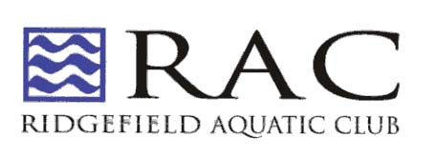
P.O. Box 256
Ridgefield, CT 06877
203-438-3951
www.racswimming.org

Dear Sir or Madam:

On Friday, January 22, 2016, the Ridgefield Aquatic Club (RAC), a 501(c) (3) not-for-profit organization, will conduct its primary fundraising event, the twelfth annual Swim-a-Thon at Barlow Mountain pool. During the Swim-a-Thon, approximately 150 children and adults will each swim 2 hours or 200 lengths (that’s over 3 miles), whichever comes first, to raise money for our program.

Last year, RAC raised over $30,000 through the Swim-a-Thon, which represents 12% of our operating budget, the remaining 88% is funded solely by the swimmers and their families. By becoming a business sponsor you will help RAC continue to provide high quality swimming programs in the area, enabling many swimmers to go on to compete in state and national level competitions. Many of our swimmers continue to represent our community at the collegiate level. Our success is only made possible through the generosity of businesses like yours.

Please consider sponsoring RAC at any of the levels below and help us to continue this tradition of success.

$1,000 and Above  Platinum Level  - Sponsorship sign at Barlow Mountain Pool for One Year  - Acknowledgement in the Ridgefield Press  - Top billing on back of event T-shirt  - Name and link on RAC website for one year | $500 to $999  Gold Level  - Sponsorship sign at Barlow Mountain Pool for One Year  - Acknowledgement in the Ridgefield Press  - Name/logo on event T-shirt  - Name and link on RAC website for one year | $350-$499  Silver Level  - Sponsorship sign at Barlow Mountain Pool for One Year  - Acknowledgement in the Ridgefield Press  - Name/logo on event T-shirt
$200-$349
Bronze Level
- Sponsorship sign at Barlow Mountain Pool for One Year
- Acknowledgement in the Ridgefield Press

In order to receive the t-shirt and sign benefit, we must receive your sponsorship by January 4th.

All donations are tax deductible as allowed by law. Checks can be made out to Ridgefield Aquatic Club and mailed to RAC, P.O. Box 256, Ridgefield, CT 06877 Attn: Swim-a-Thon. If you have questions or would like to coordinate your donation, please contact Tracy Inall at inall@sbcglobal.net

Sincerely,

The Ridgefield Aquatic Club

