West Coast B Championships
Florida Swimming mandates that all persons on the pool deck or in the facility during a Florida Swimming sanctioned/approved meet must always wear a mask and is enforceable by meet and/or facility management.
June 26 – 27, 2021
Hosted by: BERKELEY BARRACUDAS and TAMPA ELITE AQUATICS
Cantonis Pool
Berkeley Preparatory School
4811 Kelly Rd | Tampa, FL 33615

SANCTION: Florida Swimming of USA-Swimming #FL- xxxxxx

"In granting this sanction it is understood and agreed that USA-S shall be free and held harmless from any liabilities or claims for damages arising by reason of injuries to anyone during the conduct of the event"
CONDITION of SANCTION: The competition course has been certified in accordance with 104.2.2C (4). The copy of such certification is on file with USA-S.

Any swimmer entered in the meet, unaccompanied by a USA-S member coach, must be certified by a USA-S member coach as being proficient in performing a racing start or must start each race from within the water. It is the responsibility of the swimmer or the swimmer’s legal guardian to ensure compliance with this requirement.

Changing into or out of swimsuits other than in locker rooms or other designated changing areas is strictly prohibited.

Operation of a drone or any other flying apparatus is prohibited over the venue, to include pools, athlete/coach areas, spectator areas and open ceiling locker rooms, any time athletes, coaches, officials and/or spectators are present. Exceptions may be granted with prior written approval by the USA-S Program & Events Committee Coordinator (or his/her designee) .

All Applicable Adults participating in or associated with this meet acknowledge that they are subject to the provisions of the USA-S Minor Athlete Abuse Prevention Policy (MAAPP) and that they understand that compliance with the MAAPP policy is a condition of participation in the conduct of this competition.

COVID-19 RULES & GUIDELINES:
In applying for this sanction, Berkeley Barracudas agrees to comply and to enforce all health and safety mandates and guidelines of USA-S, FL Swimming LSC, the State of Florida, Hillsborough County and the City of Tampa.

FACILITY PROTOCOLS:
SOCIAL DISTANCING:
- All visitors are asked to please social distance (6 feet apart) as you move through the campus and pool deck. All visitors are required to wear a mask for the duration of their stay.
- All participants will be required to sign a COVID-19 waiver as well as agree to all Safety Protocols. Individuals not following protocols will be asked to leave the campus.
- Teams will be assigned large specific seating/tent areas and warm-up lanes (limit 10 per lane). Swimmers will maintain social distance in their areas and lanes and wear masks whenever they are not in the water.
- Entry to the pool deck of Cantonis Pool will be limited to Swimmers, Coaches, Officials and Volunteers. No spectators are allowed on the pool deck. There is one entrance and exit for swimmers and a separate one for coaches and officials, both will be monitored. Temperatures will be checked upon entry. A reading of 100.4+ will not be granted access. Individuals should not come to the facility if they have a fever or have felt ill in the past 24hrs. Negative test results will be required of out-of-state participants prior to entry.
• Hand Sanitizing Dispensers and Hand Washing Stations are located throughout the campus.
• Locker rooms, including showers and changing areas will allow 4 swimmers at one time.
SPECTATORS:
- No spectators will be allowed on the pool deck. There is one viewing area behind the diving boards, behind the fence where spectators may gather while their swimmer is in the water. All other times, spectators may relax in the 2 quads near the pool or under the covered patio of the library. Chairs and tents are acceptable in these areas only. (maps attached)

*In the event of new government, health department, USA-S, FL Swimming, State of Florida, City of Tampa or Berkeley Preparatory School guidelines, these protocols may be modified at any time to ensure full compliance and the safety of all in attendance.

Please note:
AN INHERENT RISK OF EXPOSURE TO COVID-19 EXISTS IN ANY PUBLIC PLACE WHERE PEOPLE ARE PRESENT. COVID-19 IS AN EXTREMELY CONTAGIOUS DISEASE THAT CAN CAUSE SEVERE ILLNESS AND DEATH. ACCORDING TO THE CENTERS FOR DISEASE CONTROL AND PREVENTION, SENIOR CITIZENS AND INDIVIDUALS WITH UNDERLYING MEDICAL CONDITIONS ARE PARTICULARLY VULNERABLE. USA-S CANNOT PREVENT YOU OR YOUR CHILD FROM BEING EXPOSED TO, CONTRACTING OR SPREADING COVID-19 WHILE PARTICIPATING IN USA-S SANCTIONED EVENTS. IT IS NOT POSSIBLE TO PREVENT AGAINST THE PRESENCE OF THE DISEASE, THEREFORE, IF YOU CHOOSE TO PARTICIPATE IN A USA-S SANCTIONED EVENT, YOU MAY BE EXPOSING YOURSELF TO AND/OR INCREASING YOUR RISK OF CONTRACTING OR SPREADING COVID-19.

BY ATTENDING OR PARTICIPATING IN THIS COMPETITION, YOU VOLUNTARLIY ASSUME ALL RISKS ASSOCIATED WITH EXPOSURE TO COVID-19 AND FOREVER RELEASE AND HOLD HARMLESS USA-S, FL SWIMMING, BERKELEY BARRACUDAS, THE STATE OF FLORIDA, HILLSBOROUGH COUNTY, THE CITY OF TAMPA AND EACH OF THEIR OFFICERS, DIRECTORS, AGENTS, EMPLOYEES OR OTHER REPRESENTATIVES FROM ANY LIABILITY OR CLAIMS INCLUDING FOR PERSONAL INJURIES, DEATH, DISEASE, PROPERTY LOSS OR ANY OTHER LOSS, INCLUDING BUT NOT LIMITED TO CLAIMS OF NEGLIGENCE AND GIVE UP ANY CLAIMS YOU MAY HAVE TO SEEK DAMAGES, WHETHER KNOWN OR UNKNOWN, FORESEEN OR UNFORESEEN, IN CONNECTION WITH EXPOSURE , INFECTION AND/OR SPREAD OF COVID-19 RELATED TO PARTICIPATION IN THIS COMPETITION.

TYPE of MEET: “B” Meet with timed finals for 8 and under and 10 and under swimmers and heat with “A” and “B” finals for 11-12, 13-14 and 15 and Over age groups.
Swimmers who have achieved ANY qualifying time for any event since June 18, 2019 for Florida Swimming Age Group Championships or Florida Swimming Senior Championships prior to the meet entry deadline based on their current age as of the start of meet (June 26th, 2021) are not eligible to swim in this meet.

DATES & TIMES: Cantonis Pool will be open to participating swimmers from 5:30am-6:30am Saturday and Sunday. Warm-Ups begin at 6:00am; each team is guaranteed 50min.: 1/2hr for General Warm-Up with team designated lanes and times, limit 10 swimmers per lane then 20min for Controlled Open Warm-Up. Each team will be assigned a Group (A, B, C or D) and time. All swimmers will enter the pool at the turn end and exit the pool at the block end, except in “sprint lanes” during controlled warm-up.

Saturday, June 26th
Session 1 (11 & Over) Session 2* (10 & Under) Session 3 (11 & Over)
Warm-Up 6:00am Group A Warm-Up 12:00pm Group A Warm-Up 4:30pm
Warm-Up 6:30am Group B Warm-Up 12:30pm Group B
Warm-Up 7:00am Group C Warm-Up 1:00pm Group C
Warm-Up 7:30am Group D Warm-Up 1:30pm Open
Warm-Up 8:00am Open
Heats 8:30am* Timed Finals 2:00pm Finals 6:00pm

Sunday, June 27th
Session 4 (11 & Over) Session 5* (10 & Under) Session 6 (11 & Over)
Warm-Up 6:00am Group D Warm-Up 12:00am Group C Warm-Up 4:00pm
Warm-Up 6:30am Group C Warm-Up 12:30pm Group B
Warm-Up 7:00am Group B Warm-Up 1:00pm Group A
Warm-Up 7:30am Group A Warm-Up 1:30pm Open
Warm-Up 8:00am Open
Heats 8:30am* Timed Finals 2:00pm Finals 5:30pm

*Note: Sessions 2 and 5 start times may change based on the projected length of Session 1 and 4 and the number of entries. The Timed Finals start time will not be earlier than 11:30 am. If a 4th group is not warranted for Sessions 1 or 3 the Heats start time will be 8:00 am.

LOCATION: Cantonis Pool
Berkeley Preparatory School
4811 Kelly Rd.
Tampa, FL 33615

POOL SPECS: Outdoor certified 8 lane, 25 yd pool, with non-turbulent lane lines. Minimum water depth at start and turn end of the pool is 5ft 3in.

TIMING SYSTEM: Colorado Timing System with Scoreboard

WARM-UPS: In accordance with the schedule in “Dates and Times” above and the notes under “Warm-up Schedule” following. See Notes. The diving well will be open for warm up and warm down during the meet.

STARTS/FINISH: All starts will be fly-over unless announced otherwise. Meet Management reserves the right to change the starting procedures during the meet if necessary.

RELAYS: Meet Management reserves the right to swim relays with an empty lane between each team to accommodate the correct social distancing. Lanes used would be 1, 3, 5, & 7. In this case, at the end of each leg, swimmers slide under the lane line and exit the pool in the empty lane to the swimmers right (2, 4, 6, 8).

EVENTS/HEATS: Meet Management reserves the right to combine events or heats as necessary to save time. The combination can include combining by gender, age groups, or by dissimilar strokes.

ELIGIBILITY: Open to all USA Swimming Members. On deck registrations will NOT be allowed.

DECK ENTRIES: Not permitted at this meet.

SEEDING: All entries are to be submitted in SCY or LCM format. Submit entry times according to the time swum; do not submit converted times. Non-conforming meter times will be seeded after SCY times. “No Times” will be seeded last. Seeding will be slowest to fastest.

All individual events will be pre-seeded. Relays may be designated as “check-in to swim” events or be pre-seeded depending on the number of entries and how lanes will be assigned.

Please Note: Entry times may be updated and entries corrected after the psych sheet is first published until 5:00pm June 20th 2021 by email to cshowalter@showtechsolutions.com, or texted to 813-334-6977. If a first FLAGS or FL Senior Championships qualifying time is achieved in any event after the entry deadline (June 18th 2021) and before the meet starts the swimmer may still compete in the meet, but may either enter another event(s), if an empty lane is available, or remain in the event(s) but not place or score.

Relays will be swum as Timed Finals. Mixed 200 yd Freestyle and Mixed 200 yd Medley relays will take place on Friday & Saturday during Finals and Timed Finals Sessions. Teams may enter up to 4 relays per event, however only 2 relays for each event may place and score.

SCRATCHES: Scratches from finals must be done individually; emailed to cshowalter@showtechsolutions.com, or texted to 813-334-6977. Heats and timed finals will be pre-seeded.

SCRATCH PENALTY: Heats and Timed Final Events: No requirement to scratch.

Finals: Any swimmer who competes in a preliminary heat and qualifies as one of the original 16 finalists must swim in that event’s final or must notify the Meet Referee that they intend to scratch from the final for that event within 30 minutes of the conclusion of the preliminary sessions for that day.
Swimmers may reverse their intention to scratch and choose to be seeded if the finals events have not been seeded. Note: this is not a set time each day.
Any swimmer in a championship or consolation final who fails to swim that event will be ejected from the meet unless excused by the Meet Referee due to one of the exceptions below.
No penalty shall apply for failure to withdraw or compete in an individual event final if:
- The swimmer was not originally qualified for the championship or consolation final and is seeded into that final due to a scratch of another swimmer will not be penalized for failing to swim in that final if they were not notified by the Meet Referee and had not agreed to swim.
- It is determined by the referee that failure to compete is caused by circumstances beyond the control of the swimmer.
- The referee is notified in the event of illness or injury and accepts the proof thereof.
All finals scratches must be emailed to cshowalter@showtechsolutions.com, or texted to 813-334-6977.

Reinstatement: Ejected swimmers may pay a $50 reinstatement fee
and continue the meet at the point of payment. Any events missed due to ejection are not re-swimmable.

Declared False Starts: Declared false starts in finals and/or a deliberate delay of meet will be treated the same as "failure to swim".
NOTES:
- Alternates wishing to swim in an open lane in finals must be standing at the starters stand, ready to step on the blocks, when the swimmers are called to the blocks. Only the starter will call for the alternate, not the announcer.
- Finals/Consolation Finals scratches must be done individually; 'team' scratches will not be accepted.
- In addition to the swimmers being required to scratch if they are not going to swim in finals, all swimmers placed 17 through 24 who do not wish to swim in finals are strongly urged to scratch.
- The Meet Referee will attempt to contact swimmers scratched into finals. If contacted, and the swimmer agrees to swim in the final penalties for failure to compete will apply.
ENTRY INFO: On-Line Meet Entry (OME) - Entries will be processed using the USA Swimming On-Line Meet Entry System (OME) ONLY. Access this entry system from the USA Swimming web site at the address, http://www.usaswimming.org/ome. Coaches must register for an account (Free) to utilize the system. Log in and select "Enter Team". Paper, FAX, and Email entries will not be accepted.
Entries are submitted through OME.
OME opens on April 19, 2021 @ 12:00 a.m.
OME closes on June 18, 2021 @ 11:59 p.m. unless entry limits are reached earlier.
Late entries will be accepted up to 24 hours after OME closing and will be charged a $100 processing plus 2x the entry fee.
Entry questions can be emailed to Cary Showalter, cshowalter@showtechsolutions.com or phoned at 813-334-6977
PROOF of TIME: Swimmers must enter with their fastest achieved time in each event (Higher seeding will result from entry using SCY times) as listed in the National Data Base. If a swimmer has achieved a FLAGS or FL Senior Championships qualifying time since June 18 2019 in any event (SCY or LCM) based on their age at the start of this meet, they are not eligible to compete in this meet. Swimmers who have not previously competed in an event, or the LCM equivalent, may enter with a No Time (NT).

ENTRY FEES: Individual Events Fee: $6.10/event
Relay Fee: $8.00/Relay
Facility Fee: $20.00/participant
Heat Sheet Fee*: $2.00/participant
Travel Surcharge: $2.00/Out-of-State participants
A financial statement will be emailed to the specified contact from Hy-Tek once OME checkout is complete.

*Heat Sheets will be emailed to coaches and posted on: www.floridaswimming.org no later than 48 hours prior to the start of the meet. Coaches, please email all swimmers and parents to make them aware of this.

ENTRY LIMIT: 11 & Over swimmers are limited to three (3) individual events per day. 10 & Under swimmers are limited to 4 individual events per day.
No individual may swim more than one relay per session.
Teams may enter up to 4 relays per relay event, however, no more than 2 relays for each team may place or score in each relay event. “Over entries” will automatically be dropped when they exceed the meet limit.
This meet will be limited to the first 300 11 & Over swimmers and 230 10 & Under swimmers.

SCORING: The top 16 places from finals in the combined results will be scored as follows:
Individual: 20, 17, 16, 15, 14, 13, 12, 11, 9, 7, 6, 5, 4, 3, 2, 1
Mixed Relays: 20, 17, 16, 15, 14, 13, 12, 11, 9, 7, 6, 5, 4, 3, 2, 1 per gender

INFO/QUESTIONS: kevinrosepapa@gmail.com or call/text 813-416-6299

AWARDS: Awards will be given as follows:
Individual: Medals 1-3, Ribbons 4 – 8. Relays: Medals Places 1-3
FLAGS or FL Senior Championship cuts – Special Sticker.
Team high point awards:
Combined: Place 1, 2 and 3, Girls 1, 2 and 3, Boys 1, 2 and 3.

RULES: Current USA-S Technical Rules and Regulations will govern the conduct of this meet. Safety rules, as outlined by USA-S and as recognized by the meet marshal, will be in effect during all warm-up session and in diving well. NO EQUIPMENT WILL BE ALLOWED DURING WARM-UPS

OFFICIALS: Meet Referee: Bob Griffiths
Starter: Karen James
Team Lead CJ: xxxxxxxxx
Armin Ref: Cary Showalter cshowalter@showtechsolutions.com
Meet Manager: Kevin Rosepapa
Meet Marshal: Mike Easton

TEAM REP: Prior to start of the meet, the name of one person, a current member of USA Swimming, other than the coach, who will check with the referee about any matter pertaining to the meet, may be given to the referee. For each team, the coach and that person only will be recognized.

IDENTIFICATION: Coaches & Officials must present their current credentials when asked and must keep them on their person at all times.
CAMERA ZONES: Per Florida Swimming Rule223.12, Meet Management shall designate and inform the public of “Camera Zones” at each swim meet where both still photography and video photography of a race or a competitor in a race may be taken. Acceptable Camera Zones may include, but are not limited to the side courses of a pool, team gathering areas, concession area, turn-end of competition course when not in use as a “start-end,” etc. Meet Management shall also designate Non-Camera Zones. Under NO circumstances will Camera Zones include the area immediately behind the starting blocks at either end of the racing course(s) while they are in use for “race starting purposes” during competition and warm-ups, locker rooms, restrooms, or any other dressing area. Any individual failing to abide by this rule could be subject to the Florida Swimming Code of Conduct violation as defined in Rule 239.2.

West Coast B Championships
WARM-UP SCHEDULE

ABSOLUTELY NO EQUIPMENT AT ANY TIME

Cantonis Pool will be open to participating swimmers from 6:00am-7:00am, Friday, Saturday
and Sunday.
Warm-Ups begin at 6:00am. Each team is guaranteed 50min.:
1/2hr for General Warm-Up with team designated lanes and times, limit 10 swimmers per lane
then 20min. for Controlled Open Warm-Up.
Each team will be assigned a Group (A, B, C or D) and time. All swimmers will enter the pool at the turn end and exit the pool at the block end. Swimmers must enter the water feet first with at least one hand in contact with the pool deck except when executing a controlled racing start,
supervised by a coach.

30 min GENERAL WARM-UP:
Lane 1 Push off 50’s pace (circle swimming)
Lane 2 Swimming and pulling only
Lane 3 swimming and pulling only
Lane 4 Swimming and pulling only
Lane 5 Swimming and pulling only
Lane 6 Swimming and pulling only
Lane 7 Swimming and pulling only
Lane 8 Swimming and pulling only

20 min CONTROLLED OPEN WARMUP:
Lane 1 Push off 50's pace (circle swimming)
Lane 2 Racing start, one length only
Lane 3 Racing start, one length only
Lane 4 General swimming - push off
Lane 5 General swimming – push off
Lane 6 Racing start one length only
Lane 7 Racing start one length only
Lane 8 Push off 50's pace (circle swimming)

FLAGS and FL Senior Championships Qualifying Times.
Any swimmer who has achieved a time in the last 2 years (since June 18th 2019 ) that would allow them to participate in the FLAGS or FL Senior Championships may NOT enter this meet.
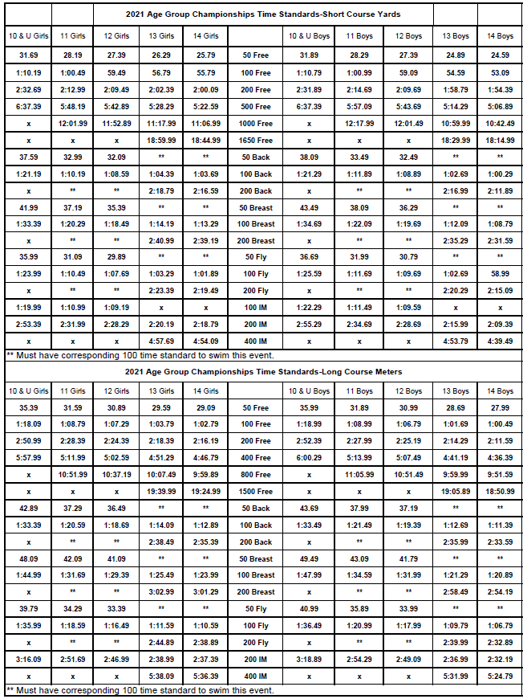

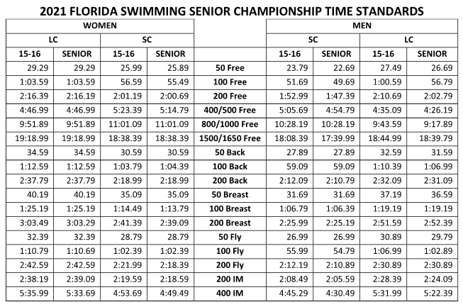

West Coast B Championships – Order of Events
June 26TH – 27TH, 2021
Event Notes:
- All Relays, 10 & U and 8 & U events are timed final events.
- The 200 Mixed Freestyle & 200 Mixed medley relays swim in Finals and Timed Final sessions.
- Finals – Fastest 16 swimmers who do not scratch for 11-12, 13-14 and 15 & Over return for two (2) finals per event. Finals will be swim A, B.

Saturday, June 26th | Day 1 | Heats Start: 8:30am¹ | Finals Start: 6:00pm | 11 and Over |
Sessions 1 (heats) and 3 (finals and mixed relays)
Girls  Event Nº | Event | Boys  Event Nº |  | Girls  Event Nº | Event | Boys  Event Nº
1 | 11-12: 200 Free | 2 |  | 19 | 11-12: 50 Fly | 20
3 | 13-14: 200 Free | 4 |  | 21 | 13-14: 200 Fly | 22
5 | 15&O: 200 Free | 6 |  | 23 | 15&O: 200 Fly | 24
7 | 11-12: 100 Back | 8 |  | 25 | 11-12: 50 Free | 26
9 | 13-14: 100 Back | 10 |  | 27 | 13-14: 50 Free | 28
11 | 15&O: 100 Back | 12 |  | 29 | 15&O: 50 Free | 30
13 | 11-12: 100 Breast | 14 |  | 31 | 11-12: 200 Mixed MR²
15 | 13-14: 100 Breast | 16 |  | 33 | 13-14: 200 Mixed MR²
17 | 15&O: 100 Breast | 18 |  | 35 | Open: 200 Mixed MR²
Notes: 1 Start may be moved to 8:00am if entries warrant.
2 Timed Final Mixed relay –2 girls and 2 boys on each relay. Check-in by 6:00pm to swim

Saturday, June 26th | Day 1 | Session 2 | Start: 12:30 pm³ | 10 and Under | Timed Finals

Girls  Event Nº | Event | Boys  Event Nº |  | Girls  Event Nº | Event | Boys  Event Nº
37 | 10&U: Mixed MR²
39 | 8&U: 25 Back | 40 |  | 45 | 10&U: 100 Breast | 46
41 | 10&U: 100 Back | 42 |  | 47 | 10&U: 50Fly | 48
43 | 8&U: 25 Breast | 44 |  | 49 | 10&U: 50 Free | 50
Notes: 2 Mixed relay – 2 girls and 2 boys on each relay.
3 Start may be moved, earlier or later) depending on entries. Not before 11:30am.

Sunday, June 27th | Day 2 | Heats Start: 8:30am¹ | Finals Start: 5:30pm | 11 and Over |
Sessions 4 (heats) and 6 (finals and mixed relays)
Girls  Event Nº | Event | Boys  Event Nº |  | Girls  Event Nº | Event | Boys  Event Nº
51 | 11-12: 100 Free | 52 |  | 69 | 11-12: 100 Fly | 70
53 | 13-14: 100 Free | 54 |  | 71 | 13-14: 100 Fly | 72
55 | 15&O: 100 Free | 56 |  | 73 | 15&O: 100 Fly | 74
57 | 11-12: 50 Back | 58 |  | 75 | 11-12: 100 IM | 76
59 | 13-14: 200 Back | 60 |  | 77 | 13-14: 200 IM | 78
61 | 15&O: 200 Back | 62 |  | 79 | 15&O: 200 IM | 80
63 | 11-12: 50 Breast | 64 |  | 81 | 11-12: 200 Mixed FR²
65 | 13-14: 200 Breast | 66 |  | 83 | 13-14: 200 Mixed FR²
67 | 15&O: 200 Breast | 68 |  | 85 | Open: 200 Mixed FR²
Notes: 1 Start may be moved to 8:00am if entries warrant.
2 Timed Final Mixed relay –2 girls and 2 boys on each relay. Check in by 5:30pm to swim.

Sunday, June 27th | Day 2 | Session 6 | Start: 12:30 pm³ | 10 and Under | Timed Finals

Girls  Event Nº | Event | Boys  Event Nº |  | Girls  Event Nº | Event | Boys  Event Nº
87 | 10&U: Mixed FR²
89 | 8&U: 25 Free | 90 |  | 97 | 8&U: 25 Fly | 98
91 | 10&U: 100 Free | 92 |  | 99 | 10&U: 100Fly | 100
93 | 10&U: 50 Back | 94 |  | 101 | 10&U: 100 IM | 102
95 | 10&U: 50 Breast | 96
Notes: 2 Mixed relay – 2 girls and 2 boys on each relay.
3 Start may be moved, earlier or later) depending on entries. Not before 11:30am.

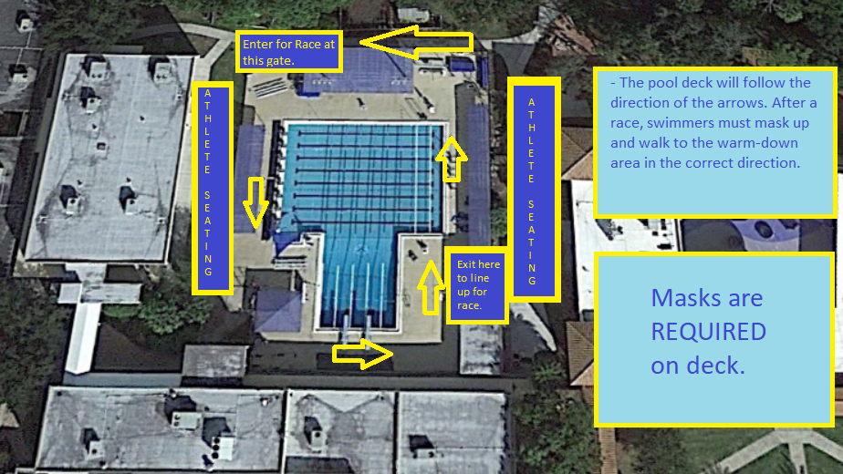

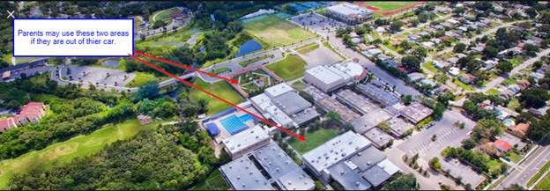

Hotels and Lodging

The Berkeley Preparatory School is located 2 miles from the Tampa International Airport with over 20 Hotels within a 5-minute drive of the school. There are plenty of restaurants as well in the area and makes for a very convenient location to have a great swim meet.

