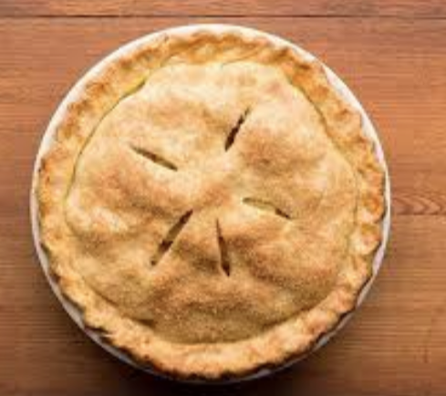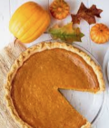

2019 Holiday Pie Fundraiser

Pies are from Blue Jay Orchards in Bethel CT. Lots of delicious varieties – see order form in pool lobby for selection.

Money raised will go towards travel meet fees or your annual fund raising commitment.

All pie orders and checks are due by Saturday November 2nd.

Pies arrive frozen and need to be picked up on Monday November25th at 5pm.

Please have checks made payable to Ridgefield Aquatic Club.
Please place your pie orders and checks in an envelope and put the envelope in the Archibald Family Folder in the lobby at the pool.
If you have any questions about the Pie Fundraiser, please email
Liz Archibald at lshaio@aol.com or call 203-561-0764.

