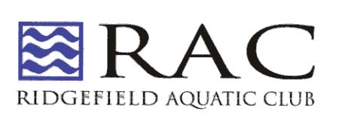
Hello RAC Swimmers,
We are bringing back the very successful Pie Sale Fundraiser. We are selling delicious pies from our local Blue Jay Orchard in Bethel CT.
From now until November 2nd, swimmers can sell pies to their family, friends and neighbors for the holidays. Each pie they sell will earn them $7.00 towards their fund raising commitment ($4 for donuts). If your swimmer is going to a travel meet this winter, the money can be used towards that. If your swimmer is not going to a travel meet, the money can be used towards their annual fund raising requirement. If a swimmer sells 10 pies, they will raise $70. Easy money! In the past, swimmers who participated in the fundraiser, raised on average.
Now is a great time for a pie sale. Blue Jay will deliver the pies frozen to Barlow Mountain Pool on Monday, November 25th, which gives you several days before Thanksgiving to deliver the pies to your family, neighbors and friends who ordered them. Please pick up your pies between 4:30 and 5:00 pm on Monday, November 25th. Pies that are not picked up will be donated to a local soup kitchen.
So go out and start selling pies today. The order form is attached. Please have checks made payable to Ridgefield Aquatic Club.
All pie orders and checks are due by Saturday November 2nd. Please place your pie orders and checks in an envelope and put the envelope in the Archibald Family Folder in the lobby at the pool.
If you have any questions about upcoming Travel Meets, please call Coach Emmanuel.
If you have any questions about the Pie Fundraiser, please email Liz Archibald at Lshaio@aol.com
Good Luck!

