12/19/2016 Rays Booster Club Minutes
Monday, December 19, 2016

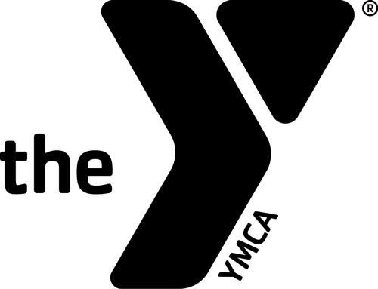

Meeting called to order at 5pm

Attendees: Tina Asido, Michelle Noonan, Michelle Lamphere, Kim Fryer, Lisa Whitaker, Barbara Glaude

Treasurers Report Provided
$8800.75 in the savings account

Board members have not received any corrections, therefore the record board will be updated with the latest records.

It was discussed that those that volunteered for Apple Harvest, there will be a volunteer credit of $10 that will be applied to your USA account. If you are not USA then the credit will be applied to the Pumpkin meet or banquet tickets.

Meeting adjourned 5:30pm

Rays Booster Club

