### Race4Chase – HELP!!!

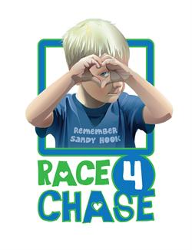

Race4Chase is Saturday, August 5th at Camp Sloper; **less than a week away**! We are still in need of donation items and volunteers to work at the concession stand.

Donations of bagels, muffins and water should be dropped off at the Y by **noon** on **Friday 8/4**. Our concession stand not only supports the athletes who are competing and their families, but is a fundraiser for the RAYS as well. Please support this event in any way you can!

Please [sign-up](https://www.teamunify.com/EvJobSignup.jsp?team=ctss&event_id=800075) to donate food items or volunteer to work on Team Unify.



Image result for wave clipart bannerImage result for wave clipart bannerImage result for wave clipart banner

### Volunteers – The RAYS Need You

The RAYS Booster Club is getting ready for the fall season. We are looking for more volunteers to ensure next season for the RAYS is the best yet.

We are looking for someone to be our **Fundraising Coordinator**. You would ensure we have a Chairperson to run each fundraising event. In the past, Apple Harvest parking, home concession stand, and Christmas wreath sales have been our primary fundraising activities, but we want someone to bring new ideas to the team. If anyone is interested in chairing a specific event or being the Fundraising Coordinator (or co-coordinators) please reply to this email and let us know.

Our first and largest fundraiser is **Apple Harvest parking**. We will be looking for everyone to take a shift and spend a couple hours collecting money for parking. Mark your calendars for September 30th and October 1st and October 7th and 8th. Sign-ups events are coming soon in Team Unify.



8/4: Race4Chase donations by **noon** at the Y

8/5: Race4Chase concession stand at Camp Sloper

8/16: RAYS swim team information night 6-7:30 PM

8/28: **New** swimmer try-out and registration

8/29: **Returning** swimmer registration

9/5: Make-up registration

9/6: **First night of practice**

9/11: Swim suit fitting

9/12: Last day to register for the team

9/18: First Booster Club meeting – everyone is encouraged to attend!

9/30: Apple Harvest parking fundraiser

10/1: Apple Harvest parking fundraiser

10/7: Apple Harvest parking fundraiser

10/8: Apple Harvest parking fundraiser

### Dates You Need to Know

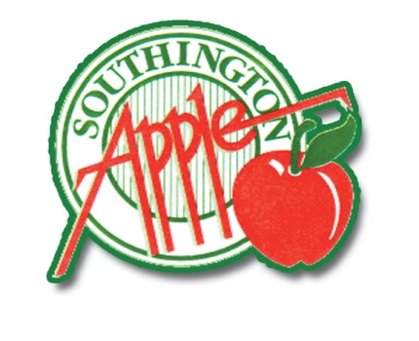



The coaches would like to take this opportunity to congratulate all of our RAYS swimmers on a successful summer season. Everyone worked hard and swam well. There were many personal best times as well as some team records.

As a team, we had more swimmers go on to Senior and Age Group Championships than any previous season. At Age Groups the RAYS combined team finished 24th out of more than 50 teams. There were many wonderful personal performances too. **Ella Nadeau** finished 10th overall in the girls 10 and under age group and **Matt Whitaker** and **Molly Whitaker** both qualified for Zones. Congratulations too all of the RAYS swimmers. We look forward to seeing everyone in the pool in September!

Enjoy the rest of your summer

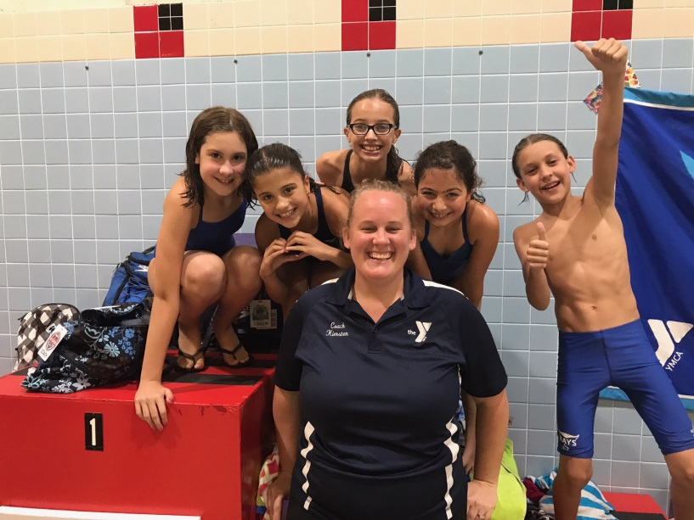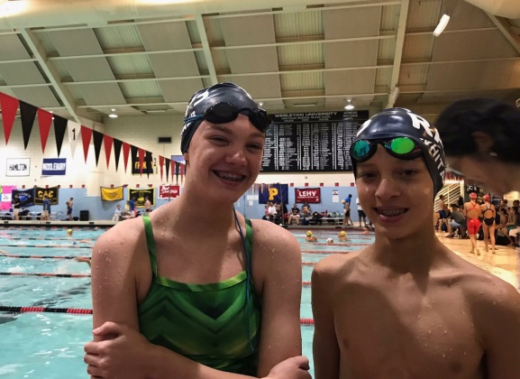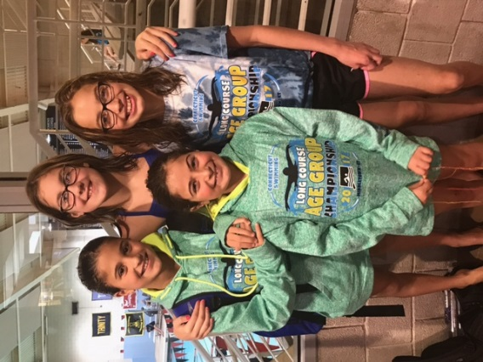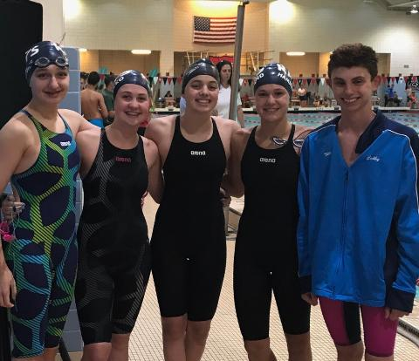

Not picture, Peter Zalewski, who finished tied for 41st overall for boys 10 and under

### End of the Season Wrap Up!