### First swim meet of the season!

### Meet vs Waterbury

[](https://www.bing.com/images/search?view=detailV2&ccid=63mWOHEO&id=C447165FDE25E3CF0364ACCD43A7B5A6E6205E2D&thid=OIP.63mWOHEOwAsVx2zQTjr40gHaFj&mediaurl=https://i.pinimg.com/736x/a0/d1/a8/a0d1a86492ed3e6355dee848353e3f3d--children-games-children-s.jpg&exph=552&expw=736&q=swim+practice+clipart&simid=608035412808107773&selectedIndex=32&qpvt=swim+practice+clipart)

Our swimmers have been working very hard in the pool and are now ready to showcase their abilities in our first USA meet of the season.

The USA swimmers will be swimming in Cheshire on Friday night and at Wesleyan University on Saturday and Sunday.

There will be regular practice for all non USA swimmers, and on Saturday for non USA mini RAYS not competing over the weekend.

### Important Meet Information

CDOG Distance meet:

CCP recently installed two new sets of bleachers. Parents must use the bleachers. No deck chairs will be allowed in the spectator area. Swimmers will still be able to use deck chairs in the team area.

- All food must be eaten over by the hospitality area. This has become an issue with the facility over the past couple of meets when team areas have been left with lots of food on the ground.

- This will be the first meet at CCP since the instillation of bleachers. Please be patient while the host works out any bugs with regard to deck space for teams.

WHAT Invitational:

NO PERSONAL FOLDING CHAIRS ARE ALLOWED IN THE FACILITY

 Swimmers must be dry and wear shoes when off the pool deck and walking through the facility.

  No spectators or swimmers will be permitted to congregate in the center of the front lobby of the Athletic Center.

Only individuals with disabilities will be permitted in the spectator viewing area

If seating is tight, we ask that spectators leave the viewing area when their swimmer is not racing offering others that opportunity to watch their swimmer.

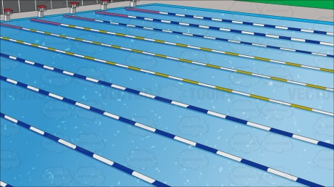

**Friday Night:**  5:00 warm up; 5:50 start

Meet manager: Samson-

Timing events 1-8: Lamphere & Zalewski

**Saturday AM:**  (11-12) 7:00 warm up; 8:00 start ; 10:40 end (est.)

Meet Manager: Nadeau

8-9:20 Alejandro 9:20-10:40 Labadze

**Saturday Middle**: 10 & under 11:00 warm up; 11:30 start; 1:00 end (est)

Meet manager: Vogt

11:30-1 Cornelio

**Saturday PM:** 13& over 2:00 warm up; 3:00 start; 7:30 end (est)

Meet manager: Hammarlund

3-5:15 Swindon 5:15-7:30 Noonan

**Saturday AM:**  (11-12) 7:00 warm up; 8:00 start ; 10:40 end (est.)

Meet Manager: Nadeau

8-9:20 Laszewski 9:20- 10:40 Malsheske

**Saturday Middle**: 10 & under 11:00 warm up; 11:30 start; 1:00 end (est)

Meet Manager: Vogt

11:30-1 Burdeshaw

**Saturday PM:** 13& over 2:00 warm up; 3:00 start; 7:00 end (est)

Meet Manager: Hammarlund

3-5 MacAllister 5-7 Kroll

Meet Manager is responsible for checking the team in at warm up and getting our team assignments

### Timing Assignments

[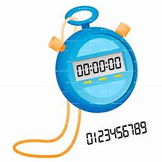](https://www.bing.com/images/search?view=detailV2&ccid=Fh1eA9%2bC&id=13A380E6607154A06ABECE1F1087D90BF5BA002A&thid=OIP.Fh1eA9-ChUKyKBUPfRnYjAHaHa&mediaurl=http://www.clipartkid.com/images/134/stopwatch-vector-ZrUyRi-clipart.jpg&exph=1500&expw=1500&q=stopwatch+clipart&simid=607995452499561671&selectedIndex=1)

### 

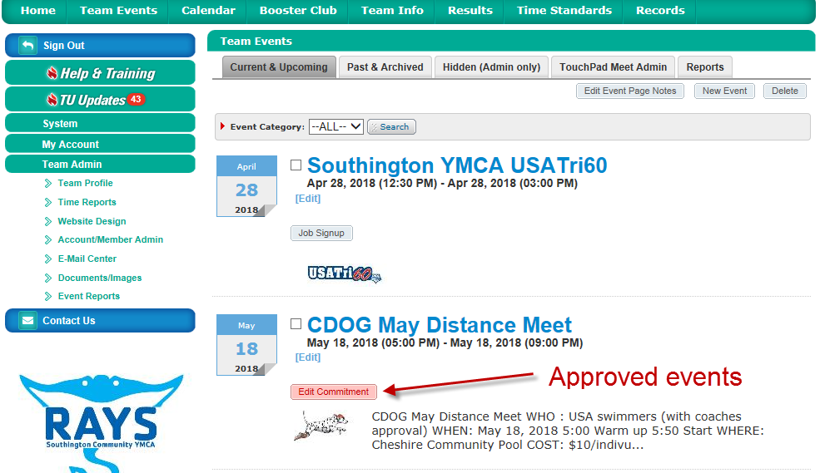[](https://www.bing.com/images/search?q=tips+clipart&id=837B1854765CD33772D6D8CB8011F1DDBE7D3C39&FORM=IQFRBA)

### Team Unify Tips

Want to know which events your child is swimming? Log on to Team Unify, select Team Events, find the event and click on the pink “Edit Commitment” button to see the coach approved events.

### [Image result for schedule clip art](https://www.bing.com/images/search?view=detailV2&ccid=c666%2bqMJ&id=8CDBAD922D65EE63D2CB8BFF22CE708E652742E7&thid=OIP.c666-qMJoQ1DhukQcGlN2AHaFQ&mediaurl=http://weclipart.com/gimg/229B91E99CFB9770/kiKnAbB4T.jpg&exph=1318&expw=1859&q=schedule+clip+art&simid=608032831572869277&selectedIndex=67)

Long course practices will be held at **Wesleyan 6-8 PM** on the following days:

May 29: Juniors & Seniors

June 13: Juniors & Seniors

July 2: Juniors & Seniors

June 2-3: MAC Qualifier (please see meet announcement for time change)

June 9: YMCA Home Meet

June 15-17: CDOG Meet

June 22: YMCA Home Meet

July 6-8: USA Swimming Regional Championships

July 12-15: USA Senior Championships

July 26-28: USA Age Group Championships

Aug 8-11: Eastern ZONE Championships

If you have not signed up for our home swim meets, please log into team unify and do so!!