How to sign up your child for a swim meet on the website:

[www.trumbullpisces.org](http://www.trumbullpisces.org)

Click on the heading “Swim Meets/Events”. The heading will get you to the list of meets for signup. The drop down items will go to different pages.



1. MAKE SURE YOUR CHILD IS ELIGIBLE FOR THE MEET by reading the announcement (practice group, child’s age, etc).
2. MAKE SURE YOU CAN ACTUALLY BE AT THE MEET. Check dates and times. If it is a multi-day meet, you can attend one day but please make a note of it
3. Once you confirm your swimmer is eligible and you can be there, click “Edit Commitment” button on the upper right of the meet announcement screen

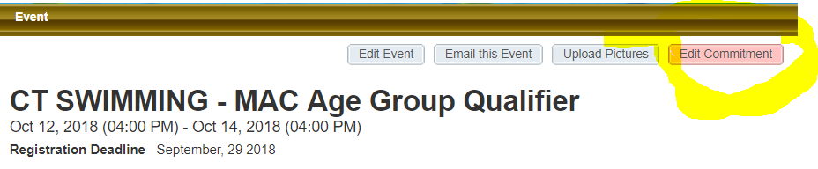

1. When the next screen opens, click on the swimmer you are committing to attend the meet (some families may have more than one swimmer)

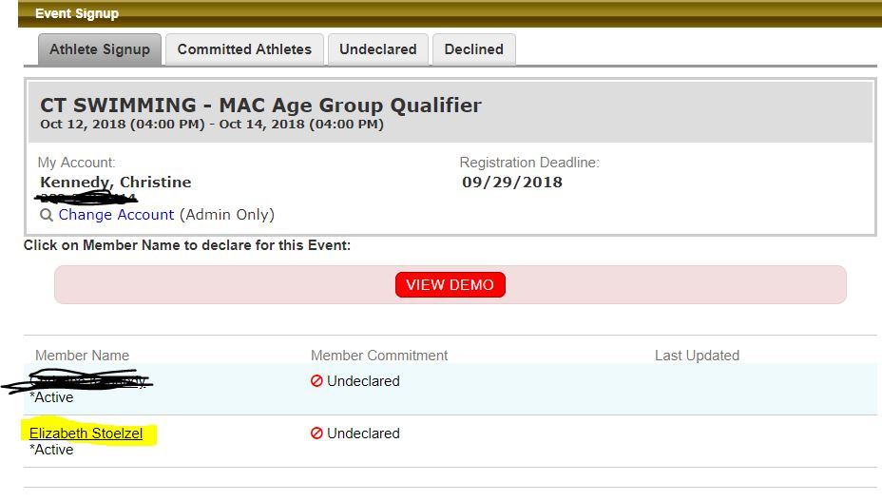

1. When the next screen comes up, select the drop down and “Yes, please…..”. There is a comment box if you need it: for example if you can only make one day of a 2 day meet (please specify).

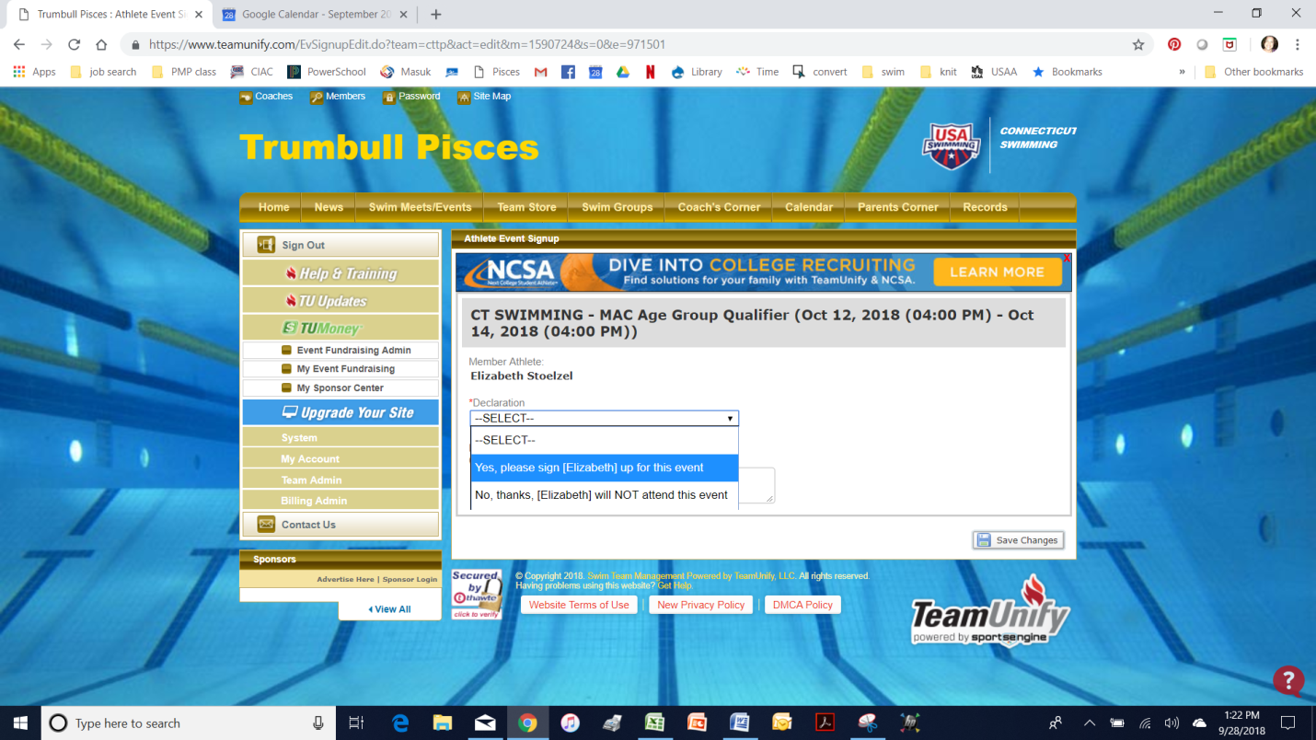

Once you have committed to the meet, Coach Bill takes it from there and builds the entry and picks the appropriate events. You will be notified via email during the week leading up to the meet.