**Swim Parent Digital Survivor’s guide**

As you spend more seasons at the pool and your swimmer progresses, you will find certain websites and apps that help you survive. This guide is not the final word in all things technology but it will get you started.

Your first stop for all things Pisces is the Team Website which is hosted by TeamUnify

<https://www.teamunify.com/Home.jsp?team=cttp>

To make sure team emails sent through the Team website don’t end up in your spam filter, please add teamunify.com as a recognized address

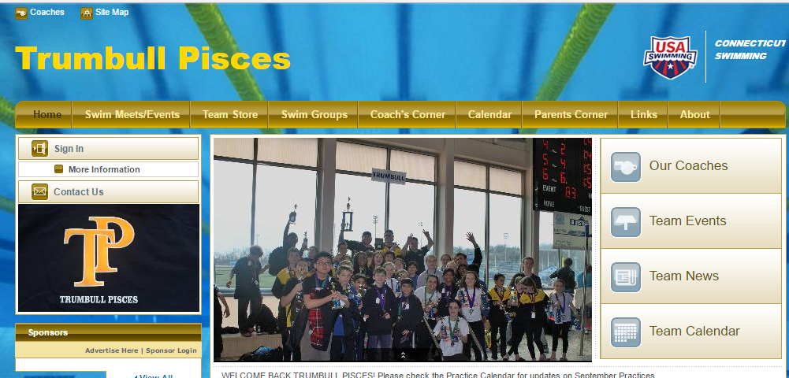

You can access the Calendar and Practice Schedule without logging in.

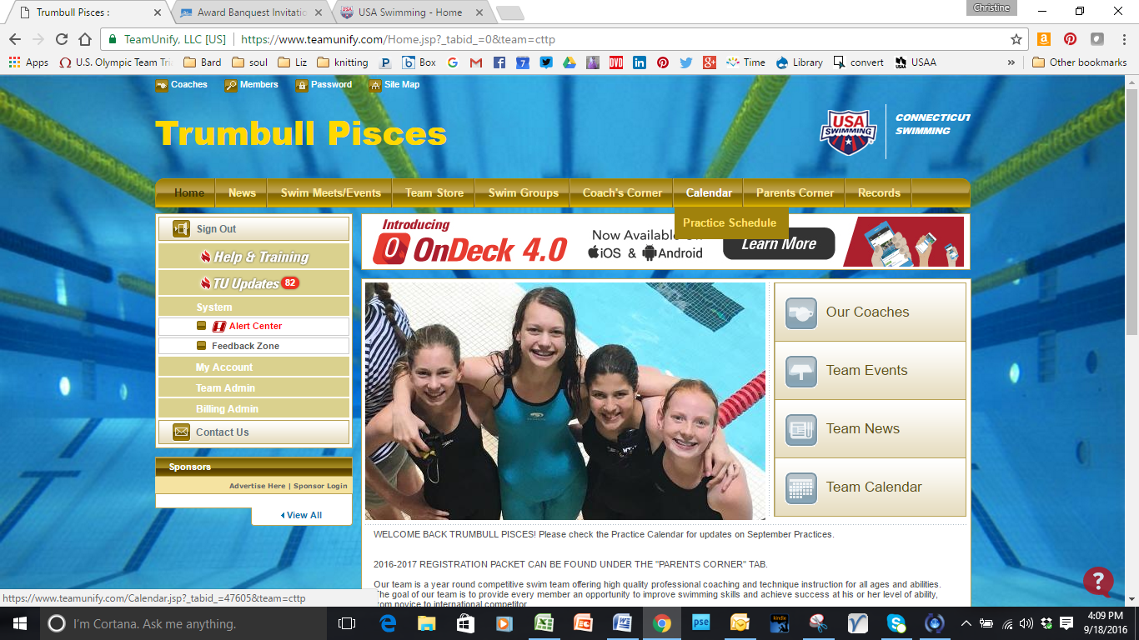

This guide is available in the “Parents Corner” for reference.

Team Store is the Tab that will have all the team gear orders: suits, jerseys, mesh bags, etc.

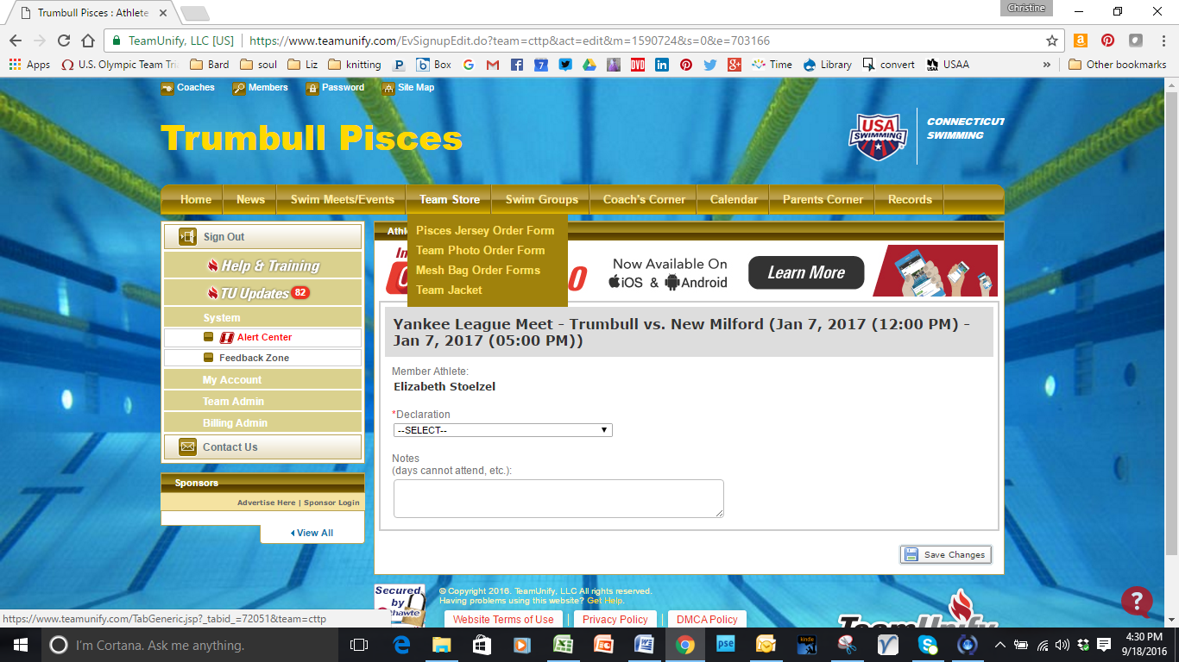

**Signing up for meets**

You sign up to attend meets by going to the “swim meets / events” tab.

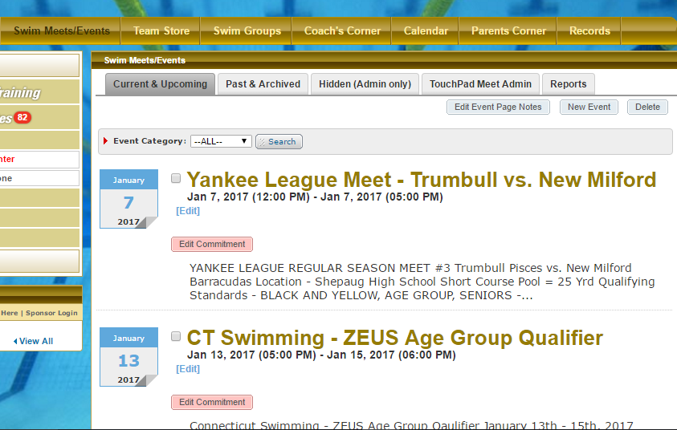

Click on Edit Commitment, which brings up the following screen. 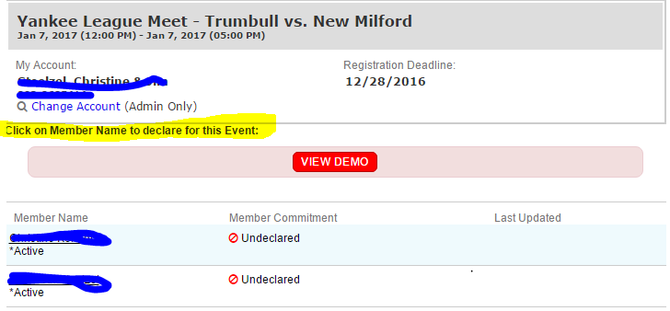

Click on the swimmer’s name for declaration of commitment.

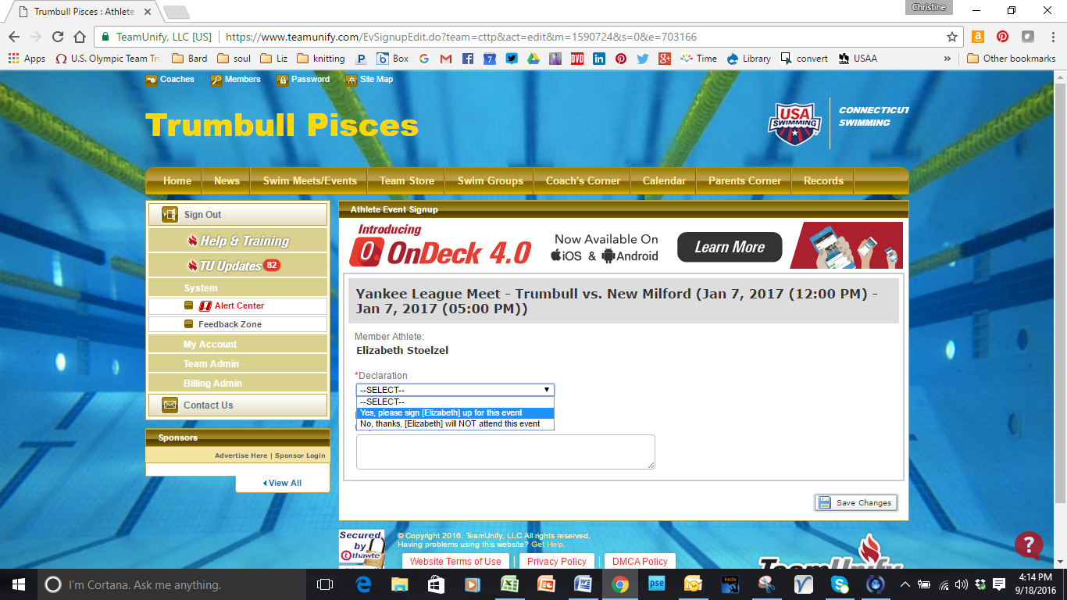

The open text box is a good place to indicate if you can only make one day of a two day meet or other considerations you’d like the coach to know. If you don’t confirm attendance by the registration deadline, the default is “no”.

If you select “yes” but before the meet you can’t make it, this is called a “scratch” and if done too close to the event, we will still be charged as a team for the swimmer’s meet entry (generally $60 per swimmer). Please check that you can attend before confirming that your swimmer is coming.

**Connecticut Swimming**

[www.ctswim.org](http://www.ctswim.org) All the information for swimming in CT (the USA swimming meets)

You can look up your swimmers best times and all the USA meet results.

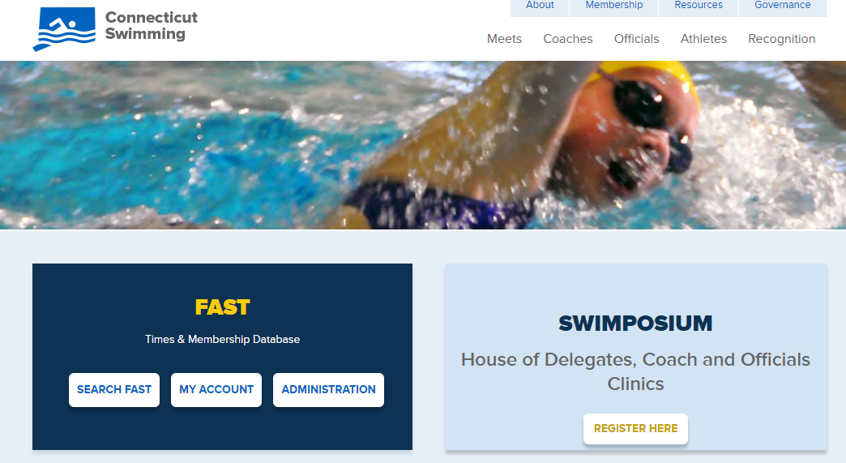

If you select “Search Fast” you can see your swimmer’s best times, USA swim meets entered and other information.

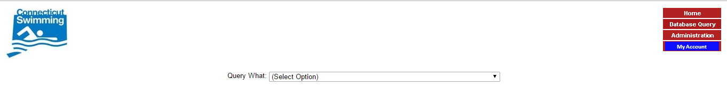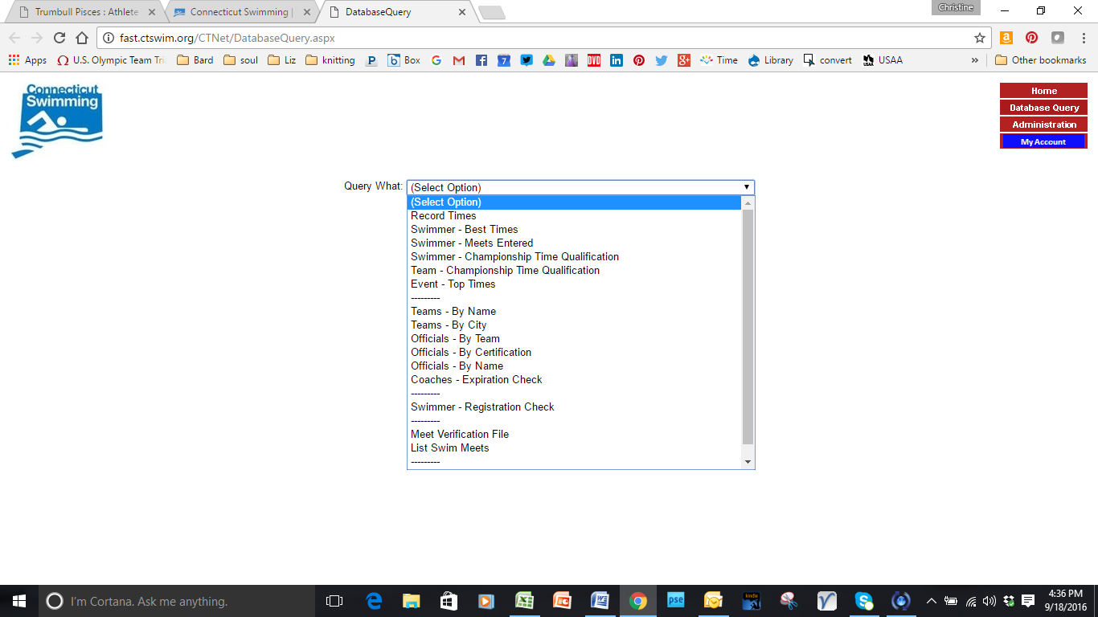

If you select My Account in upper right you can create a parent account.

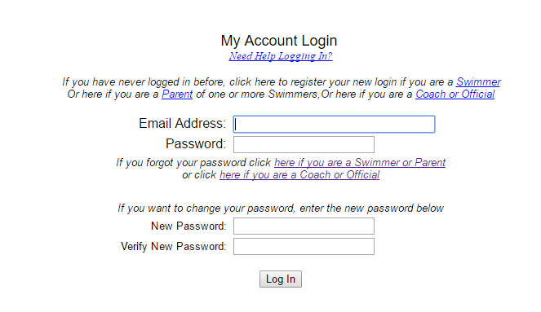

**USA swimming** [**www.usaswimming.org**](http://www.usaswimming.org)

This is the repository for all things swim. You can find inspirational time standards, the official rule book [here](http://www.usaswimming.org/DesktopDefault.aspx?TabId=1636&Alias=Rainbow&Lang=en)., and videos on what is considered “legal” for each stroke [here](http://usaswimming.org/DesktopDefault.aspx?TabId=2775&Alias=Rainbow&Lang=en)

You can also livestream most National meets and see replays from others.

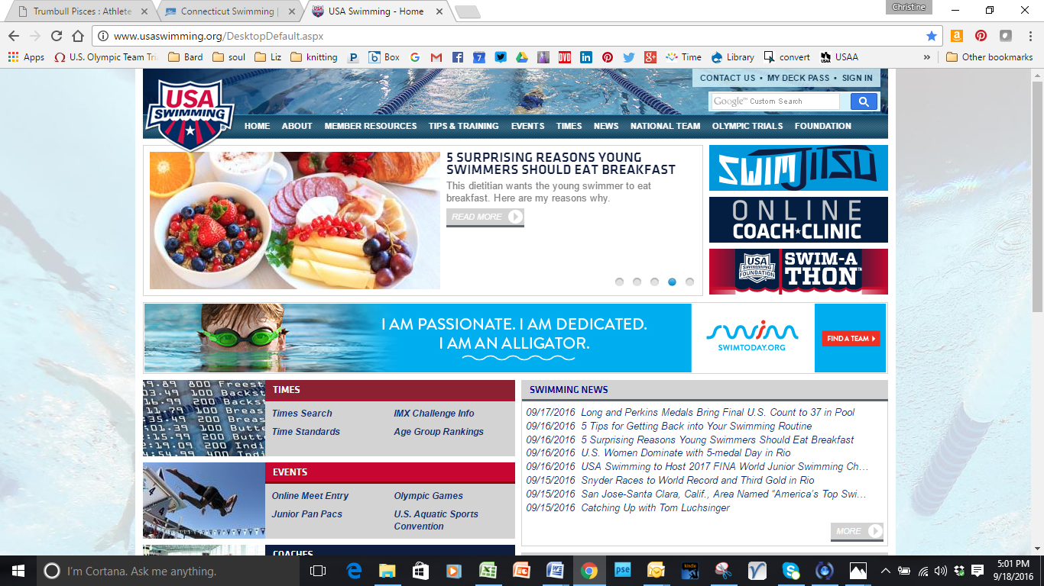

If you click on Member Resources, you have many options to look at.

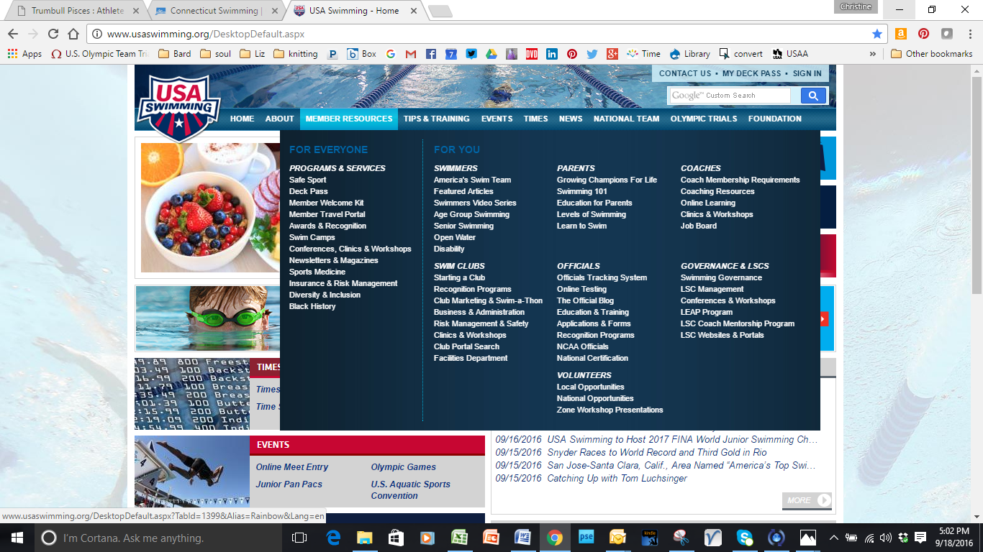

**Apps:**

The work horse for the season is OnDeck Parent v 4.0 (new version just released) which is a free app. It is linked to the TeamUnify site and Pisces are “cttp” when you sign in. It has meet entries, meet results, time standards, a stop watch and other features. It does not have heat or lane information.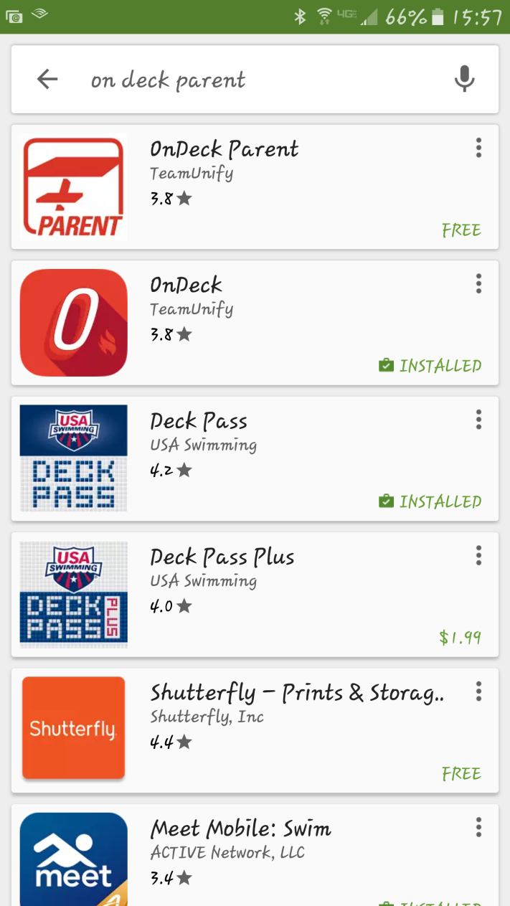

OLD VERSION

NEW VERSION – this is the one you want

Another useful app for some of the bigger meets is meet mobile.

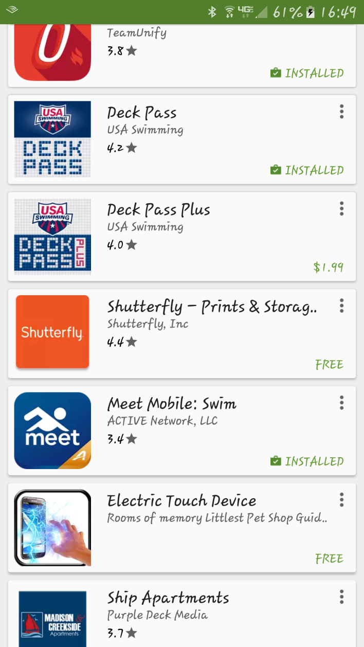

You can see registered swimmers, event line up, and psych sheets for free. This is dependent upon whether the meet Administrative Official connects the console to mobile.

You can purchase an annual subscription for a reasonable price and you can see live results and sometimes heat and lane assignments, again depending on what is released by the Administrative Official.