HOST
Irish Aquatics Swim Club
PO Box 10142, South Bend, IN 46680
www.irishswimming.org

MEET DIRECTORS
Christie Hannewyk Matt Dorsch
gage@ncpcoatings.com mdorsch@gmail.com
(574) 315-3613 (248) 321-7845

ENTRY CHAIR
Matt Dorsch
mdorsch@gmail.com
(248) 321-7845

FACILITY
Rolfs Aquatic Center on the campus of the University of Notre Dame
- The pool has 8 lanes and is 50 meters in length with two bulkheads
- A Colorado Time Systems scoreboard and electronic timing system will be used
- The competition course has been certified in accordance with 104.2.2C(4). The copy of such certification is on file with USA Swimming
- Water depth ranges from 4’ at the South end to 14’ at the North end

ADMISSION
- $8.00 per day for non-participants aged 10 and over.
- $18.00 for a wristband good for admission for all 3 days
- Admission includes meet program; heat sheets will be provided free of charge via meet mobile and www.irishswimming.org.

PARKING
Parking is available north of the pool in the library lot, south of the pool in the Joyce Lot and in the Bulla Lot (see map at the end of this document). Swimmer drop-off may be possible at Gate 5, but due to the possibility of other events at the venue, this area may be closed to automotive traffic. A 2 to 5-minute walk to the pool entrance should be anticipated.

ELIGIBILITY
Swimmers must be registered with USA Swimming prior to the competition to be accepted into the meet. Age as of July 6, 2018 shall determine the swimmer’s age for the entire meet. Indiana Swimming does not process on-site memberships

SEATING/ATHLETE AREAS
There will be bleachers on the pool deck for swimmers. Swimmers should not camp in the spectator area.

The spectator gallery has seating for 400 people spanning the length of the pool.

Please be courteous to all spectators at the meet and refrain from blocking off large areas of the gallery or saving seats.

DECK ACCESS/CREDENTIALS
Coaches and officials must display their current USA Swimming coach credential or Deck Pass to gain deck access. As a secondary measure, upon checking in each day, coaches, officials and meet workers will be given a wristband to be worn for that day’s sessions. The meet referee and/or meet director reserves the right to ask for coach credential or Deck Pass and/or deny deck access if a coach does not comply or card is no longer valid/current.

FACILITY NOTE
All swimmers, coaches, officials and spectators are asked to please treat this facility like it was their own.
- Smoking is not permitted in any building on campus
- Please keep all trash picked up on deck, in the locker rooms, hallways and the spectator area
- Do not go or let children go into any unauthorized areas. There may be other events going on that will prevent access to parts of the building.
- No parents on deck
- Lost items will be placed in the facility lost and found
- Please treat all university ushers, workers and parking lot attendants with respect

RULES
- Current USA Swimming and Indiana Swimming rules will govern this meet
- At a sanctioned competitive event, USA Swimming athlete members must be under the supervision of a USA Swimming member coach during warm-up, competition, and warm-down. The Meet Director or Meet Referee may assist in making arrangements for such supervision, but it is the swimmer’s responsibility to make such arrangements prior to the start of the meet.
- Any swimmer entered in the meet must be certified by a USA Swimming-member coach as being proficient in performing a racing start or must start each race from within the water. When unaccompanied by a member-coach, it is the responsibility of the swimmer or the swimmer’s legal guardian to ensure compliance with this requirement.
- In swimming competitions, the competitor must wear only one swimsuit in one or two pieces except as provided in USA Swimming Rule 205.10.1. All swimsuits shall be made from textile materials. For men, the suit shall not extend above the navel or below the knees, and for women, shall not cover the neck, extend past the shoulder, nor extend below the knee
- Deck changes are prohibited
- Use of audio or visual recording devices, including cell phones, is not permitted in changing areas, restrooms, or locker rooms.
- Operation of a drone or any other flying apparatus is prohibited over the venue (pools, athlete/coach areas, spectator areas and open-ceiling locker rooms) any time athletes, coaches, officials and/or spectators are present. Exceptions may be granted with prior written approval by the Program Operations Vice Chair.

ENTRY LIMITS
Swimmers may swim up to 4 individual events in a session. Swimmers may compete in 4 events in their age group’s session and compete in the evening distance session as well.

ACCEPTANCE/LIMITED EVENTS
In the event the meet is over-entered, Irish Aquatics reserves the right to determine which teams’ entries to accept. Team entries will not be split. Teams will be notified of their acceptance within 48 hours of the entry deadline.

Irish Aquatics reserves the right to place a cap on the number of swimmers in any event to maintain a reasonable timeline. Any limits placed on events will be sent out to coaches of the attending teams by June 28 and will also post the limited events on the team’s website (www.irishswimming.org). Fees paid for any swimmer limited from an event will be refunded for that event.

ENTRY FEES
- $4.00 per individual entry
- $8.00 per individual deck entry
- $2.00 IN Swimming surcharge per athlete

ENTRY PROCEDURE
Entries will be accepted starting at 12:00 AM May 31 and will be accepted until midnight on June 1. If the meet is not filled by the entry deadline, additional entries will be accepted on a first come, first served basis. Accepted teams may update entries until Tuesday, June 26 at 10:00 AM. If the meet is full, only time updates will be accepted.

All times must be submitted in Long Course Meters (LCM). Use the Hy-Tek Time Converter for any converted times. If you are entering a swimmer who does not have a time, please estimate the swimmer’s time and manually enter it in Team Manager/Team Unify before exporting the file. No NT entries will be accepted.

DECK ENTRIES
- If the meet is not full, deck entries will be accepted for all events.
- If the meet is full, deck entries may be accepted on a first come, first served basis, and only to fill open lanes in existing heats. Swimmers will be entered at NT and will fill the lanes in the open heats.
- In either case, the deck entry table will open when the doors open and will close 30 minutes before the start of the session.

CHECK IN
There will be a positive check in for all sessions of this meet. Sign in sheets will be posted near the entry to the facility. Sign in sheets will be pulled 45 minutes prior to the start of the session.

FORMAT
The meet will be deck seeded and timed final. Fly over starts may be used at the discretion of the Meet Referee. All sessions involving 12 & Under swimmers will follow the four-hour rule. There will be no clerk of course for any age groups. All events will start from the North end of the pool. If the timeline allows, the competition will be run in lanes 1-7, leaving lane 8 for warm up/warm down. The decision on this will be made after the entry period has closed.

AWARDS & SCORING
Ribbons will be awarded for individual events places 1st-16th for the 10 & Under and 11-12 age groups only. There will be no team scoring for this meet.

OFFICIALS & TIMERS
Irish Aquatics appreciates help with timing and officiating from visiting clubs. Please submit the names of your officials that will be in attendance and include their level and which sessions they can work with your team entry email. Any team with more than 5 swimmers in a session will be required to provide 2 timers for that session. Those volunteering to time will get free admission.

CONCESSIONS
University food concessions will be available. The food selection, prices and location of the concession stand are determined by the University’s food service provider and Irish Aquatics has no control over these.

VENDORS
Just Add H2O will be on site selling swim apparel as well as meet t-shirts.

INCLEMENT WEATHER
It is the policy of Notre Dame that when there is lightning in the immediate area, the pool must be cleared. In the event of a lightning storm, swimmers and spectators will be informed of where they should go until the storm has passed. The meet directors and referee will decide on the proper course of action in the event of any meet delay and will inform all coaches and families via PA announcements.

ACCOMODATIONS
We have many local hotels that have partnered with us for this event. Please use the reservation link to reserve rooms at the pre-negotiated group rate. The link is also available on the Summer Spectacular page at www.irishswimming.org.

SCHEDULE
Friday 7/6 and Saturday 7/7 AM Sessions
- Doors open at 6:30 AM
- Warm-up: 7:00-7:45 AM
- Meet starts 8:00 AM

Friday 7/6 and Saturday 7/7 PM Sessions
- The warm up will last 45 minutes and the start time will be determined by the estimated timeline of the AM session. The start time will be posted at www.irishswimming.org by Friday 6/29.
- Meet starts one hour after the start of warm-up

Friday 7/6 and Saturday 7/7 Distance Sessions
- There will be a 20 minute warm up period immediately following the last event of the PM session. The distance session will start immediately following the warm up. Pre-scratch timelines will be posted at www.irishswimming.org by Friday, 6/29.

Sunday 7/8 AM Session
- Doors open at 6:30 AM
- Warm-up: 13 & Over - 6:45-7:25 AM; 12 & Under - 7:25-7:50 AM
- Meet starts at 8:00 AM

PARKING MAP

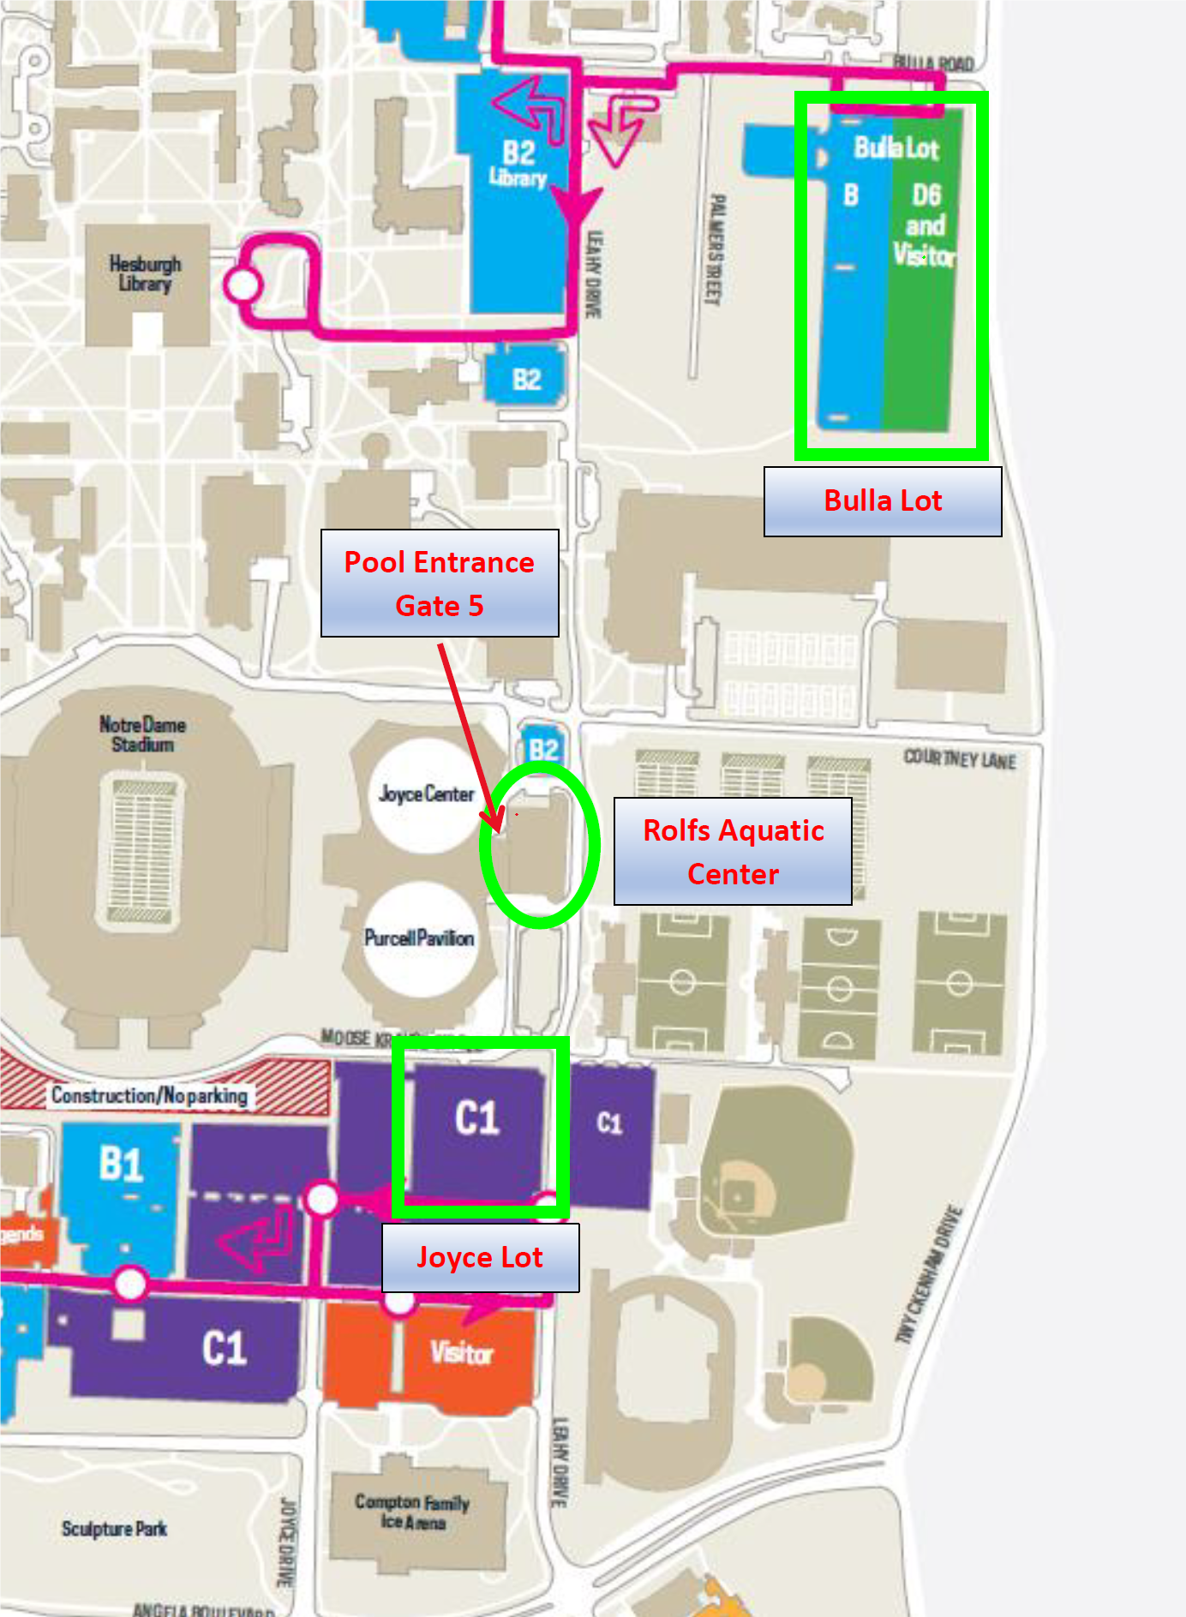

ORDER OF EVENTS

Friday 7/6 AM
1 | 12 & Under 200 Backstroke | 2
3 | 12 & Under 50 Freestyle | 4
5 | 12 & Under 100 Breaststroke | 6
7 | 12 & Under 50 Backstroke | 8
9 | 12 & Under 100 Butterfly | 10

Friday 7/6 PM
11 | 13 & Over 200 Freestyle | 12
13 | 13 & Over 100 Butterfly | 14
15 | 13 & Over 200 Breaststroke | 16
17 | 13 & Over 100 Backstroke | 18

Friday 7/6 Distance#
19 | Open 400 IM* | 20

Saturday 7/8 AM
21 | 12 & Under 100 Freestyle | 22
23 | 12 & Under 50 Breaststroke | 24
25 | 12 & Under 100 Backstroke | 26
27 | 12 & Under 50 Butterfly | 28
29 | 12 & Under 200 Breaststroke | 30

Saturday 7/8 PM
31 | 13 & Over 100 Freestyle | 32
33 | 13 & Over 200 Backstroke | 34
35 | 13 & Over 100 Breaststroke | 36
37 | 13 & Over 200 IM | 38

Saturday 7/8 Distance#
39 | Open 400 Freestyle* | 40

Sunday 7/10 AM
41 | 12 & Under 200 IM | 42
43 | Open 200 Butterfly* | 44
45 | 12 & Under 200 Freestyle | 46
47 | 13 & Over 50 Freestyle | 48

#Swimmers in the distance sessions will need to provide a counter (if necessary) and a timer

*The Open 400 Freestyle, 200 Butterfly and 400 IM will be ranked in 10 & Under, 11-12 and 13 & Over for results purposes. The 400 Freestyle and 400 IM will be swum fastest to slowest alternating one heat of girls with one heat of boys.

**All 12 & Under events will be ranked as 10 & Under and 11-12 for results purposes

SUMMARY OF EVENTS
Payments should be made payable to IRISH AQUATICS and are due by the first day of competition for the team. Please include this form with all payments. Payments can be mailed ahead of time to the entry chair at the following address:
Matt Dorsch
5608 Trippel Dr.
Mishawaka, IN 46545
NAME OF CLUB: ________________________________ CODE: _______________

NUMBER OF SWIMMERS ENTERED: _______ X $2.00 = _______
NUMBER OF INDIVIDUAL ENTRIES: _______ X $4.00 = _______
TOTAL AMOUNT ENCLOSED: _______

CLUB OFFICIAL SUBMITTING ENTRY
NAME: ________________________________
ADDRESS: ______________________________
CITY: __________________________________
STATE/ZIP: _____________________________

COACH’S NAMES
_______________________________
_______________________________
_______________________________
_______________________________
RESULTS FORMAT PREFERENCE
___ Hard Copy (pdf file emailed)
___ Meet Manager Backup (emailed)
___ Team Manager .cl2 file (emailed)
___ All of the above
Email address to send to: ___________________________________

Release and Hold Harmless Agreement
In consideration of being permitted to participate in the swim meet, Club, and its swimmers, coaches, parents, members and volunteers hereby release and forever discharge Irish Aquatics Swim Club, USA Swimming, Indiana Swimming, the University of Notre Dame, the respective owners, trustees, directors, officers, agents, employees, members, successors, and assigns of each of them, and all other persons or entities in any way connected with sponsoring or holding this swim meet, of and from any and all liabilities, claims, demands, actions, causes of action, losses, damages or expenses, of whatever kind or character, arising out of or in connection with said swim meet and the facilities and personnel for it. Further, Club and its swimmers, coaches, parents, members and volunteers shall indemnify and hold harmless Irish Aquatics Swim Club, USA Swimming, Indiana Swimming, University of Notre Dame, the respective owners, trustees, directors, officers, agents, employees, members, successors, and assigns of each of them, and all other persons or entities in any way connected with sponsoring or holding this swim meet, of and from any and all liabilities, claims, demands, actions, causes of action, losses, damages or expenses, of whatever kind or character, arising out of or in connection with any injury to any person, including death, or injury or damage to any property.

The undersigned represents that he/she is authorized by the Club and its swimmers, coaches, parents, members and volunteers to execute this release and hold harmless agreement on behalf of each of them, binding Club, and its swimmers, coaches, parents, members, and volunteers to the terms hereof.
EXECUTED THIS____DAY OF _________, 20____
SIGNATURE_______________________________________________
PRINTED NAME____________________________________________
POSITION_______________________________ CLUB____________________________

