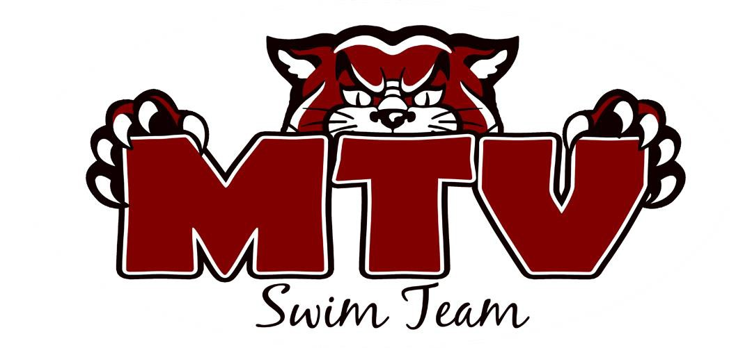
MTV KICKOFF MEET
October 14 & 15, 2017
SANCTION: This meet is sanctioned by USA Swimming and Indiana Swimming.
Sanction #IN18.78

HOST: Mt. Vernon Swim Team (MTV)

LOCATION: Mt. Vernon Jr. High School
701 Tile Factory Road Mt. Vernon, IN 47620

FACILITY: The pool is 25 yards long with 6 lanes and anti-turbulent lane lines. The pool length has not been certified in accordance with 104.2.C(4). The Daktronics Electronic Timing equipment and six-lane scoreboard displays all splits and final times with touch pads located on both ends of the pool. The pool is all 13 to 4 ½ feet in depth and the guttering system provides excellent wave dissipation. The seating area for the swimmers and coaches is on the pool deck with ample deck area for all. Spectator seating is available on the elevated observation deck or behind deck level windows. A separate warm down area will be provided. Parking is available at no charge to the north of the building. Concessions will be available. NO SMOKING is allowed in the building and/or premises.

MEET TYPE: This is an open invitational meet, with timed finals.

RULES: 202.5.3 – At a sanctioned competitive event, USA Swimming athlete members must be under the supervision of a USA Swimming member coach during warm-up, competition, and warm-down. The Meet Director or Meet Referee may assist in making arrangements for such supervision, but it is the swimmer’s responsibility to make such arrangements prior to the start of the meet.

202.4.9 D – Any swimmer entered in the meet, must be certified by a USA Swimming-member coach as being proficient in performing a racing start or must start each race from within the water. When unaccompanied by a member-coach, it is the responsibility of the swimmer or the swimmer’s legal guardian to ensure compliance with the requirement.

202.4.9 H – Use of audio or visual recording devices, including a cell phone, is not permitted in changing areas, restrooms or locker rooms.

202.4.9 I – Deck changes are prohibited.

202.4.9 J – Operation of a drone, or any other flying apparatus, is prohibited over the venue (pools, athlete/coach areas, spectator areas and open-ceiling locker rooms) any time athletes, coaches, officials and/or spectators are present. Exceptions may be granted with prior written approval by the Program Operations Vice Chair.

2.2.4.9 E & 205.2.2 & 202.4.9 F – Swimmer(s) must be registered with USA Swimming to be accepted into this meet. Age as of October 14, 2017 shall determine the swimmer’s age for the entire meet. Indiana Swimming does not process on site membership.

Coaches and Officials MUST display their current USA Swimming coach credential of Deck Pass to gain deck access. The meet referee and/or meet director reserves the right to ask for coach credential or Deck Pass and/or deny deck access of coach does not comply or card is no longer valid/current.

In swimming competitions, the competitor must wear only one swimsuit in one or two pieces except as provided in USA Swimming rule 205.10.1. All swimsuits shall be made from textile materials. For Men, the swimsuit shall not extend above the navel nor below the knees, and for women, shall not cover the neck, extend past the shoulder, nor extend below the knee.

The meet referee reserves the right to ask for coach credential display and/or deny deck access if coach does not comply or card is no longer valid/current.

FEES: All fees are due at the start of the meet or a team’s entries will be scratched. Fees are $4.00 per individual event, $6.00 per relay. There is also a $2.00 Indiana Athlete Surcharge per swimmer. Please make checks payable to MTV Swim Team. Entries will be accepted on a “first come, first served” basis until the heats are filled and the Meet Director reserves the right to limit the number of heats in an event if there are time constraints.

REFUNDS: In any meet sanctioned by Indiana Swimming other than Championship Meets, the host team shall limit the number of swimmers in any one or more events to maintain a reasonable length of the meet. In the event that entries are limited, the host club must return the entry fees to the club(s) whose swimmers are not allowed to compete in the specific event(s).

ENTRY INFO: All entries are to be submitted in yard times. Include age of swimmer in all events. The meet will be run with Hytek’s Meet Manager Software, so electronic entries are highly encouraged. The Meet Setup file will be posted on the Indiana Swimming website for your convenience.

DEADLINE: Entries will begin being accepted on Friday, September 22, and must be received by Friday, October 6, 2017.
Deadline will be extended if meet is not full.

Email or send entries to:
Jessica Anselman/MTV Swim Team PO Box 782
Mt. Vernon, IN 47620 PHONE: 812.306.6716
Jessica_anselman@yahoo.com

Estimated and “No Times” will be accepted. Any corrections to the seed times must be made by Monday, September 26th. Each swimmer will be limited to five (5) individual events and two (2) relays. If an entry is submitted with an individual entered in more events than allowed, the entry will be made by order of events, starting with Event 1, until the limit is exceeded.

CLERK OF Swimmers 8 and under, must report to the Clerk of Course before their event. All other
COURSE: swimmers report to the starting blocks.

AWARDS: Ribbons will be awarded for 1st through 6th places in individual events. Ribbons will be awarded for 1st through 3rd places in relay events. No team scores will be kept. Awards will be giving to following age groups 13&14, 11&12, 9&10, 7&8, 6&UNDER. 15&OLDER will not receive awards.

HOSPITALITY: A Hospitality Suite will be provided for all coaches and officials.

MEET DIRECTOR:
For additional information or assistance, please contact: Jessica Anselman/MTV Swim Team
PO Box 782
Mt. Vernon, IN 47620 PHONE: 812.306.6716
Jessica_anselman@yahoo.com

PLEASE NOTE:
Please advise your parents of the following:
- We would appreciate it if officials from each team would help with officiating. Please contact the Meet Director if you are willing to officiate.
- There will be NO spectator entrance or exit from the pool deck entrance. All spectators must enter the viewing gallery from the stairs at the East end of the hallway outside of the pool.
- We reserve the right to expel for the remainder of the meet, with no refund of entry fees, any swimmer or person, who is disorderly, destructive or in any unauthorized area. The Southern Indiana Swim Conference and MTV are grateful to the Metropolitan School District of Mt. Vernon for the use of their facilities. Coaches and parents are expected to monitor their swimmer’s behavior at all times. Mt. Vernon Swim Team is not responsible for missing or damaged personal items. All swimmers are advised to leave valuables with parents or guardians.

SESSION 1 – SATURDAY AM OCTOBER 14
WARM-UPS: 7:00-7:45 AM CST MEET STARTS: 8:00 AM CST

GIRL AGE EVENT BOY
1 9 & 10 25 UNDERWATER KICK 2
3 OPEN 25 UNDERWATER KICK 4
5 8 & UNDER 25 FLUTTER KICK W/BOARD 6
7 9 & 10 50 FREESTYLE 8
9 OPEN 100 FREESTYLE 10
11 8 & UNDER 25 BACKSTROKE 12
13 9 & 10 25 BACKSTROKE 14
15 OPEN 50 BACKSTROKE 16
17 8 & UNDER 25 BREASTSTROKE KICK W/BOARD 18
19 9 & 10 25 BREASTSTROKE 20
21 OPEN 50 BREASTSTROKE 22
23 8 & UNDER 25 BUTTERFLY 24
25 9 & 10 50 BUTTERFLY 26
27 OPEN 100 BUTTERFLY 28
29 8 & UNDER 25 FREESTYLE 30
31 9 & 10 100 FLUTTER KICK W/BOARD 32
33 OPEN 100 FLUTTER KICK W/BOARD 34
35 8 & UNDER 100 KICKBOARD RELAY 36
37 9 & 10 200 KICKBOARD RELAY 38
39 OPEN 200 MEDLAY RELAY 40

*AWARDS FOR 13&14, 11&12, 9&10, 7&8, 6 & UNDER THERE WILL BE NO RIBBONS FOR 15 & OLDER

SESSION 2 – SUNDAY AM OCTOBER 15, WARM-UPS: 7:00-7:45 AM CST MEET STARTS: 8:00 AM CST

41 8 & UNDER 100 IM 42
43 9 & 10 100 IM 44
45 OPEN 100 IM 46
47 8 & UNDER 50 FREESTYLE 48
49 9 & 10 25 FREESTYLE 50
51 OPEN 50 FREESTYLE 52
53 8 & UNDER 25 FLUTTER KICK ON BACK 54
55 9 & 10 50 BACKSTROKE 56
57 OPEN 100 BACKSTROKE 58
59 8 & UNDER 25 BREASTSTROKE 60
61 9 & 10 50 BREASTSTROKE 62
63 OPEN 100 BREASTSTROKE 64
65 8 & UNDER BUTTERFLY KICK W/BOARD 66
67 9 & 10 25 BUTTERFLY 68
69 OPEN 50 BUTTERFLY 70
71 8 & UNDER 100 FREESTYLE 72
73 9 & 10 100 FREESTYLE 74
75 OPEN 200 FREESTYLE 76
77 8 & UNDER 100 FREESTYLE RELAY 78
79 9 & 10 200 FREESTYLE RELAY 80
81 OPEN 200 FREESTYLE RELAY 82

*AWARDS FOR 13&14, 11&12, 9&10, 7&8, 6 & UNDER THERE WILL BE NO RIBBONS FOR 15 & OLDER

Summary of Entries
Please supply the information requested below and mail with your Entry Forms and check to the Entry Chairperson. Make check payable to: MTV Swim Team

Club Name: Club Code: Number of Swimmers Entered: Boys + Girls = Total Number of Total Swimmers (Indiana Swimmer Surcharge) X $2.00 =$ Number of Boys’ Timed Finals Entries X $ 4.00 = $ Number of Girls’ Timed Finals Entries X $ 4.00 = $ Total Number of Relay Entries X $ 6.00 = $ Total Amount Enclosed: $

Club Official Submitting Entry:
Name Address

City State/Zip Tele# Email

Release and Hold Harmless Agreement
In consideration of being permitted to participate in this swim meet, and for other good and valuable consideration, the undersigned for himself, his successors and assigns, hereby releases and forever discharges the host club, and its Board of Directors, United States Swimming, MTV Swim Team and each of their respective officers, agents, employees, members, successors and any other persons in any way connected with this meet, from any and all liabilities, claims, demands, actions, or causes of action of whatever kind of character arising out of or in connection with said event. Further the undersigned shall indemnify and hold harmless the host club, United States Swimming, MTV Swim Team and the officers, trustees, agents, employees and members of the foregoing and all other persons in any way and claims arising out of or in connections with any injury, including death, or alleged injury of damage to property sustained or alleged to have sustained in connection with or to have arisen out of said event.
Executed this day of , 2017.
Signature of club Official or Coach:

Did you include:
Individual entry sheets or hard copy of meet entries
Check (made payable to MTV Swim Team)
Summary of Entries Form (this page)

RESULTS:
Hard Copy (snail mailed OR .PDF file emailed)
Meet Manager Backup (emailed)
Team Manager .cl2 file (emailed)
ALL of the above

