DEADLINE CHECKLIST

DATE | DEADLINE | DESCRIPTION
Thursday April 18th | 8:00 am | Entries open; can be emailed to ktrella01@gmail.com
Wednesday, May 1st | 8:00 pm | Entry deadline; all entries must be received
Friday, May 3rd |  | Teams will be notified whether or not their entry has been accepted into the meet.
Tuesday, May 14th | 8:00 pm | Deadline for changes to entry
Tuesday, May 14th | 8:00 pm | Deadline to submit names/contact # of timers; can be emailed to nikkim716@gmail.com
Friday, May 17th  (Day 1 of meet) | 3:30 pm  3:45 pm  4:15 pm  4:30 pm | Warm up begins  Positive check in closes  Deck entries close  Coaches meeting  Session begins
Saturday, May 18th  (Day 2 of meet) | 7:30 am  7:45 am  8:15 am  8:30 am  5:00 pm  6:00 pm | Prelim warm up begins  Positive check in closes  Deck entries close  Coaches meeting  Session begins  Finals warm up begins  Finals session begins
Sunday, May 18th  (Day 3 of meet) | 7:30 am  7:45 am  8:30 am  4:00 pm  5:00 pm | Prelim warm up begins  Positive check in closes  Deck entries close  Session begins  Finals warm up begins  Finals session begins

SANCTION: This meet is sanctioned by USA Swimming and Indiana Swimming.
Sanction #:IN19267

HOST: Boilermaker Aquatics

FACILITY: Purdue University's Morgan J. Burke Aquatic Center, 355 N. Martin Jischke Drive (formerly Intramural Drive), West Lafayette, IN 47907. Click here for directions.

COMPETITION
COURSE: The competition course is a 50 meter 8 lane pool with non-turbulent lane lines with a water depth of 9’ at the start and 4’ at the turn end. The competition course has been certified in accordance with 104.2.2C(4). The copy of such certification is on file with USA Swimming. Daktronics 2000 automatic timing system with touch pads, backup buttons and watches will be used to measure performances. There will be a 25-yard continuous warm-up area with lane ropes.

MEET FORMAT: All meet events will be Preliminaries/Finals format except for 400 Freestyle, 800 Freestyle, and Relays. Finals sessions will feature 3 heats for each individual Prelim/Finals event. (Finals, Consolations and Bonus Consolations) Boilermaker Aquatics reserves the right to use “Fly Over” starts for all events. At the Meet Referee's discretion, events may be combined by age, gender, distance, and/or stroke provided there is at least one empty lane between such combined events. Distance events require athletes to provide their own timers (2) and counter (1).

MEET REFEREE: Justin Monger, jmonger81@msn.com

ENTRY CHAIR: Kristen Trella, ktrella01@gmail.com P.O. Box 2782, West Lafayette, Indiana 47996-2782

MEET DIRECTOR: Nikki Monger, nikkim716@gmail.com

ENTRY
DEADLINE &
FORMAT: Entries will be accepted starting April 18, 2019 at 8:00am. Entry deadline is May 1, 2019 at 8:00pm. Deadline will be extended if the meet is not full. Any adding/removing of swimmers or events after acceptance to the meet should be done with a new entry file for the entire team and must be accompanied by written list of those changes. Time changes/updates will be accepted until May 14th, 2019 at 8:00pm. Time updates can be made only by means of a new team entry file but do not require a written list of changes. Teams not accepted into competition will have their entries and fees returned as soon as possible or by May 1st, 2019. If you do not receive notification of our receipt of your entries within three business days after submission, please contact the entry chair.

The preferred method of entry file is Hy-Tek format; any team which sends any other format of competition entries will be charged a $50.00 administration fee.

ENTRY LIMIT: Each swimmer will be limited to 3 events and 1 relay per day. If an entry is submitted with a swimmer in more individual events than allowed, the swimmer will be entered into the order of events until the rule is satisfied. Entry times must be in long course meter time or short course yard times. Entry times should meet or exceed the 15-16 “A” time standard. Deck entries will be accepted to fill existing heats only. BA reserves the right to limit entries and all events in order to achieve a reasonable timeline. In the event the meet is full, teams will be accepted based on competitiveness, geographic diversity, participation in previous meets, officials provided, and timeliness of entries.

Once the meet entry deadline has passed, all entries are considered final and no refunds will be provided and all post deadline entries are considered and charged as deck entries.

ENTRY FEES &
SURCHARGES: Individual events $5.00 per timed final event entry, individual events $6.00 per prelim/final event entry, and relay events $8.00 per entry. Each athlete is charged a $2.00 surcharge for entering the competition which in turn gets forwarded/paid to Indiana Swimming Inc. Entry fees can be paid by check addressed to Boilermaker Aquatics. The check should be included with the entry list which is mailed to P.O. Box 2782, West Lafayette, Indiana 47996-2782.

DECK ENTRY: At the discretion of BA and Meet Referee, deck entries for individuals will be allowed in open lanes. The fees for individual deck entries is twice as much as the standard fee, and these fees must be paid in full in the form of cash at the time of entry. Deck entries can be completed any time prior to 45 minutes before competition begins.

POSITIVE
SIGN-IN: Positive check in WILL BE REQUIRED FOR ALL SESSIONS of the meet. Sign-in sheets will be posted in the hallway, and will be pulled 45 minutes prior to the start of each session. Any swimmer not checked in will be scratched from the session. Any swimmer scratched may present to the meet referee prior to the start of the meet, and will be allowed to swim on a first-come basis only if the event has empty lane(s) available in the slowest (first) heat. Additional heats will not be added. If a swimmer misses their event, they will be declared a “no show” and will not be placed in any other heat to make up the swim.

SCRATCH
RULES: After the results of preliminary heats are announced, swimmers have 30 minutes to scratch out the finals (including consolation and bonus heats.) If a swimmer who has not scratched fails to swim in any finals heat, that swimmer will be scratched from his/her first event the following day. This penalty will be imposed as many times as a swimmer misses a non-scratched finals event, declared false starts count as a miss. Fees for scratched events will not be refunded. If a swimmer who has not scratched fails to swim in any finals heat on Sunday evening, the swimmer’s teams will be assessed a fine of $50 per event.

COACHES &
OFFICIALS: All coaches and officials are required to show a valid government‐issued picture ID and USA Swimming Credentials to gain deck access at this event. The Meet Referee reserves the right to deny deck access if a coach or official does not comply or the card is no longer valid.

TIMERS: Each participating team will be required to provide 2 timers per session. These volunteers should check in at the volunteer check-in table located in the foyer, 30 minutes prior to the start of the session. Please provide names, along with the day(s) and session(s) and contact number to the meet director.

OFFICIALS: All USA Swimming certified officials are welcome & encouraged to officiate. All officials will be assigned positions by the Meet Referee. Please provide names of any officials interested in participating, along with day(s) and session(s) available, along with a contact number to the meet referee and timers to the meet director.

MEET RULES: Current USA Swimming and Indiana Swimming rules will govern this meet.
- At a sanctioned competitive event, USA Swimming athlete members must be under the supervision of a USA Swimming member coach during warm-up, competition, and warm-down. The Meet Director or Meet Referee may assist in making arrangements for such supervision, but it is the swimmer’s responsibility to make such arrangements prior to the start of the meet.
- Any swimmer entered in the meet must be certified by a USA Swimming-member coach as being proficient in performing a racing start or must start each race from within the water. When unaccompanied by a member-coach, it is the responsibility of the swimmer or the swimmer’s legal guardian to ensure compliance with this requirement.
- Use of audio or visual recording devices, including cell phones, is not permitted in changing areas, restrooms or locker rooms.
- Deck changes are prohibited.
- Swimmers must be registered with USA Swimming to be accepted into this meet. Age as of May17, 2019 shall determine the swimmer’s age for the entire meet. Indiana Swimming does not process onsite memberships.
- It is understood and agreed that USA Swimming shall be free from any liabilities or claims for damages arising by reason of injuries to anyone during the conduct of the event.
- Operation of a drone, or any other flying apparatus, is prohibited over the venue (pools, athlete/coach areas, spectator areas and open-ceiling locker rooms) any time athletes, coaches, officials and/or spectators are present.
- In swimming competitions, the competitor must wear only one swimsuit in one or two pieces except as provided in USA Swimming rule 205.10.1. All swimsuits shall be made from textile materials. Men’s’ swimsuit shall not extend above the navel nor below the knees, and women’s’, shall not cover the neck, extend past the shoulder, nor extend below the knee.

FACILITY RULES: This is a non-smoking facility. As guests of the University, we would like to remind all participants and spectators to leave a clean facility at the end of the meet. It is important that all people attending this meet, whether swimmers, coaches, or spectators, treat this facility with the utmost care. The following facility rules will be strictly enforced:
- Keep all trash picked up (swimmers, teams and spectators)
- No access to unauthorized areas. Specifically any place other than the lobby, seating areas, or spectator’s restrooms.
- Purdue’s dry land equipment, located in the observation deck, is completely off limits to sit, play or touch. (Zero tolerance)
- Only swimmers, coaches, officials, and volunteers are allowed on deck due to USA Swimming insurance requirements.
- Boilermaker Aquatics will have security persons patrolling the deck and locker room areas. If anyone is caught abusing the building or facility, they will immediately be asked to leave the meet and will be barred from further competition. Damages incurred become the responsibility of the swim club of the violator.

PARKING: Friday Afternoon, all visitors should be careful about parking in restricted areas. After 5:00 PM on Friday, most lots will become available and free throughout the remainder of the weekend. All paved and gravel areas are signed/posted for permit parking so visitors may not park in A, B, or C spaces unless a parking permit has been purchased and displayed. Please see the Boilermaker Aquatic Center Parking map for more details.

ADMISSION: 12 and under free
$8.00 daily pass
$20.00 weekend pass

CONCESSIONS: Concessions are available at Freshin’s located inside Purdue’s co-rec. Hours will be posted at the meet.

HEAT SHEET: Heat sheets will be available for purchase. Psych sheets will not be available for this competition.

WARM-UP: No lane assignments for warm-ups. There will be No Diving during general warm-up. Feet first entry only. When doing racing starts, swimmers will start from starting end only. Swim one way. Walk back. Warm-Ups will not start earlier than the listed times. In the event that the competition is not full, warm-up times and schedules will be updated to make best use of our volunteers' time. Communication about these changes will be made by May 15th.
TIME
SCHEDULE: All times are Eastern Daylight Time. A final schedule will be released 10 days prior to the event. **Below is a tentative time line**

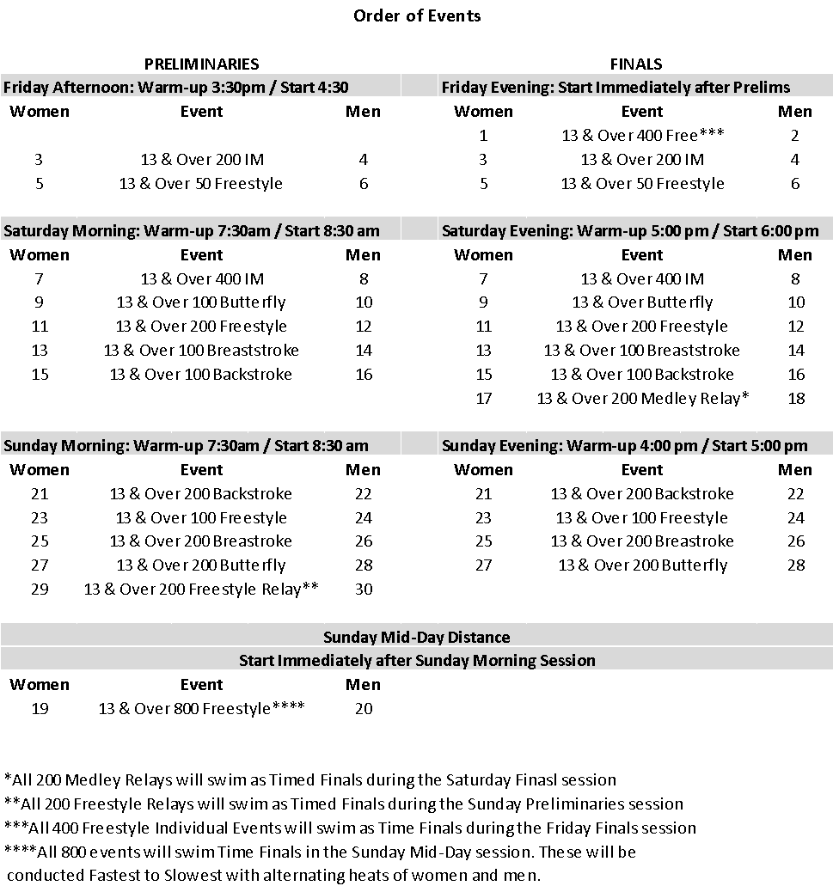
Summary of Entries

Please complete and mail with your check (payable to Boilermaker Aquatics) to the Entry Chairperson.
Club name____________________________________ Code____________

IN Swimming surcharge: No. of swimmers entered ___ X $2.00 each = = $_____
Number of Men’s Timed Final Entries ___ X $5.00 each = = $_____
Number of Women’s Timed Final Events___ X $5.00 each = = $_____
Number of Men’s Prelim/Final Entries ___ X $6.00 each = = $_____
Number of Women’s Prelim/Final Events___ X $6.00 each = = $_____
Number of Men’s Relay Entries ___ X $8.00 each = = $_____
Number of Women’s Relay Entries___ X $8.00 each = = $_____
TOTAL = $_____
Club Official Submitting Entry: Coaches Names:

Name_______________________________________ ______________________________
Address_____________________________________ ______________________________
City/State/Zip________________________________ ______________________________
Phone______________________________________ ______________________________
e-mail______________________________________ ______________________________

Release and Hold Harmless Agreement: In consideration of being permitted to participate in this swim meet, and for other good and valuable consideration, the undersigned for himself, his successors and assigns, hereby releases and forever discharges the Boilermaker Aquatics Swim Team, and its Board of Directors, United States Swimming, and each of their respective officers, agents, employees, members, successors any other persons in any way connected with this meet, from any and all liabilities, claims, demands, actions, or causes of action of whatever kind of character arising out of or in connection with said event. Further the undersigned shall indemnify and hold harmless the Boilermaker Aquatics Swim Team, United States Swimming and the officers, trustees, agents, employees and members of the foregoing and all other persons in any way and claims arising out of or in connection with any injury, including death, or alleged injury of damage to property sustained or alleged to have sustained in connection with or to have arisen out of said event.

Signature of Club Official or Coach: ______________________________________ Date ______________
The person who signs is responsible for any fines imposed upon the club.

You may have one designated spokesperson for your team to talk to the referee or Clerk-of-Course. The coach would be the logical person.
Please list the name of your spokesperson:____________________________________________________

RESULTS Please check how you would like to receive your results:
________ Hard copy (mailed ___ OR .htm/.pdf file e-mailed ___)
________ Meet Manager Backup (e-mailed)
________ Team Manager .c12 file (e-mailed)
________ ALL of the above.
E-mail address to which above should be sent:_____________________________

