Sanction #: IN19318

Host: Brownsburg Swim Club (BBSC)

Location: Brownsburg High School, 1000 S. Odell Street, Brownsburg, IN, 46112

Facility: The Brownsburg Aquatic Center is an 8 lane, 50 meter pool. The pool is equipped with non-turbulent lane dividers, Omega touchpads and Daktronics electronic timing system. Bleacher seating is available for more than 600 spectators. The facility has not been certified in accordance with 104.2.2C(4). The water depth at the start end is 5’ and 13’ at the turn end.

Eligibility: Swimmers must be registered with USA Swimming. Age as of July 12th, 2019 will determine the swimmers age for the entire meet.

Fees: $2.00 ISI surcharge
$5.00 per Timed Final events
$6.00 per Prelim/Final events

Admission: $5 per person each day.
Weekend Pass $12
Children 10 and under are free
Heat Sheets $2

Eligibility: Swimmer(s) must be registered with USA Swimming prior to the competition. Age as of July 12, 2019 shall determine swimmer’s age for the entire meet. Indiana Swimming does not process on-site registration.

Format: All distance events (400m Free, 400m IM and 1500m Free) and 10 & Under events are Timed Finals. 11-12 stroke 200s (200 Fly, 200 Back and 200 Breast) are Timed Finals.

All other events will be Prelim/Final swimming with the top 21 swimmers advancing to Finals. Finals will be swum in the order of C-B-A heats.

For all sessions, other than Session 1 (1500m Free), competition will be held in lanes 1-7 with lane 8 remaining open for warm-up, warm-down throughout the meet.
The Scratch Deadline for preliminary and timed-finals sessions will be 30 minutes prior to the start of the session. For all 13-14 and Open events, the Scratch rule as stated in the current USA Swimming Rule Book, Section 207.11.6, will be in effect, modified as stated below. Note: Swimmers in the 13-14 and Open Preliminary Sessions, who have checked in and miss an event that they did not scratch, will be scratched from their next individual event that session. Swimmers in the 13-14 and Open who fail to compete in a Finals will be scratched from any subsequent events in that session and will be required to sign an Intent to Compete form prior to the Scratch Deadline for their next session or they will be scratched. An Intent to Scratch form will be available.

For 10 & U and 11-12 Events, there will be no penalty for failure to compete.

The Brownsburg Swim Club reserves the right to limit the number of entries in one or more events to maintain a reasonable length of the meet. In the event that entries are limited, the host club will return the entry fees to the club(s) whose swimmers are not allowed to compete in the specific event(s).

Entry Limits: 11 & Over swimmers are limited to 3 events per day (Timed Finals and Prelims combined). 10 & Under swimmers are limited to 4 events per day. After the scratch deadline, if too many events are entered, swims will be accepted in numerical order. No refunds of entry fees will be made to swimmers who enter more than three events per day.

Entries: Entries will be accepted starting 8:00am Monday, June 10th 2019 until 11:59pm Sunday, June 23rd 2019. The entry deadline will be extended if the meet does not fill. Teams not accepted will be notified by Monday, June 24th. Events will be seeded LCM, SCM, SCY.

Entry Format: The meet will be run using Hytek’s Meet Manager. Entries must be made by emailing an Entry File (jschrier248@gmail.com). BBSC will send an acknowledgement that your entry file has been received within 48 hours of submission. Should you not receive an acknowledgement of entry within 48 hours, please contact the entry chair.

For all teams, Release and Hold Harmless agreement and payment for entry fees must be received prior to the start of warm-ups on the first day of the meet that your team has participants unless other arrangements have been made in advance.

Make checks payable to Brownsburg Swim Club.

Entry Chair: Brownsburg Swim Club
Jen Schrier
PO Box 971
Brownsburg, IN 46112
jschrier248@gmail.com

Meet Directors: Jen Schrier (jschrier248@gmail.com)

Meet Referee: Jay Watson (we4watsons5891@gmail.com)

Rules: Current USA Swimming Rules, including the Minor Athlete Abuse Prevention Policy
(“MAAPP”), will govern this meet.
202.4.9 D – Any swimmer entered in the meet, must be certified by a USA Swimming-member coach as being proficient in performing a racing start or must start each race from within the water. When unaccompanied by a member-coach, it is the responsibility of the swimmer or the swimmer’s legal guardian to ensure compliance with this requirement. 202.4.9 E & 205.2.2 & 202.4.9 F- Swimmer(s) must be registered with USA Swimming to be accepted into this meet. Age as of (May 10, 2019) shall determine the swimmer’s age for the entire meet. Indiana Swimming does not process onsite memberships. USA Swimming Rules 202.5.3 - At a sanctioned competitive event, USA Swimming athlete members must be under the supervision of a USA Swimming member coach during warm-up, competition, and warm-down. The Meet Director or Meet Referee may assist in making arrangements for such supervision, but it is the swimmer’s responsibility to make such arrangements prior to the start of the meet. The competitor must wear only one swimsuit in one or two pieces except as provided in USA Swimming Rule 205.10.1. All swimsuits shall be made of textile materials. For men, the swimsuit shall not extend above the navel nor below the knees, and for women, shall not cover the neck, extend past the shoulder, nor extend below the knee. 202.4.9 H – Use of audio or visual recording devices, including a cell phone, is not permitted in changing areas, restrooms or locker rooms.

Coaches and Officials MUST display their current USA Swimming coach credential or Deck Pass to gain deck access. The meet referee and/or meet director reserves the right to ask for coach credential or Deck Pass and/or deny deck access if coach does not comply or card is no longer valid/current.
It is understood and agreed that USA Swimming shall be free from any liabilities or claims for damages arising by reason of injuries to anyone during the conduct of the event.
202.4.9 I – Deck changes are prohibited.
202.4.9 J – Operation of a drone, or any other flying apparatus, is prohibited over the venue (pools, athlete/coach areas, spectator areas and open-ceiling locker rooms) any time athletes, coaches, officials and/or spectators are present. Exceptions may be granted with prior written approval by the Program Operations Vice Chair.

NOTES: ONLY COACHES AND PARTICIPATING OFFICIALS ARE ALLOWED ON THE POOL DECK. BROWNSBURG COMMUNITY SCHOOL CORPORATION IS A TOBACCO FREE CAMPUS. SMOKING IS NOT PERMITTED ANYWHERE ON THE BROWNSBURG HIGH SCHOOL CAMPUS.

It is the responsibility of the coaches and team parents to monitor and be responsible for your swimmers. We ask for your cooperation in taking care not to damage the school property and to clean up your area before leaving for the day.

1500 Freestyle: The 1500 freestyle will be limited to the top 14 swims by gender. If space exists BBSC reserves right to combine genders to fill all heat. All swimmers must provide a timer. Swimmers are responsible to provide a lap counter for the 1500 freestyle should they choose to use one.

Warmups: Warm ups for will be broken into A and B groups of 30 minute each for all sessions except Friday, Saturday and Sunday Evening.

Coaches: A Coaches meeting will be held 30 minutes before the start of each session.

Scoring: Ribbons will be awarded for places 1st thru 14th. High Point award for all age groups (8 & Under, 10 & under, 11-12, 13-14, OPEN)

Individual Scoring – 21 places:
27, 24, 23, 22, 21, 20, 19, 17, 15, 14, 13, 12, 11, 10, 8, 6, 5, 4, 3, 2, 1

Officials: We would appreciate any help your club’s USA Swimming registered and certified officials may be willing to give us on deck. With a meet of this size, we rely on officials from other clubs

Attire is whites over blues. Shorts are acceptable throughout the meet.

Official briefings will be held approximately 45 minutes prior to the start of the session in Hospitality.

CONCESSIONS: Concession stand on site and various food trucks in the parking lot.

PARKING: Parking is available in the North lot of Brownsburg High School. Please use door #14 for entry.

Event Sessions and Times

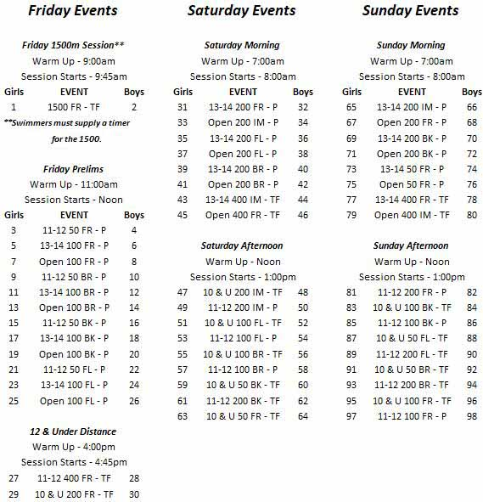
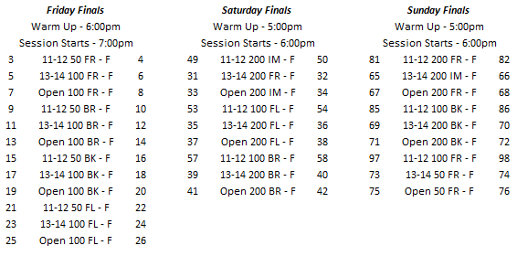
TEAM SUMMARY REPORT
Please send this in once you are accepted into the meet!

Club Name: ______________________________ Club Code: _________

Number of Swimmers Entered: Boys ____ Girls ____ = Total _____

Total Number _____ X $2.00 = __________ (Indiana Swimming Surcharge)
Number of Girls’ Timed Final Events ________ X $5.00 each = $ __________
Number of Girls’ Prelim/Final Events ________ X $6.00 each = $ __________
Number of Boys’ Timed Final Events ________ X $5.00 each = $ __________
Number of Boys’ Prelim/Final Events ________ X $6.00 each = $ __________
Release and Hold Harmless Agreement:
In consideration of being permitted to participate in this swim meet, and for other good and valuable consideration, the undersigned for himself, his successors and assigns, hereby releases and forever discharges the Pike Township Swim Club, and its Board of Directors, USA Swimming, Indiana Swimming and each of their respective officers, agents, employees, members, successors, and any other persons and any way connected with this meet, from any and all liabilities, claims, demands, actions, or causes of action of whatever kind of character arising out of or in connection with said event. Further, the undersigned shall indemnify and hold harmless Pike Township Swim Club, USA Swimming, Indiana Swimming and the officers, trustees, agents, employees and members of the foregoing and all other persons in any way and claims arising out of or in connection with any injury, including death or alleged injury of damage to property sustained or alleged to have sustained in connection with or to have arisen out of said event.
Executed this _______________day of _______________, 2019.

Signature of Club Official or Coach_______________________________________________________________________

