Sanctioned by USA and Indiana Swimming #IN20037
Table of Contents
IMPORTANT DATES & DEADLINES CHECKLIST 1
GENERAL INFORMATION 2
MEET PROCEDURES & FORMAT 4
MEET ENTRY 5
ORDER OF EVENTS 5
DIRECTIONS 7
SUMMARY OF ENTRIES 8

IMPORTANT DATES & DEADLINES CHECKLIST
Clubs are encouraged to use the checklist to ensure all responsibilities have been met and to avoid any problems at the meet.

DATE | TIME – DEADLINE | DESCRIPTION
Monday, September 23rd | 8:00 AM | Entries accepted
Friday, October 25th | 11:59 PM | Entry & Update deadline, or when meet is full (whichever is earlier). If the meet is not full, the deadline will be extended.  ** Entries not submitted via email in Hy-Tek format will be subject to a $50.00 data processing fee.  ** If you do not receive a confirmation email within 48 hours, please follow up to ensure we have received your file.
Monday, October 28th | 11:59 PM | Teams not accepted will have their entries returned as soon as possible but no later than this date/time, via email or US Postal Service depending on the form of entry.
Friday, November 08th | 5:00 PM | Warm-Ups Start not before this time (10&U, 11-12, 13-14, Open events)
 | 5:15 PM | Positive Check-In Closes (10&U, 11-12, 13-14, Open events)
 | 6:00 PM | Meet Starts not before this time (10&U, 11-12, 13-14, Open events)
Saturday, November 09th | 7:00 AM | Warm-Ups Start not before this time (13-14, Open events)
 | 7:15 AM | Positive Check-In Closes (13-14, Open events)
 | 8:00 AM | Meet Starts not before this time (13-14, Open events)
 | 12:00 PM | Warm-Ups Start not before this time (10 & under, 11-12 events)
 | 12:15 PM | Positive Check-In Closes (10 & under, 11-12 events)
 | 1:00 PM | Meet Starts not before this time (10 & under, 11-12 events)
Sunday, November 10th | 7:00 AM | Warm-Ups Start not before this time (13-14, Open events)
 | 7:15 AM | Positive Check-In Closes (13-14, Open events)
 | 8:00 AM | Meet Starts not before this time (13-14, Open events)
 | 12:00 PM | Warm-Ups Start not before this time (10 & under, 11-12 events)
 | 12:15 PM | Positive Check-In Closes (10 & under, 11-12 events)
 | 1:00 PM | Meet Starts not before this time (10 & under, 11-12 events)

GENERAL INFORMATION
Coaches, swimmers, and legal guardians are responsible for the information contained in this meet announcement.

HOST
Plainfield Community Aquatics (PCA)
PO Box 774
Plainfield, IN 46168

www.swimpca.org

FACILITY
Plainfield High School Natatorium
1 Red Pride Drive
Plainfield, IN 46168
POOL CERTIFICATION
- The competition course has not been certified in accordance with USA Swimming Rule 104.2.2C(4).
- Eight-lane 25-yard pool.
- Seven (7) feet at start end and six (6) feet at the turn end.
- Separate diving well for warm-up/warm-down during competition.
- Daktronics electronic timing system with 8-lane display board and Daktronics touch pads. Hy-Tek Meet Manager for Windows Software used to time and score meet.
TIME ZONE
All times are local, Eastern Standard Time.
MEET DIRECTOR
Brandon Beasley: pcameetdirector@gmail.com
ENTRY CHAIRPERSON
CJ Keating: pcaentries@gmail.com
MEET REFEREE
Dan Brackney: pcameetreferee@gmail.com
OFFICIALS
- All USA Swimming certified officials are welcome & encouraged to officiate.
- All officials will be assigned positions by the Meet Referee.
- Please provide names of any officials interested in participating, along with day(s) and session(s) available, along with a contact number to the Meet Referee.
- There will be an officials meeting, 45 minutes prior to each sessions start time.
RULES
Current USA Swimming Rules, including the Minor Athlete Abuse Prevention Policy (“MAAPP”), will govern this meet.202.5.3 - At a sanctioned competitive event, USA Swimming athlete members must be under the supervision of a USA Swimming member coach during warm-up, competition, and warm-down. The Meet Director or Meet Referee may assist in making arrangements for such supervision, but it is the swimmer’s responsibility to make such arrangements prior to the start of the meet.
202.4.9 D – Any swimmer entered in the meet, must be certified by a USA Swimming member coach as being proficient in performing a racing start or must start each race from within the water. When unaccompanied by a member-coach, it is the responsibility of the swimmer or the swimmer’s legal guardian to ensure compliance with this requirement.
202.4.9 H – Use of audio or visual recording devices, including a cell phone, is not permitted in changing areas, restrooms or locker rooms.
202.4.9 I – Changing into or out of swimsuits other than in locker rooms or other designated areas is prohibited.
202.4.9 J – Operation of a drone, or any other flying apparatus, is prohibited over the venue (pools, athlete/coach areas, spectator areas and open-ceiling locker rooms) any time athletes, coaches, officials and/or spectators are present. Exceptions may be granted with prior written approval by the Program Operations Vice Chair.
202.4.9 E & 205.2.2 & 202.4.9 F- Swimmer(s) must be registered with USA Swimming to be accepted into this meet. Age as of November 8, 2019 shall determine the swimmer’s age for the entire meet. Indiana Swimming does not process onsite memberships.
ISI rule - Coaches and officials MUST display their current USA Swimming coach credential or Deck Pass to gain deck access. The Meet Referee and/or Meet Director reserves the right to ask for coach credential or Deck Pass and/or deny deck access if coach does not comply or card is no longer valid/current.
ISI rule - In swimming competitions, the competitor must wear only one swimsuit in one or two pieces except as provided in USA Swimming rule 205.10.1. All swimsuits shall be made from textile materials. For men, the swimsuit shall not extend above the navel nor below the knees, and for women, shall not cover the neck, extend past the shoulder, nor extend below the knee.
INDIANA SWIMMING BROADCAST POLICY AND IMAGE AUTHORIZATION
Videotaping & Photography on deck during this event is only allowed by approved USA Swimming members Coaches, Media, Webcasting staff & Host Photographer in their professional capacities or Volunteers assigned by the meet host if so designated to do so.
NO FLASH PHOTOGRAPHY is permitted at the start of any race.

GENERAL INFORMATION, cont.
PARKING
Free parking is available in the parking lots adjacent to the Athletic Complex Entrance (door 7). See map pg.7.
NATATORIUM ENTRANCE
The pool is located on the south side of Plainfield High School. Please enter through the Athletic Complex Entrance (door 7).
ADMISSIONS CHARGES
Individual Sessions - $5.00 per person per session
All Sessions pass - $20.00 per person
Children ages 10 & under are free.
PSYCH & HEAT SHEETS
- No Psych Sheets will be printed.
- Paper Heat Sheets will be available for sale after positive check-in has been closed, the session has been seeded & copies are made - $2.00 each.
RESULTS
Meet Mobile will be utilized during this meet. These results are considered UNOFFICIAL RESULTS, and are provided as a courtesy only.
SALES
Elsmore Swim Shop will be on-site for all your swimming needs, as well as other vendors.
CONCESSIONS
A full concession stand will be available.
HOSPITALITY
A hospitality area will be available for coaches, officials and volunteers.
LOST AND FOUND
PCA is not responsible for items left at the facility.
FACILITY NOTES
Plainfield High School has been very gracious to our swim club in allowing us to use their facilities. It is important that EVERYONE attending this meet, whether they are swimmers, coaches, officials, volunteers or spectators, treat this facility with the utmost care. The following rules will be strictly enforced:
- This is a 100% Tobacco-Free facility and campus.
- Keep all trash picked up.
- Spectators, coaches and athletes are to remain out of any unauthorized areas. This means any place other than the lobby or seating areas.
- No radios, bells, balls, or any other device that will be an inconvenience will be allowed.
- No posting of signage/banners on ANY PAINTED SURFACES.
- Vandalism will not be tolerated.
PCA will have security people roaming the deck and locker room areas. If any swimmer, coach, or spectator is caught abusing the building or facility, they will immediately be asked to leave the facility and will be barred for the remainder of the meet.
SPECTATOR SEATING
There is seating for 550 in the elevated spectator area.
In order to alleviate wet stairs and ramps in the spectator area of the pool, the following safety rules are being implemented:
- All swimmers should keep gear, towels and clothing in their team section on deck.
- Please do not allow wet swimmers into the stands.
COACH AND ATHLETE DECK ACCESS ONLY
Due to USA Swimming insurance requirements, only swimmers, coaches, officials and volunteers are allowed on deck. There can be NO exceptions.
DECK SEATING CAPACITY
The deck has ample seating for each session’s swimmers.
ACCIDENTS
All accidents resulting in injury are to be reported to the Meet Director, and an Accident Occurrence form submitted.

MEET PROCEDURES & FORMAT
POSITIVE CHECK-IN
Positive check-in will be utilized for this meet. Positive check-in means, “I am here and I intend to swim.” There will be positive check-in for all sessions. Check-in will close 45 minutes before the session start time. Positive check-in sheets will be located next to the pool entrance. Signs will be posted. Please highlight your name to mark yourself present. Swimmers not checked-in will be scratched.
WARM-UPS
- Lanes for warm-ups will be assigned. A complete schedule of lanes and times will be posted at the facility during the meet.
- During general warm-up, there will be No Diving. Feet First Entry Only.
- When doing racing starts, swimmers will start from starting end only. Swim one way. Walk back.
- The diving well will be available for general warm-up and will remain open during competition periods.
MEET FORMAT
- All Sessions will be run in a TIMED FINAL format with one session Friday and two sessions each on Saturday and Sunday.
- The 8 & Under and 9-10 Age Groups will compete together in 10 & Under events, but be awarded and scored separately.
- PCA reserves the right to use “Fly Over” starts for all events.
- PCA reserves the right to limit the number of entries in any event to achieve a 4-hour maximum timeline. In the event that entries are limited, PCA will return the entry fees to the club(s) whose swimmers are not allowed to compete in the limited event(s).
- At the Meet Referee’s discretion, events may be combined by age, gender, distance, and/or stroke provided there is a least one empty lane between such combined events.
- Distance event swimmers must provide their own lap counter. Lap counters that do not have deck access via their coach credentials or athlete status will not be allowed on deck until 15 minutes prior to the distance event start time(s) and must exit the deck immediately following the swim. These counters must sign-in and out at the deck entrance security table.
- Courtesy rest (12-15 minutes) shall be given for swimmers in consecutive events. It is the responsibility of the coach or swimmer to notify the Meet Referee of a swimmer’s situation PRIOR TO the swimmer’s first event.
CLERK OF COURSE
There will not be a Clerk of Course at this meet. Lane assignments will be posted around the pool.
AWARDS
- Age Groups Awarded: 8 & under, 9-10, 11-12, 13-14. The 8 & Under and 9-10 Age Groups will compete together in 10 & Under events, but be awarded and scored separately.
- Open events will not count towards age group high point awards. No awards for Open swimmers.
- INDIVIDUAL EVENTS: Ribbons for 1st - 10th place.
- RELAY EVENTS: Ribbons for 1st – 3rd place
- HIGH POINT: Trophy for the top male and female swimmer in each age group. No high point awards for Open swimmers.
- No team awards will be given.
- Coaches should pick up awards at the end of the meet. No awards will be mailed.
SCORING
Points will be awarded to the top 16 places in each individual event (20, 17, 16, 15, 14, 13, 12, 11, 9, 7, 6, 5, 4, 3, 2, 1).

MEET ENTRY

ENTRY LIMITS
Swimmers will be limited to four (4) individual events and one (1) relay event per day.
ELIGIBILITY
Swimmers must be registered with USA Swimming to be accepted into this meet. Age as of November 8, 2019 shall determine the swimmer’s age for the entire meet.
Please note: Indiana Swimming does not process on-site athlete registration.
ENTRY FEES
$2.00 per swimmer Indiana Swimming surcharge
$5.00 per Individual Event
$8.00 per Relay Team Event
$8.00 per Individual Event for Deck Entries
All checks should be made payable to Plainfield Community Aquatics or PCA. All payments are due on the first day your team is scheduled to compete. Please send only ONE check per team.
ON-DECK REGISTRATION/ENTRY
On-deck registration or additional entries will only be allowed if the event is not full at the discretion of the Meet Referee.
ENTRY FORMAT & DEADLINE
Entries will be accepted beginning Monday, September, 23rd at 8:00 AM ET. Entry and update deadline will be: 11:59 PM ET on Friday, October 25th, 2019 or when the meet is full, whichever is earlier. Teams not accepted will have their entries returned as soon as possible, but no later than by Monday, October 28th, 2019 via email or US Postal Service depending on the form of entry.

Hy-Tek Team Manager meet entry files will be accepted by email, which is the preferred entry method. A confirmation entry list will be emailed back to the person who sent the email entry. All team entries larger than 5 swimmers must be submitted in Hy-Tek file format. Team entries larger than 5 swimmers not in electronic Hy-Tek format will be charged a $50.00 administration fee. Be sure to age-up swimmers before completing the entry. Age as of November 8, 2019 shall determine the swimmer’s age for the entire meet.

Entry Chair: CJ Keating
pcaentries@gmail.com

ORDER OF EVENTS

FRIDAY NIGHT EVENTS
Session 1
Warm-Ups Start not before 5:00PM (45 mins)
Meet Starts Not Before 6:00PM
GIRLS | 10 & Under, 11-12, 13-14, Open |  | BOYS
1 | 10 & Under | 200 IM | 2
3 | 11-12 | 200 IM | 4
5 | 13-14 | 400 IM | 6
7 | Open | 400 IM | 8
9 | 10 & Under | 200 Freestyle | 10
11 | 11-12 | 500 Freestyle | 12
13 | 13-14 | 500 Freestyle | 14
15 | Open | 500 Freestyle | 16
** Entries may be limited to preserve the timeline **

**All times are local, Eastern Standard Time.

ORDER OF EVENTS, cont.

SATURDAY EVENTS |  |  |  |  | SUNDAY EVENTS
Session 2 |  |  |  |  | Session 4
Warm-Ups Start not before 7:00AM (45 mins)  Meet Starts Not Before 8:00AM |  |  |  |  | Warm-Ups Start not before 7:00AM (45 mins)  Meet Starts Not Before 8:00AM
GIRLS | 13-14, Open |  | BOYS |  | GIRLS | 13-14, Open |  | BOYS
17 | 13-14 | 200 Freestyle | 18 |  | 63 | 13-14 | 200 IM | 64
19 | Open | 200 Freestyle | 20 |  | 65 | Open | 200 IM | 66
21 | 13-14 | 200 Breaststroke | 22 |  | 67 | 13-14 | 100 Freestyle | 68
23 | Open | 200 Breaststroke | 24 |  | 69 | Open | 100 Freestyle | 70
25 | 13-14 | 50 Freestyle | 26 |  | 71 | 13-14 | 100 Breaststroke | 72
27 | Open | 50 Freestyle | 28 |  | 73 | Open | 100 Breaststroke | 74
29 | 13-14 | 200 Backstroke | 30 |  | 75 | 13-14 | 200 Butterfly | 76
31 | Open | 200 Backstroke | 32 |  | 77 | Open | 200 Butterfly | 78
33 | 13-14 | 100 Butterfly | 34 |  | 79 | 13-14 | 100 Backstroke | 80
35 | Open | 100 Butterfly | 36 |  | 81 | Open | 100 Backstroke | 82
37 | 13-14 | 200 Free Relay | 38 |  | 83 | 13-14 | 200 Medley Relay | 84
39 | Open | 200 Free Relay | 40 |  | 85 | Open | 200 Medley Relay | 86
 |  |  |  |  | 87 | Open | 1650 Freestyle* | 88
 |  |  |  |  | *1650 Free may be limited to maintain 4-hr session time. Teams will be notified by Monday, October 28th if 1650 Free is limited so swimmer may choose another event. 1650 Free will be swam fastest to slowest alternating heats of girls and boys.
Session 3 |  |  |  |  | Session 5
Warm-ups Start not before 12:00PM (45 mins)  Meet Starts Not Before 1:00PM |  |  |  |  | Warm-ups Start not before 12:00PM (45 mins)  Meet Starts Not Before 1:00PM
10 & Under, 11-12 |  |  |  |  | 10 & Under, 11-12
41 | 10&Under | 50 Freestyle | 42 |  | 89 | 10&Under | 100 Freestyle | 90
43 | 11-12 | 50 Freestyle | 44 |  | 91 | 11-12 | 100 Freestyle | 92
45 | 10&Under | 100 Butterfly | 46 |  | 93 | 10&Under | 50 Butterfly | 94
47 | 11-12 | 100 Butterfly | 48 |  | 95 | 11-12 | 50 Butterfly | 96
49 | 10&Under | 50 Breaststroke | 50 |  | 97 | 10&Under | 100 Breaststroke | 98
51 | 11-12 | 50 Breaststroke | 52 |  | 99 | 11-12 | 100 Breaststroke | 100
53 | 10&Under | 100 Backstroke | 54 |  | 101 | 10&Under | 50 Backstroke | 102
55 | 11-12 | 100 Backstroke | 56 |  | 103 | 11-12 | 50 Backstroke | 104
57 | 11-12 | 200 Freestyle | 58 |  | 105 | 10&Under | 200 Medley Relay | 106
59 | 10&Under | 200 Free Relay | 60 |  | 107 | 11-12 | 200 Medley Relay | 108
61 | 11-12 | 200 Free Relay | 62

**All times are local, Eastern Standard Time.

DIRECTIONS
From US 40:
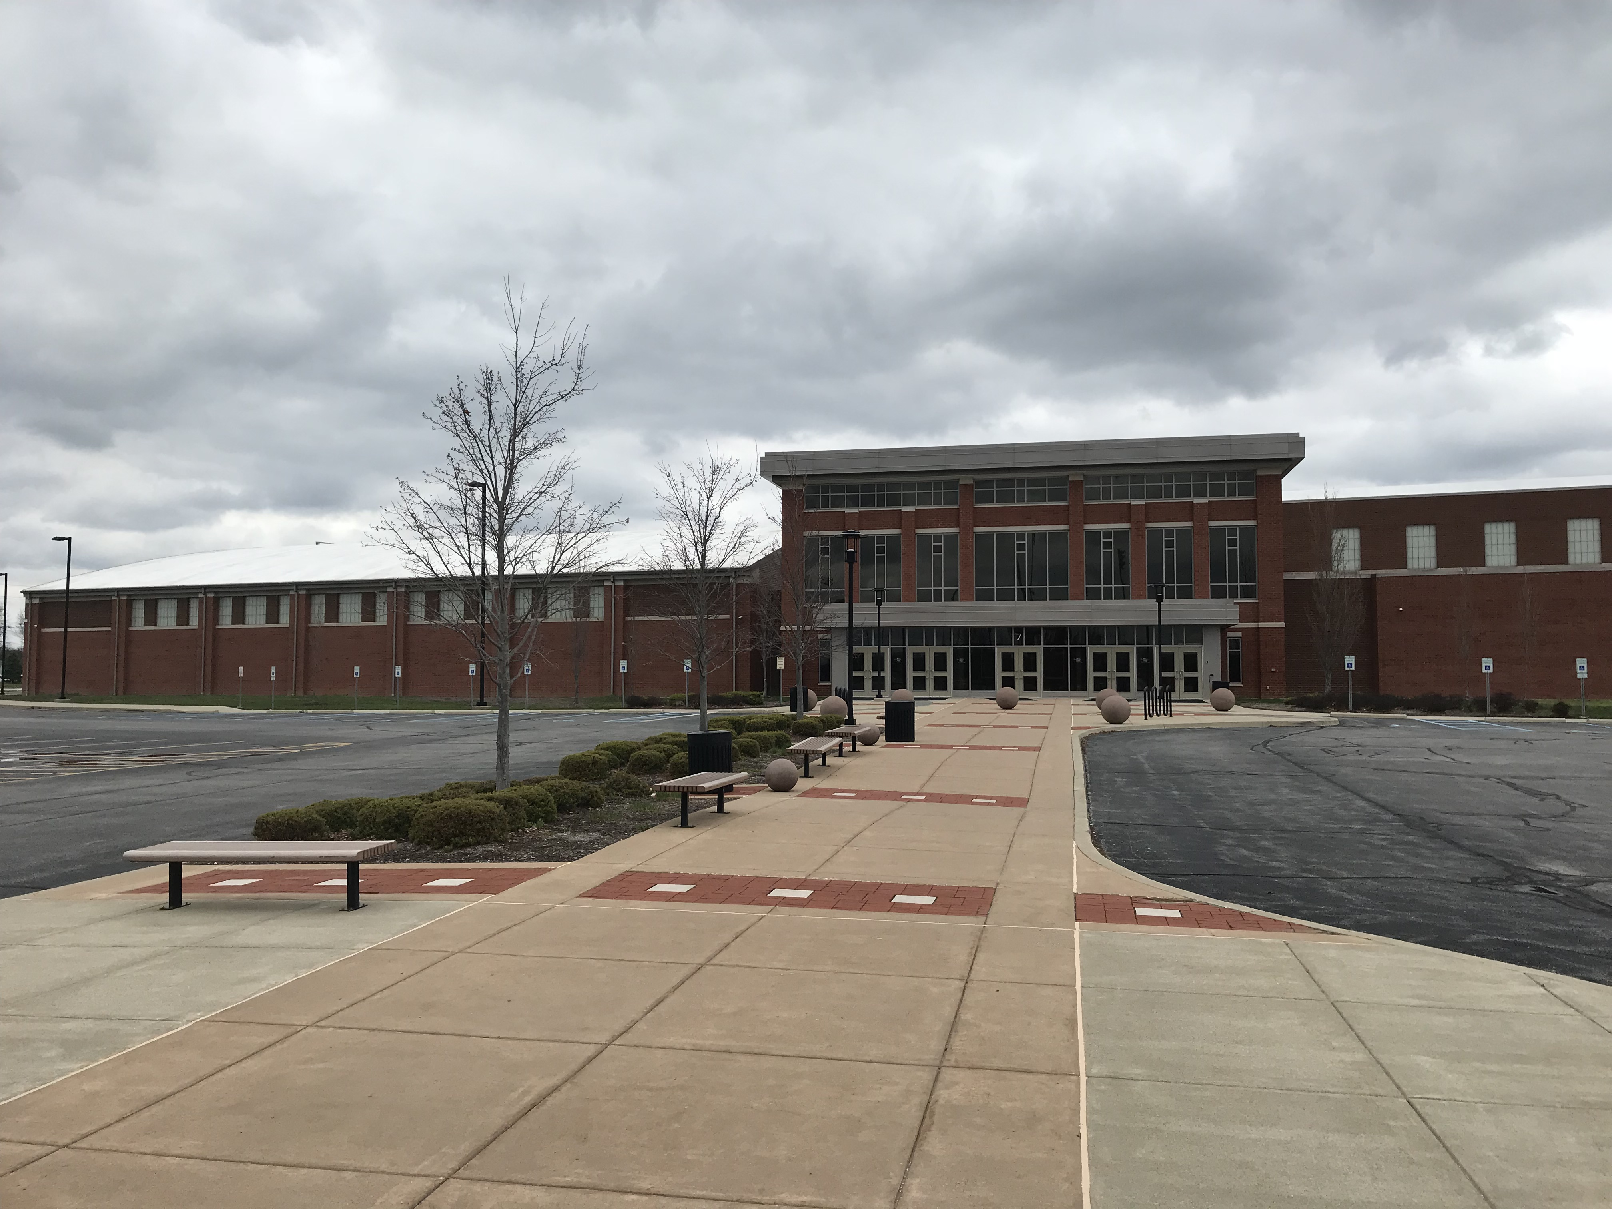
Turn South onto SR 267 (Quaker Blvd)
Turn Right (West) onto Reeves Road (school entrance)
Turn left onto Red Pride Drive
Athletic Complex Entrance to Pool is at the south end of the school
Use Door 7 to enter the building
From I70:
Take Exit 66 for SR 267 and turn North toward Plainfield
Go North on SR 267 to Hadley Road (first stop light)
Turn Left (West) onto Hadley Road
Turn Right (North) onto Red Pride Drive
Athletic Complex Entrance to Pool is at the south end of the school
Use Door 7 to enter the building
.
ATHLETIC COMPLEX ENTRANCE
DOOR 7

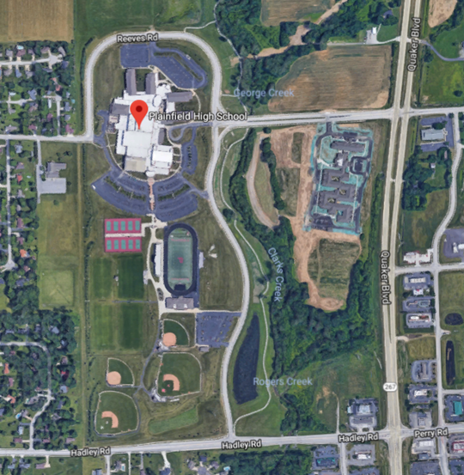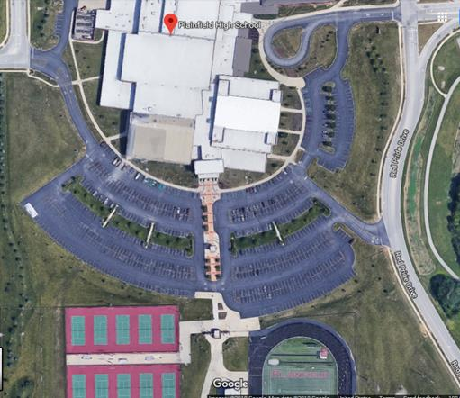
ENTER PHS FROM SR 267 OR FROM HADLEY ROAD

Sanctioned by USA and Indiana Swimming #INXXXX
SOUTH ENTRANCE
GATE 22, DOOR 21

SUMMARY OF ENTRIES
THIS FORM IS REQUIRED WITH PAYMENT DUE ON THE 1ST DAY YOUR TEAM COMPETES IN THE MEET
Please fill out the information requested below and email or mail with your entry form and check OR deliver in person on the first day your team competes in the meet. Please refrain from sending cash and make checks payable to Plainfield Community Aquatics or PCA.
Club Name: |  |  | Club Code:
Indiana Swimming Surcharge |  | Total Swimmers: |  | X | $2.00 | $
Timed Final Individual Entries |  | Number of Individual Entries: |  | X | $5.00 | $
Relay Entries |  | Number of Relay Entries |  | X | $8.00 | $
Total Fees for PCA Invitational: |  |  |  |  |  | $

Club Official Submitting Entry: |  |  | Coaches’ Names:
Name:
Email:
Phone:

Release and Hold Harmless Agreement
In consideration of being permitted to participate in this swim meet, and for other good and valuable consideration, the undersigned, for himself, his successors and assigns, hereby releases and forever discharges Plainfield Community Aquatics (PCA) and its Board of Directors, USA Swimming, Indiana Swimming, Plainfield Community School Corporation, and each of their respective officers, agents, employees, members, successors and assigns, and all other persons in any way connected with this swim meet, from any and all liabilities, claims, demands, actions, or causes of action of whatever kind of character arising out of or in connection with said event. Further, the undersigned shall indemnify and hold harmless PCA, USA Swimming, Indiana Swimming, Plainfield Community School Corporation, and the officers, trustees, agents, employees and members of the foregoing and all other persons in any way connected with this event, from any and all losses, expenses, damages, demands, and claims arising out of or in connection with any injury, including death, or alleged injury or damage to property sustained or alleged to have sustained in connection with or to have arisen out of said event.

Executed this ___________ day of ________________________, 2019.

Signature of Club Official or Coach: ______________________________________

Printed Name of Signature: _____________________________________________

You may have one designated spokesperson for your team to talk to the Meet Referee. The coach would be the logical person. Please print the name of your spokesperson: ____________________________

Entry Method: _______ Email ______ Disk

How would you like your results communicated:
______Hard Copy (snail mail or .pdf file emailed)
______Meet Manager Backup (emailed)
______Team Manager .c12 file (emailed)
______All of the above Email address to send above to: _____________________________

Did you include:
________ Check for entries and surcharges
________ Hard copy of entries (if applicable)
________ I have read the meet letter and understand it

