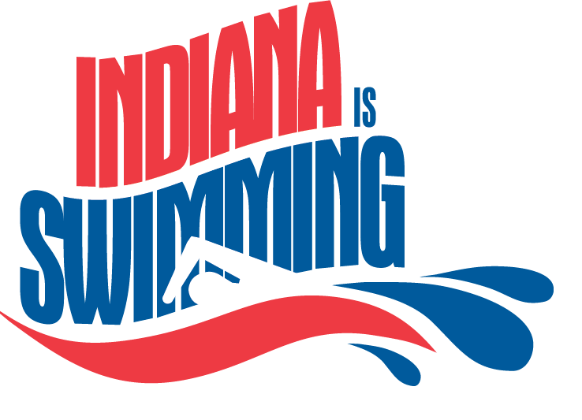
Spring Divisional Championship Assignment
Updated 7/7/2021
NW NE CW CE CM SW SE
CPSC CON ACST CARD CSC AGON ASC
DUNE ELK BA CCS HCA BOON CAST
HHSC FORT BBSC FAST JAGS CA CGAC
HOT GSI CCHA JAY LIFE GEVV COST
HSC MAC DTAC NOB LST ISC DCS
IA NASA FISH OAK PA JAWS DON
LCB PAC GA PSC RIV LCA ECST
LDSC RR HEAT SSC SIA MTV FA
MCPS SCA LEB TAC WA NSC FRST
MSC STRS MAST YSC WAC PACE GCAT
PPSC TVAC PCA WTSC RAC GRE
SBSC WAR PCST TCC H2O
SCBD WAVE PIKE TCSC ICAC
STAR WCO SCSC THT JCSC
TWSC WS TRIW VST MA
UTSC WWST ZSC MVP
VSC NPAC
SCAC
SDS
SEY
SIYS
TST
WWSC

