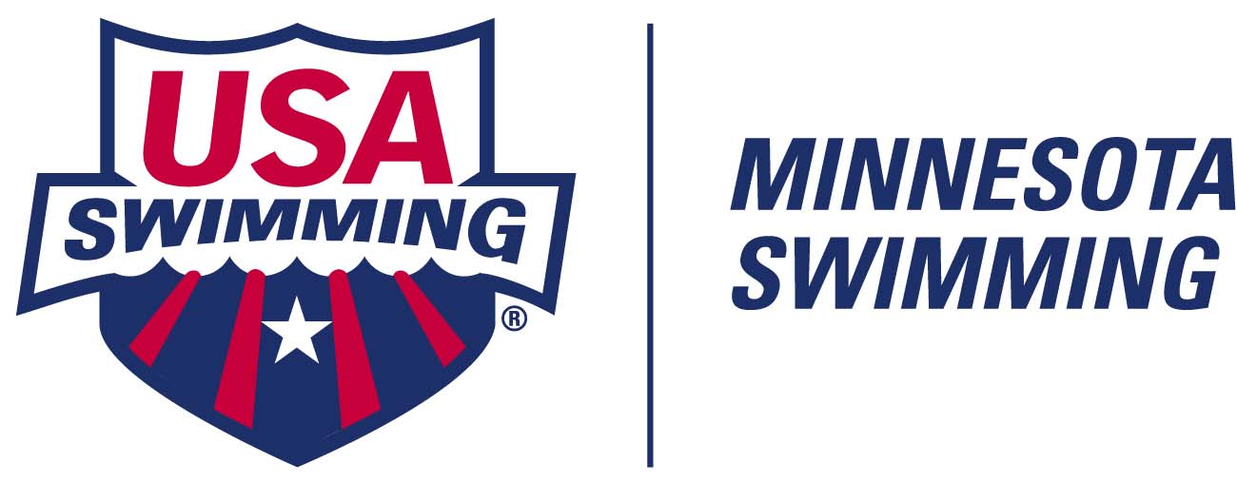

2021-2022 BOARD OF DIRECTORS & CONTACT LIST
PUBLICATION VERSION
Follow us on www.twitter.com/mnswim Like us at www.facebook.com/mnswim Follow us on www.instagram.com/wearemnswim

Minnesota Swimming Office
P.O. Box 1456, Minnetonka, MN 55345

MINNESOTA SWIMMING STAFF

Interim Executive Director/ Danielle Wentzel dwentzel@mnswim.org (c) 952-240-3993
Treasurer
Operations Mgr (Member Svs Tracy Meece tmeece@mnswim.org (c) 320-247-0940
& Registration and Sanctions)
Member Services Asst Becky Vonderharr bvonderharr@mnswim.org

EXECUTIVE BOARD MEMBERS (voting)

General Chair Ann Watanabe awatanabe.mnsi@gmail.com
Administrative Vice Chair Rebecca Binder rmbinder@gmail.com
Finance Vice-Chair Jon Blixt jsblixt@aim.com
Senior Vice Co-Chairs Sarah Lucas lucas.sarah429@gmail.com
Dave Molesworth moleswd@morris.umn.edu
Age Group Vice-Chair Justin Haycraft swimminfam@gmail.com
Senior Coach Rep Ted Patton teddpatton@gmail.com
Senior Athlete Rep Ignacio Michelena athleterep@mnswim.org
Junior Athlete Rep Emily Garrison athleterep@mnswim.org
Secretary Sara Durham mnsi.secretary@gmail.com

OTHER ELECTED BOARD MEMBERS (voting)

At-Large Athlete Bryan Chen athleterep@mnswim.org
At-Large Athlete Chloe Johnson athleterep@mnswim.org
Diversity & Inclusion Chair Darcy Samson djsamson@comcast.net
Junior Coach Rep Jessica Colby reddragonswimming@outlook.com
Official’s Committee Chair Jack Swanson jswanson1519@gmail.com
Operational Risk/Safety Coord John Raby mn.safety@gmail.com
Safe Sport Chair Anne Knapp safesport@mnswim.org
Technical Planning Chair John Bradley john.bradley@minnetonkaschools.org
XO Immediate Past-GC Luke Day lday@umn.edu
(non-elected/non-voting)

APPOINTED STANDING COMMITTEE CHAIRS (non-voting)

Nominating Committee Co-Chairs Amy Parratto amy@riptideswimteam.org
Mike Jasperson mjasperson@gmail.com
Disability Swimming Chair Melissa Wymer mwymer18@gmail.com
Governance Committee Co-Chairs Luke Day lday@umn.edu
Theresa Jurisch tmjurisch@gmail.com
Open Water Swimming Chair Heidi Miler westexpresscoach@hotmail.com
Times/Natl AG Recog Coord Michael Bougie bougieml@msn.com

MISSION: To serve athletes and the swimming community by providing great experiences in and out of the water.
VISION: To lead youth sports in participation, opportunity, performance & service.
CORE VALUES: Integrity. Sportsmanship. Excellence. Fun.

