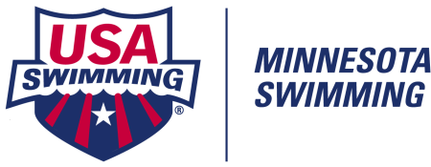 NATIONAL TRAVEL REIMBURSEMENT for COACHES

MINNESOTA SWIMMING REIMBURSES A PORTION OF TRAVEL TO DESIGNATED SWIM MEETS

Reimbursement Amounts: Summer 2021

USA Olympic Trials Wave I or Wave II June 4-7, 2021 Omaha, NE $800.00
June 13-20, 2021
2021 Speedo Summer Championships August 3-7, 2021 Various $450.00

MINNESOTA SWIMMING REQUIREMENTS FOR COACH REIMBURSEMENT TO NATIONAL MEETS

MSI Legislation Passed 11/16/2010: To allow one coach per club to apply for a single share of reimbursement equal to that of an athlete’s reimbursement for a given meet.

1. The applying Coach must be a member in good standing with a current Minnesota Swim Club.
2. The applying coach must have attended the meet for which he/she applies for reimbursement.
3. This coach must have coached athletes from his/her team at the meet for which he/she requests reimbursement.
4. A club may request reimbursement for one (1) coach per season.
5. For verification purposes, the coach must submit a copy of their flight or hotel receipt (with name and dates) pertaining for the meet requested.
(Send as an email attachment, along with this reimbursement form.)

Summer 2021 Request Forms Must Be Received by September 30, 2021

Reimbursement Request Form Directions:
- Download this form to your computer desktop. Tab through the document to complete. Save.
- Send an email to MNSI Office (dwentzel@mnswim.org and tmeece@mnswim.org), with this completed request form as an attachment.
- Attached your coach hotel or flight “proof” on the same email.

MINNESOTA SWIMMING COACH NATIONAL TRAVEL REIMBURSEMENT REQUEST FORM

Swim Club Requesting Funds: Club Code:

COACH'S NAME | SWIM MEET NAME | AMOUNT REQUESTED
SWIM MEET LOCATION | SWIM MEET DATES
 |  | $

Coach’s Day Phone #: E-Mail Address:

Total Amount Requested: $ Date Requested:

(Checks are payable to clubs only)

Date Email Request Rec’d by MNSI:

Proof of Meet Attendance Received: YES NO Type of Proof: Hotel Receipt Flight Receipt

TOTAL AMT APPROVED: $

Date Paid: Amount Paid: $

