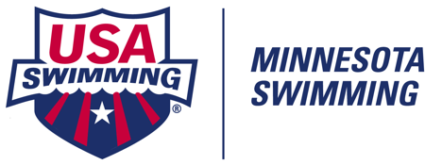

National Travel Reimbursement Request for Athletes
Attending Disability Swimming Meets

MINNESOTA SWIMMING REIMBURSES A PORTION OF TRAVEL TO DESIGNATED MEETS

REIMBURSEMENT AMOUNTS

Fall/Winter 2021-22

US Para National Championships
December 17-19, 2021 Greensboro, NC $400

Spring/Summer 2022

Indianapolis 2019 World Para Swimming World Series Indianapolis, IN $600
TBA

MINNESOTA SWIMMING ATHLETE REQUIREMENTS FOR REIMBURSEMENT

1. The athlete must be a member in good standing with a current Minnesota Swimming Chartered Swim Club or registered as a current Minnesota Swimming Unattached Swimmer (no team affiliation).
2. The athlete must swim in at least two (2) Minnesota Swimming sanctioned meets in the previous
12 months of the meet for which he/she is collecting.
3. An athlete may only collect from one (1) meet per season.

Request Form Directions for Completion & Submission:
Download this form to your PC desktop. Put your cursor on the request form and click. It should go to the first item to be completed. Continue to tab through the form to complete all the requested information. Save your information. Send the same Word Document as an email attachment to tmeece@mnswim.org and Dwentzel@mnswim.org

Fall/Winter 2021-22 Request Forms must be received by April 15, 2022
Spring/Summer 2022 Request Forms must be received by Sept 30, 2022

Minnesota Disability Swimming Athlete National Travel Reimbursement Request

Swim Club Requesting Funds: Club Code:

Meet Name: Location: Dates:

ATHLETE'S NAME | EVENT SWUM AT MEET | AMOUNT REQUESTED

Title: Club Coach Other: Name: Cell Phone #

Total Amount Requested: $ Date: E-Mail Address:

(Checks are payable to clubs only, unless athlete is registered unattached)

Date Email Request Received by MSI: TOTAL AMT APPROVED: $

Date Paid: Amount Paid: $

