USA SWIMMING 2019 JUNIOR COACH REGISTRATION APPLICATION [Must be Age 16 or 17]
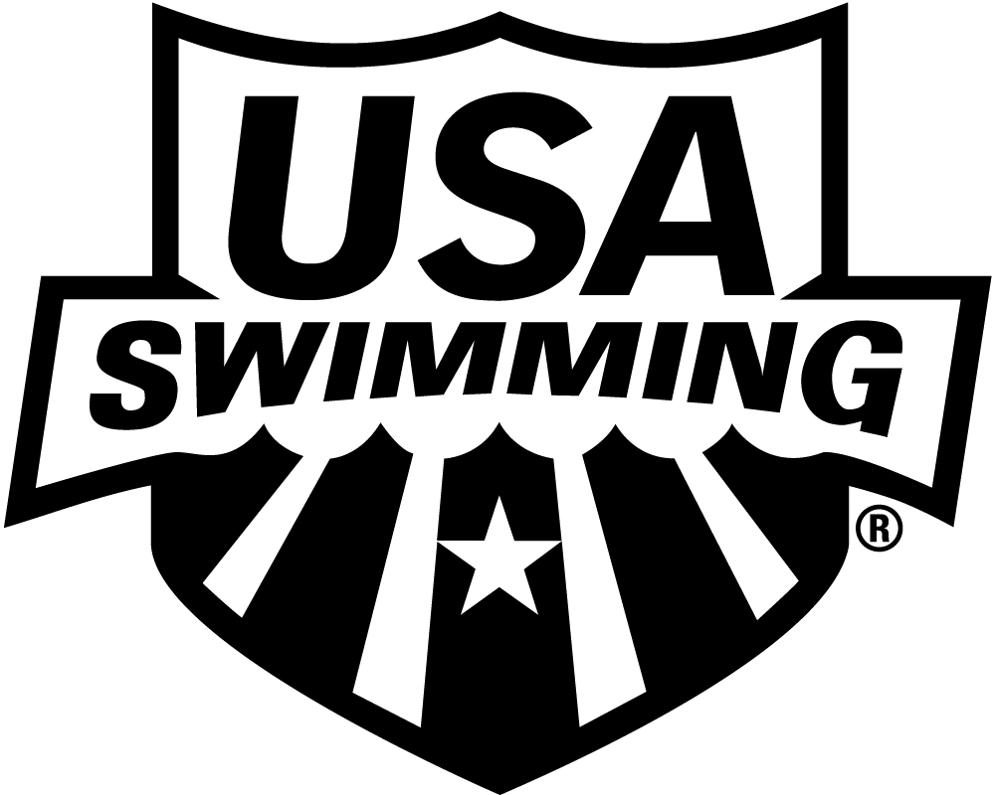

LSC: Minnesota Swimming, Inc.

PLEASE PRINT LEGIBLY COMPLETE ALL INFORMATION TO ENSURE THAT CONTACT INFORMATION IS CORRECT AND UP TO DATE:

LAST NAME LEGAL FIRST NAME MIDDLE NAME

Have you ever been a member of USA Swimming under a different last name? If yes, please provide that name:
Previously registered with USA Swimming? Yes No If registered in a different LSC, which LSC:

PREFERRED NAME DATE OF BIRTH (MO/DAY/YR) Age CLUB CODE CLUB NAME

(Bill, Beth, Scooter, Liz, Bobby) (Required) If not affiliated with a club, enter “Unattached”

SEX (M-F) MAILING ADDRESS

CITY STATE ZIP CODE

–

AREA CODE TELEPHONE NO. AREA CODE TELEPHONE NO. EXTENSION AREA CODE TELEPHONE NO.

HOME WORK MOBILE

E-MAIL ADDRESS

IF ANY OF THE ABOVE INFORMATION CHANGES DURING THE YEAR – PLEASE NOTIFY YOUR LSC REGISTRATION/MEMBERSHIP PERSON OF THE CHANGES

RACE AND ETHNICITY (OPTIONAL): You may check up to two choices
Q. Black or African American R. Asian
S. White T. Hispanic or Latino
U. American Indian & Alaska Native V. Some Other Race
W. Native Hawaiian & Other Pacific Islander
CITIZENSHIP/FINA:
U.S. Citizen: Yes No
Are you a member of another FINA federation: Yes No
If Yes, which federation:____________________________________

Check if you would like to receive the electronic USA Swimming Newsletter

MEMBERSHIP CODE: Check all that apply
Junior Coach (Part Time) No background check required, requires Athlete Protection Training
Junior Coach (Full Time) No background check required, requires Athlete Protection Training

If coach, primary age group that you coach (may be more than one): 10-Un 11-12 13-14 15-18 19+ Masters

Junior Coach Requirements:
APT at www.usaswimming.org/protect Current CPR/AED & Safety Training for Swim Coaches certifications
Concussion Training: https://www.cdc.gov/headsup/youthsports/training/index.html
Educational Requirements for Coaches at usaswimming.org/FOC:
- An individual registering as a coach for the first time must complete the online Foundations of Coaching 101 test prior to becoming a Coach Member.
- Prior to registering as a coach for the second year, the online tests for Foundations of Coaching 201 and Rules and Regulations must be completed.
ACCEPTABLE SAFETY REQUIREMENT COURSES AND ONLINE TESTS ARE AVAILABLE AT www.usaswimming.org/coachmember

By becoming a member of USA Swimming, I hereby agree to abide by the rules, regulations and Code of Conduct of USA Swimming.
I acknowledge that when I learn of facts that give reason to suspect that a child has suffered an incident of abuse, including sexual abuse,
I must report to law enforcement within 24 hours pursuant to The Protecting Young Children from Sexual Abuse and Safe Sport Authorization Act.

_______________________________________________________________________________________________ / ___________________________
Signature Date
By signing this application I verify that the above is true and correct. APPLICANT MUST SIGN.

2019 REGISTRATION FEE
September 1, 2018 through December 31, 2019
USA Swimming Fee + LSC Fee = TOTAL DUE

Junior Coach $60.00 + 5.00 = $ 65.00

Junior Coach * .00 + 5.00 = $ 5.00
* Already registered for 2019 as a Premium Athlete Member
MAKE CHECK PAYABLE TO:
Minnesota Swimming, Inc.

MAIL APPLICATION & PAYMENT TO:

.
Minnesota Swimming, Inc.
1001 Highway #7
Hopkins, MN 55305

FOR LSC REGISTRAR USE ONLY:

REGISTRATION DATE__________________________________ UPGRADED TO FULL COACH MEMBER / DATE: ________________________

