USA SWIMMING 2019 SINGLE-MEET OPEN WATER ATHLETE APPLICATION
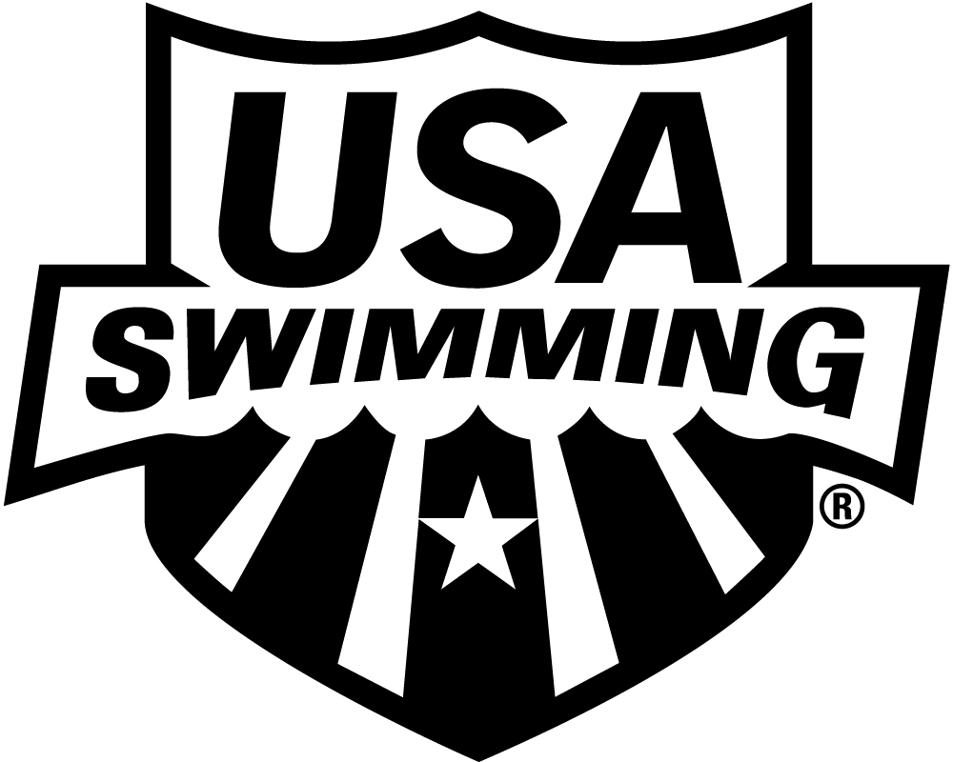
NAME OF MEET / DATE(S) LSC: Minnesota Swimming
THIS MEMBERSHIP IS ONLY FOR MEETS BELOW THE

ZONE, SECTIONAL AND NATIONAL LEVELS.
PLEASE PRINT LEGIBLY COMPLETE ALL INFORMATION:

LAST NAME LEGAL FIRST NAME MIDDLE NAME

PREFERRED NAME DATE OF BIRTH (MO/DAY/YR) SEX (M/F) AGE

(Bill, Beth, Scooter, Liz, Bobby)

PARENT/GUARDIAN #1 LAST NAME PARENT/GUARDIAN #1 FIRST NAME PARENT/GUARDIAN #2 LAST NAME PARENT/GUARDIAN #2 FIRST NAME

MAILING ADDRESS

U.S. CITIZEN: YES NO

CITY STATE ZIP CODE
ARE YOU A MEMBER OF ANOTHER FINA
FEDERATION? ☐ YES ☐ NO
IF YES, WHICH FEDERATION:

HAVE YOU REPRESENTED THAT
FEDERATION AT INTERNATIONAL
COMPETITION? ☒ YES ☐ NO

–

AREA CODE TELEPHONE NO. FAMILY/HOUSEHOLD E-MAIL ADDRESS

OPTIONAL
MAKE CHECK PAYABLE TO:

DISABILITY: RACE AND ETHNICITY (You may
Minnesota Swimming, Inc.
A. Legally Blind or Visually Impaired check up to two choices):

B. Deaf or Hard of Hearing Q. Black or African American
MAIL APPLICATION & PAYMENT TO:
C. Physical Disability such as R. Asian

2019 REGISTRATION FEE
USA Swimming Fee $10.00

LSC Fee 8.00

TOTAL DUE $18.00
amputation, cerebral palsy, S. White

Minnesota Swimming
1001 Highway #7
Hopkins, MN 55345

dwarfism, spinal injury, T. Hispanic or Latino
mobility impairment U. American Indian & Alaska Native
D. Cognitive Disability such as V. Some Other Race
severe learning disorder, W. Native Hawaiian & Other Pacific
autism Islander

REG. DATE/LSC USE ONLY: __________________________________ YEAR LAST REGISTERED: _________________

