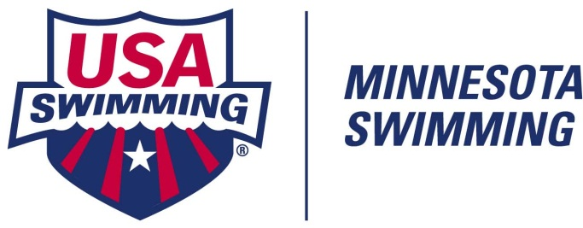
House of Delegates Afternoon Club Workshops
Registration Form
Saturday, April 27, 2013 ~ 12:30 – 4:30 pm
Location: Eisenhower Community Center (Conference Room #209)
1001 Highway #7, Hopkins, MN 55305
(about ¼ mile W of Highway #169 on the North side of Highway #7)

Open to all existing and new MSI Swimming Member Clubs

Pre-Registration is NOT required. However, a preliminaty headcount to plan for lunch and/or any handouts would be helpful.

Instructions:
Download form. Tab through requested information to complete form. Return form as email attachment to cshapley@mnswim.org

Please send ONE REGISTRATION FORM per person attending!

Name:

Check One:

Head Coach Assistant Coach Club President Club Board Member Other

Club Name: Club Code:

Email Address:

Phone Number where you can be reached:

Questions? Contact the MSI office: 952-988-4181 or email: cshapley@mnswim.org
(Fax, if necessary: 952-988-4183)

