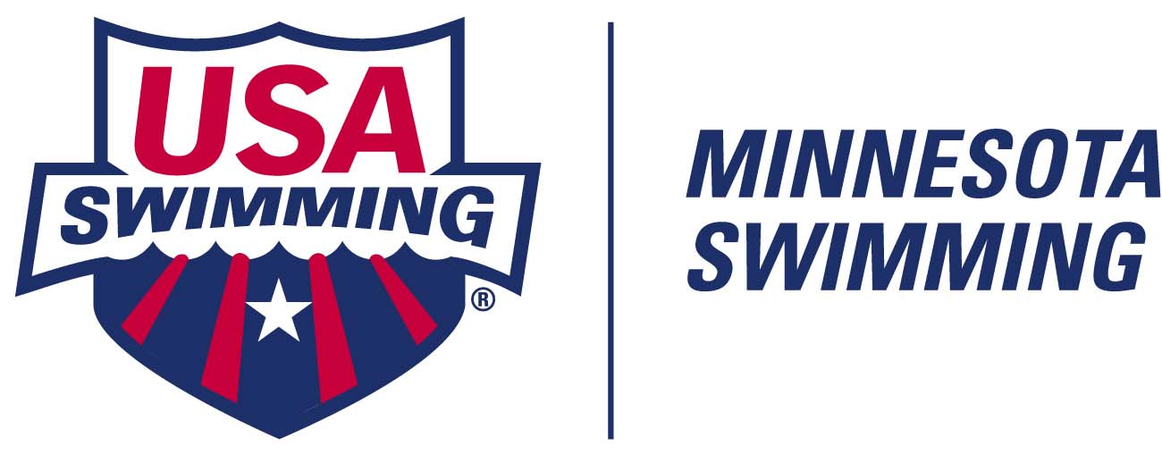

2020-2021 BOARD OF DIRECTORS & CONTACT LIST
PUBLICATION VERSION
Follow us on www.twitter.com/mnswim Like us at www.facebook.com/mnswim Follow us on www.instagram.com/wearemnswim

Minnesota Swimming Office
Eisenhower Community Center 1001 Highway #7, Hopkins, MN 55305-4723 (p) 952-988-4184 (f) 952-988-4183

MINNESOTA SWIMMING STAFF

Executive Director
Sport Development Director John Bradley jbradley@mnswim.org (c) 507-226-1955
Member Svs & Registration Tracy Meece tmeece@mnswim.org (c) 320-247-0940
Meet Sanctions/Tech Asst Tracy Meece tmeece@mnswim.org (c) 320-247-0940
Webmaster/Social Media Michael Duncan webmaster@mnswim.org
Member Services Asst Becky Vonderharr bvonderharr@mnswim.org (w) 952-988-4179

EXECUTIVE BOARD MEMBERS (voting)

General Chair Ann Watanabe awatanabe.mnsi@gmail.com
Administrative Vice Chair Rebecca Binder rmbinder@gmail.com
Finance Vice-Chair Debbie McCormick mdmccormick22@yahoo.com
Senior Vice-Chair Kelly Kremer kreme010@umn.edu
Age Group Vice-Chair Justin Haycraft swimminfam@gmail.com
Senior Coach Rep Tom Walsh coachtom@rochesterswimclub.com
Senior Athlete Rep Carter Brown athleterep@mnswim.org
Junior Athlete Rep Ignacio Michelena athleterep@mnswim.org
Secretary Sara Durham sarabdurham@gmail.com

OTHER ELECTED BOARD MEMBERS (voting)

Junior Coach Rep Tricia Lilleberg wavesaquaticclub@gmail.com
Official’s Committee Chair Bill Stephan wastephan007@gmail.com
Operational Risk/Safety Coord John Raby mn.safety@gmail.com
Safe Sport Chair Anne Knapp safesport@mnswim.org
Technical Planning Chair Scott Tripps scott@genesisaquatics.org
Athlete Committee Katelyn Smith athleterep@mnswim.org
Co-Vice-Chairs Josh Johnston athleterep@mnswim.org
XO Immediate Past-GC Luke Day lday@umn.edu
(non-elected/non-voting)

APPOINTED STANDING COMMITTEE CHAIRS (non-voting)

Camps Coordinator Mikaela Bagley ekbl0011@umn.edu
Disability Swimming Chair Melissa Wymer mwymer18@gmail.com
Diversity & Inclusion Chair Darcy Samson djsamson@comcast.net
Governance Committee Chair Jim Hanton jandchanton@comcast.net
Open Water Swimming Chair Heidi Miler westexpresscoach@hotmail.com
Nominating Committee Chair Jack Swanson jswanson1519@gmail.com
State Records Coordinator Carl Schulze velocityheadcoach@gmail.com
Times/Natl AG Recog Coord Michael Bougie bougieml@msn.com

MISSION: To serve athletes and the swimming community by providing great experiences in and out of the water.
VISION: To lead youth sports in participation, opportunity, performance & service.
CORE VALUES: Integrity. Sportsmanship. Excellence. Fun.

