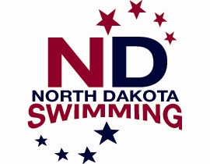

A.18 Request for Swimmer/Coach Reimbursement

Reimbursement will be granted ONLY for the following meets;
Speedo Sectionals, Futures Championships, Speedo Junior National Championships, Arena Pro Swim Series (previously Grand Prix Series), Phillips 66 National Championships, and AT & T Winter National Championships.

In accordance with the North Dakota LSC Policy Manual, part 8, swimmers and coaches participating in the above meets may request reimbursement for swimmer entry fees, transportation and lodging. Check the NDSwimming.org website or most recent HoD minutes for reimbursement amounts.

This form must be sent electronically to the Senior Vice Chair and copied to the Treasurer for approval within 30 days from the last day of the meet that reimbursement is being requested for.

Name: Date:

Club Affiliation: Contact Phone:

Meet Attended: Dates:

Expenses: Meet Fees:
Transportation:

Lodging:
Total:
All applicable receipts must be attached to receive reimbursement.

Who incurred the expenses? Swimmer Club Coach

Send payment to (name/address):

Email to: NDLSC Sr. Vice Chair AND: NDLSC Treasurer
Anne McDonagh Amanda Finck
annemcdonagh5@gmail.com amanda31880@gmail.com

Treasurer Information:
Date Received:

Date Paid:

Check #: Amount:

