Sport-Tek Mens & Womans Dri-Mesh Pro Polo

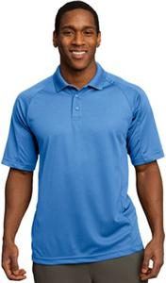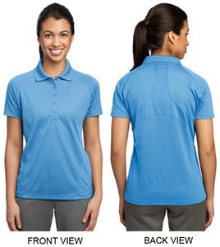

Mens Spec Sheet Sizing | AXS | AS | AM | AL | AXL | A2XL | A3XL
Chest | 32 - 34" | 35 - 37" | 38 - 40" | 41 - 43" | 44 - 46" | 47 - 49" | 50 - 53"

Mens Product Measurements | AXS | AS | AM | AL | AXL | A2XL | A3XL
Chest (on the half) | 19" | 20.5" | 21.5" | 23.5" | 25.5" | 27" | 28.5"
Body Length | 28" | 29" | 30" | 31" | 32" | 33" | 34"
How to Measure:
Chest: Measured across the chest one inch below armhole when laid flat.
Bust: Measured one inch below armhole.
Length: Measured from center front neck to hem. - See more at:

Sport-Tek Ladies Dri-Mesh Pro Polo
Womens Spec Sheet Sizing | WXS |  | WS |  | WM |  | WL |  | WXL |  | W2XL |  | W3XL
Size | 2 |  | 4/6 |  | 8/10 |  | 12/14 |  | 16/18 |  | 20/22 |  | 24/26
Bust | 32 - 34" |  | 35 - 36" |  | 37 - 38" |  | 39 - 41" |  | 42 - 44" |  | 45 - 47" |  | 48 - 51"
Womens Product Measurements |  | WXS |  | WS |  | WM |  | WL |  | WXL |  | W2XL |  | W3XL
Bust (on the half) |  | 18" |  | 19" |  | 20" |  | 21.5" |  | 23" |  | 24.5" |  | 26.5"
Body Length |  | 25" |  | 25.5" |  | 26" |  | 27" |  | 28" |  | 29" |  | 29.5"

