USA SWIMMING 2022 SEASONAL ATHLETE REGISTRATION APPLICATION
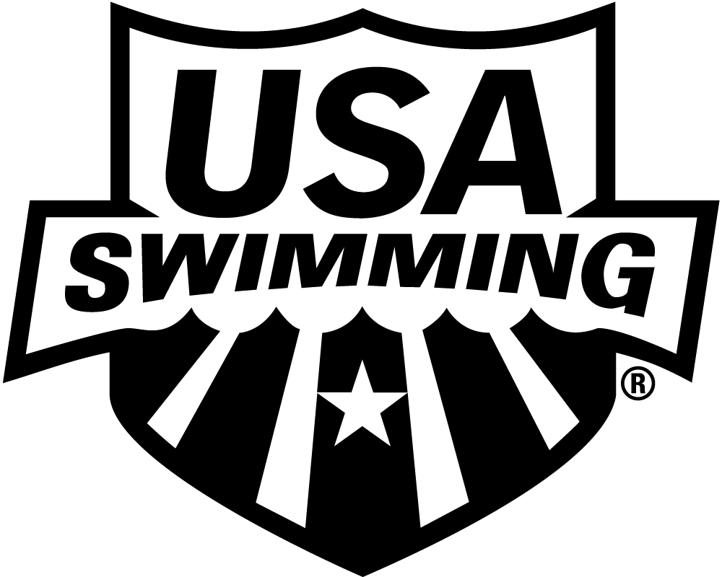
LSC: NORTH DAKOTA
CHECK APPROPRIATE SEASONAL PERIOD: THIS MEMBERSHIP IS ONLY FOR MEETS BELOW
SEASON 1 SEASON 2 INDIVIDUAL SEASON ZONE, SECTIONAL AND NATIONAL LEVELS.
PLEASE PRINT LEGIBLY COMPLETE ALL INFORMATION:

LAST NAME LEGAL FIRST NAME MIDDLE NAME

PREFERRED NAME DATE OF BIRTH (MO/DAY/YR) SEX (M/F) AGE CLUB CODE NAME OF CLUB YOU REPRESENT

(Bill, Beth, Scooter, Liz, Bobby) If not affiliated with a club, enter “Unattached”

NOTE: If you are 18 years of age or older, you are required to abide by the Minor Athlete Abuse Prevention Policy. In addition, in order to be a member in good standing you must complete the Athlete Protection Training. The training can be accessed at www.usaswimming.org/apt

GUARDIAN #1 LAST NAME GUARDIAN #1 FIRST NAME GUARDIAN #2 LAST NAME GUARDIAN #2 FIRST NAME

MAILING ADDRESS

CITY STATE ZIP CODE

–

AREA CODE TELEPHONE NO. FAMILY/HOUSEHOLD EMAIL ADDRESS MEMBER’S EMAIL ADDRESS

ARE YOU A MEMBER OF ANOTHER FINA
FEDERATION? ☐ YES ☐ NO
IF YES, WHICH FEDERATION:

HAVE YOU REPRESENTED THAT
FEDERATION AT INTERNATIONAL
COMPETITION? ☐ YES ☐ NO
U.S. CITIZEN: YES NO

“I understand and agree that the FINA Anti-Doping Rules and U.S. Anti-Doping Agency Protocol for Olympic and Paralympic Movement Testing (USADA Protocol) and all other policies and rules adopted by FINA, USADA, and the USOPC apply to me and that it is my responsibility to comply with those rules. I agree to submit to drug testing at any time and understand that the use of methods or substances prohibited by the applicable anti-doping rules would make me subject to penalties including, but not limited to, disqualification and suspension. If it is determined that I may have committed a doping violation, I agree to submit to the results management authority and processes of USADA, including arbitration under the USADA Protocol, or to the results management authority of FINA and/or USA Swimming, if applicable or referred by USADA.”

OPTIONAL

DISABILITY: RACE AND ETHNICITY (You may

A. Legally Blind or Visually Impaired check up to two choices):

B. Deaf or Hard of Hearing Q. Black or African American
C. Physical Disability such as R. Asian
amputation, cerebral palsy, S. White

dwarfism, spinal injury, T. Hispanic or Latino

2022 REGISTRATION FEE
USA Swimming Fee: $30.00

LSC Fee: $10.00

TOTAL DUE: $40.00
mobility impairment U. American Indian & Alaska Native
D. Cognitive Disability such as V. Some Other Race
severe learning disorder, W. Native Hawaiian & Other Pacific
PAYMENT DUE UPON RECEIPT OF INVOICE FROM THE ND LSC TREASURE
autism Islander

HIGH SCHOOL STUDENTS – Year of high school graduation:
Check if you would like to learn more about the USA Swimming Foundation’s initiatives
Check if you would like to receive the electronic USA Swimming Newsletter (must be 13 years of age or older)
YEAR LAST REGISTERED: . IF YOU REGISTERED WITH A DIFFERENT USA SWIMMING CLUB IN 2021, ENTER THAT
CLUB CODE: LSC CODE: AND THE DATE OF YOUR LAST COMPETITION REPRESENTING THAT CLUB: .

SIGN
HERE x
SIGNATURE OF ATHLETE, PARENT OR GUARDIAN DATE REG. DATE/LSC USE ONLY

