Event Hosted By: | Williston Sea Lions
Approved By | Held under the sanction of USA Swimming. Sanction issued by the ND LSC.
Meet Sanction #: | TBD
Liability | In granting this sanction it is understood and agreed that USA Swimming shall be from any liabilities or claims for damages arising by reason of injuries to anyone during the conduct of the event. Specific Covid-19 changes are highlighted in yellow along with a Covid-19 Protocol Page.
Meet Purpose | To encourage and promote good sportsmanship, competitive swimming among all athletes and to have fun. Good sportsmanship is required of all athletes, coaches, officials, and spectators.

Meet Referee | Shane Peterson | Admin Official | Susan Draper
 | 701-570-2701 | Starter | Joel Babcock
 | shanepeterson320@gmail.com | Other Officials | Jessica Hansen
 |  | Safety Marshall | Jill Zander

Meet Manager / Entries
Name | Susan Draper
Phone # | 385-225-0476
Email Address | Draperkands98@msn.com
Entry Deadline
Electronic Copies | Wednesday February 5, 2021 – 12:00 pm CST
Paper Entries | Only Electronic entries accepted

Meet Site | Williston Area Recreation Center
Address | 822 18th St. E.Williston, ND 58801

Facility Information | The E.J. Hagan, MD Natatorium is an 8 lane 50-meter indoor pool, which is housed within the Williston ARC. The competition pool conforms to USA Swimming Rules and Regulations – 2010 Article 103.3. The pool is in the process of being certified in accordance with USA Swimming requirements 104.2 C (3). Water depth is 12.5’ at the start end, 7’ at course center, and 4’ at the turn end.
Timing Information | DakTronics electronic timing system with horn/light start, one backup button, and one stop watches per lane, and touch pads at the start and turn ends of the pool will be used.
Course Certification | The competition pool conforms to USA Swimming Rules and Regulations, Article 103.3. The competition course has been certified in accordance with 104.2.2C (3) and (4). The copy of such certification is on file with USA Swimming.  OR  The competition pool has not been certified in accordance with 104.2.2C(4)
Eligibility / Meet Type | Age as of February 12, 2021 shall determine age group for swimmers, including age group relays. This is a Three day, two session, timed finals meet. All events will be swum as mixed gender and seeded by time slowest to fastest according to entry times submitted.
Disability Statement | Swimmers with permanent disability as defined by USA Swimming are welcome to participate in any ND Swimming sanctioned meet in any event corresponding to the swimmer’s gender within the daily individual event limit for the meet. The entering coach or swimmer must contact the meet referee to discuss any modification for the disabled swimmer to participate.
Racing Start Proficiency | Any swimmer entered in the meet must be certified by a USA Swimming member-coach as being proficient in performing a racing start or must start each race from within the water. When unaccompanied by a member-coach, it is the responsibility of the swimmer or the swimmer’s legal guardian to ensure compliance with this requirement.
USA Swimming Membership | ALL current 2021 registered athlete member of USA Swimming are eligible to participate.  No swimmer will be permitted to compete unless the swimmer is a member as provided in Article 302.  Current 2021 USA Swimming coaches’ registration with required additional certification is required of all Coaches. Upon request, Coaches must be able to provide proof of current certification. Deck pass is an acceptable form of proof of membership.
Swimmers without a coach present | USA Swimming athlete members must be under the supervision of a USA Swimming member coach during warm-up, competition, and warm-down. The Meet Director or Meet Referee shall assist the athlete in arranging for such supervision. Coaches are encouraged to make arrangements in advance if they cannot attend the meet with their swimmers.
Officials | All officials will be USA Swimming certified officials. An Officials meeting will be held 45 minutes before the start of each Session. Uniform for officials is a white North Dakota Officials polo shirt with khaki shorts, pants or skirts, with white shoes.
Rules | Current USA (Long/Short) Course rules and safety policies as adopted by the NDLSC and USA Swimming Rules and Regulations <Current year> edition will govern the meet.  - This is a timed final meet.  - The whistle protocol and horn start with no recall for false starts will be used.  - The Meet Referee has the right to combine any events or heats.  - If timeline exceeds the 4 hour time limit relays will be scratched.  - Swimmers should appear at designated area which will be addressed at the coaches meeting prior to the start of the meet Swimmers arriving at the blocks and not ready to swim when their heat is called will be scratched from the event.  - Individual and relay events will be accepted with no times (NT).  - Swimmers names and USA/CASA registration numbers are to be submitted at time of entries.  - Events may be seeded and swam as mixed-gender events.  - All events will be swam based on entry time with the fast entry times being swam in the last heat of each event.  - NT entries will be accepted.  - All relays may be swam as mixed gender relays.
On Deck Registration | On deck registration is not allowed for this meet.
Warm-up & Safety Policy  MAAPP | North Dakota Swimming, Inc. warm-up procedures and safety guidelines will be in effect at this meet. Backstroke swimmers must step into the water feet first. Safety Marshalls will remind all swimmers and athletes on deck of any violation of NDLSC and US Swimming safety policies.  Only Swimmers, coaches, officials, and working volunteers will be allowed on the pool deck. The locker rooms are for swimmers only. Safety Marshals will check credentials. ALL deck personnel and volunteers will be required to wear a mask approved by the CDC that always covers both the nose and mouth. Deck personnel are required to maintain 6 feet apart when on deck. Swimmers will be encouraged to wear masks when not swimming and maintain 6 feet apart both in and out of the pool.  Option 1: All applicable adults participating in or associated with this meet, acknowledge that they are subject to the provisions of the USA Swimming Minor Athlete Abuse Prevention Policy (“MAAPP”), and that they understand that compliance with the MAAPP policy is a condition of participation in the conduct of this competition.  Option 2: Current USA Swimming Rules, including the Minor Athlete Abuse Prevention Policy (“MAAPP”), will govern this meet.
Awards | Individual Ribbons: 1-16 Relay Ribbons: 1-8 Individual awards will be based on USA Swimming’s Standard Age Groups and gender: 8 & Under, 9‐10, 11‐12, 13‐14, 15‐18, 19 & Over – Male and Female All relays will be scored as mixed gender relays (any combination): 8 & Under, 10 & Under, 11 & Over Scoring: No Team Awards or Team Scoring. 19 & Over will not receive awards.
Entry Limitations: | The entry limitation is 7 individual events.
Time Trials | There will be no time trials.
Swimsuits: | Current US Swimming policies governing swimsuits will be in effect and enforced.
Deck Changing: | Deck changing is not allowed. Athletes may change in the locker room quickly, but no showering. Athletes are encouraged to arrive in and leave in their swimsuits.
Audio or Visual Recording Devices: | Use of audio or visual recording devices, including a cell phone, is not permitted in changing areas, rest rooms, locker rooms, or behind the start blocks. Live Streaming will be available on YouTube that will be recorded by an assigned volunteer
Operations of Drones | Operation of a drone, or any other flying apparatus, is prohibited over the venue (pools, athlete/coach areas, spectator areas and open-ceiling locker rooms) any time athletes, coaches, officials and/or spectators are present.
Meet Jury | A meet jury will be formed by the meet referee. It will consist of one official (not the  Meet Referee), and a Coaches' Rep. from the smallest and largest teams represented. Until the Meet Jury renders a decision, the swimmer may compete under protest.  An announcement to this effect shall be made prior to the race. The results of any race conducted under protest shall not be announced, nor prizes awarded, nor points scored until the jury has determined if and how their decision may affect the final scoring or awards.  The decision of the jury may be appealed by either party to the Central Zones Board of Review, pursuant to Article 401.
Changes to the Meet Information:  COVID-19 Risk Statement | Any changes to the meet information will be discussed, reviewed, and voted on at the coaches meeting held before the beginning of the first session of the day. Changes must be approved by a unanimous vote of coaches in attendance at the appointed meeting.  An inherent risk of exposure to COVID-19 exists in any public place where people are present. COVID-19 is an extremely contagious disease that can lead to severe illness and death. According to the Centers for Disease Control and Prevention, senior citizens and individuals with underlying medical conditions are especially vulnerable.  USA Swimming, Inc., cannot prevent you (or your child(ren)) from becoming exposed to, contracting, or spreading COVID-19 while participating in USA Swimming sanctioned events. It is not possible to prevent against the presence of the disease. Therefore, if you choose to participate in a USA Swimming sanctioned event, you may be exposing yourself to and/or increasing your risk of contracting or spreading COVID-19.  BY ATTENDING OR PARTICIPATING IN THIS COMPETITION, YOU VOLUNTARILY ASSUME ALL RISKS ASSOCIATED WITH EXPOSURE TO COVID-19 AND FOREVER RELEASE AND HOLD HARMLESS USA SWIMMING AND NDLSC AND EACH OF THEIR OFFICERS, DIRECTORS, AGENTS, EMPLOYEES OR OTHER REPRESENTATIVES FROM ANY LIABILITY OR CLAIMS INCLUDING FOR PERSONAL INJURIES, DEATH, DISEASE OR PROPERTY LOSSES, OR ANY OTHER LOSS, INCLUDING BUT NOT LIMITED TO CLAIMS OF NEGLIGENCE AND GIVE UP ANY CLAIMS YOU MAY HAVE TO SEEK DAMAGES, WHETHER KNOWN OR UNKNOWN, FORESEEN OR UNFORESEEN, IN CONNECTION THEREWITH.
Concessions | Concessions will be offered.
Parking Information | Free parking is available in the lots to the south and west of the ARC
Food & Container Policy | No glass containers are allowed in the bleacher seating area, in the locker rooms or anywhere on the pool deck. TEAMS ARE RESPONSIBLE FOR CLEANING UP THEIR AREAS AT THE CONCLUSION OF EACH SESSION.
Programs | Programs containing seeded events for all sessions will be available for purchase. Heat sheets will also be emailed out the night before the meet. Meet Mobile will be available for meet results.
Lodging | Best Western Plus Williston Hotel & Suites 701-572-8800  Holiday Inn Express & Suites Williston 701-577-0400  Four Points by Sheraton Williston 701-609-5490  Hampton Inn & Suites Williston 701-774-5909

Fees: $ 2.75 per swimmer for NDLSC fee
$ 1.50 per swimmer per individual event
$ 3.00 per Relay event
$ 1.00 per unattached swimmer (if applicable)
$ 21.50 per swimmer – pool fee

Meet Schedule:

Friday PM Session – Open
Meet Schedule – ALL TIMES ARE IN Central Standard Time!!
Warm-ups: 5:00 pm
Competition starts at 6:15 pm
Officials meeting: 5:15 pm
Timers meeting with Chief Timer: 5:45pm on pool deck under crow’s nest

Saturday AM Session – 11 & Over
Meet Schedule – ALL TIMES ARE IN Central Standard Time!!
Warm-ups: 7:30-8:45 AM
Competition starts at 9:00 AM
Officials meeting: 8:15 AM
Timers meeting with Chief Timer: 8:30 AM on pool deck under crow’s nest

Saturday PM Session – 10 & Under
Meet Schedule – ALL TIMES ARE IN Central Standard Time!!
Warm-ups: 2:00 pm -3:00 pm Tentative
Competition starts at 3:15 pm
Officials meeting: 2:15 PM
Timers meeting with Chief Timer: 2:45 pm on pool deck under crow’s nest

Sunday AM Session – 11 & Over
Meet Schedule – ALL TIMES ARE IN Central Standard Time!!
Warm-ups: 7:30-8:45 AM
Competition starts at 9:00 AM
Officials meeting: 8:15 AM
Timers meeting with Chief Timer: 8:45 AM on pool deck under crow’s nest

Sunday PM Session – 10 & Under
Meet Schedule – ALL TIMES ARE IN Central Standard Time!!
Warm-ups: 2:00 pm -3:00 pm Tentative
Competition starts at 3:15 pm
Officials meeting: 2:15 PM
Timers meeting with Chief Timer: 2:45 pm on pool deck under crow’s nest

Friday PM Session – Open Events

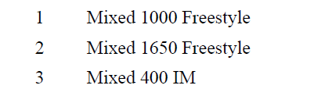

Saturday AM Session – 11 & Over Events

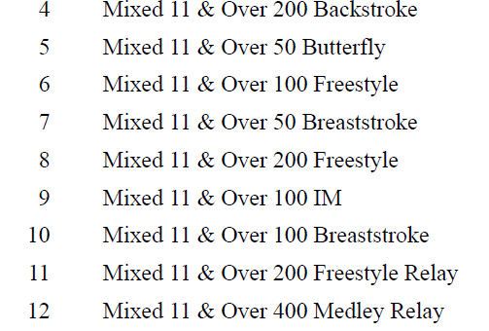

Saturday PM Session – 10 & Under Events

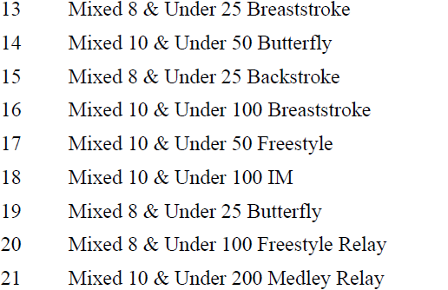

Sunday AM Session – 11 & Over Events

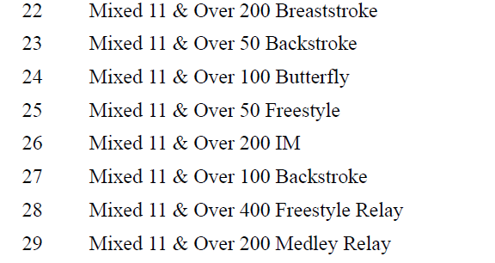

Sunday PM Session – 10 & Under Events

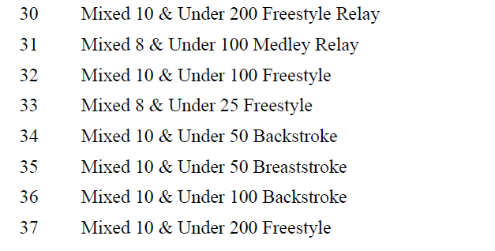

Fee Calculation Form – return with your entry

Club Name: Club Abbreviation:
Coach: Coach’s Cell Phone # ( )
Entries Chair: Phone # ( )

# |  | Amount |  | Number |  | Number
 | Total Swimmers x $2.75 NDLSC Fee =
 | $0.00 per swimmer for timer/pool rental
 | $1.00 per unattached swimmer (if applicable)
 | Total Individual Events x $1.50 = |  | # of boys |  | # of girls
 | Total Relay Events x $3.00 = |  | # of boys |  | # of girls
 |  |  | Total  Boys |  | Total  Girls
 | Total Due =

Make checks payable to:<Insert payment information>
All fees are due with your entry.

Entries & Summaries should be mailed to the following:
<insert name of person receiving entries>
<Insert address of person receiving entries>
<Insert phone # of people receiving entries>

Who should <host club name> contact if we have a problem with your entry?
PRINT CLEARLY and provide an e-mail contact you trust!

Name: E-Mail:
Day Phone # ( ) Evening Phone # ( )

ENTRIES DUE Electronic Entries draperkands98@msn.com Wednesday February 5th 2021

Paper Entries Will not be allowed
Late ENTRIES WILL BE CHARGED A $50.00 LATE FEE

