SPONSORSHIP
Greetings!

The Williston Sea Lions Swim Club(WSL) looks forward to partnering with you during our swim season.
We are a 501(C)(3) non-profit organization with more than 150 children involved in our competitive and pre-competitive programs. The Williston Sea Lions Swim Club has proudly represented the Williston Area and Williams County at the highest level of the sport of swimming since 1967. The Sea Lions are consistently recognized as one of the premiere swim teams in North Dakota.
Maintaining our high quality of swim programs while keeping fees affordable is an ongoing challenge. We ask for your help to keep these important programs alive and thriving. Your sponsorship will provide additional funds for our developing swim programs throughout the year while helping support our long term goal of maintaining WSL’s most passionate and professional coaching staff.
Our sponsorship program provides multiple marketing and advertisement opportunities for our supporters. For questions please contact Coach Cameron Elmer at willistonsealions@gmail.com or 504-421-1366.
THANK YOU FOR YOUR GENEROUS SUPPORT!
Sincerely,
Williston Sea Lions Swim Club Board and Staff

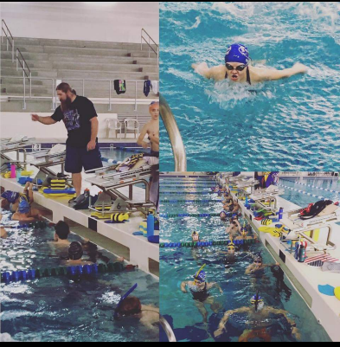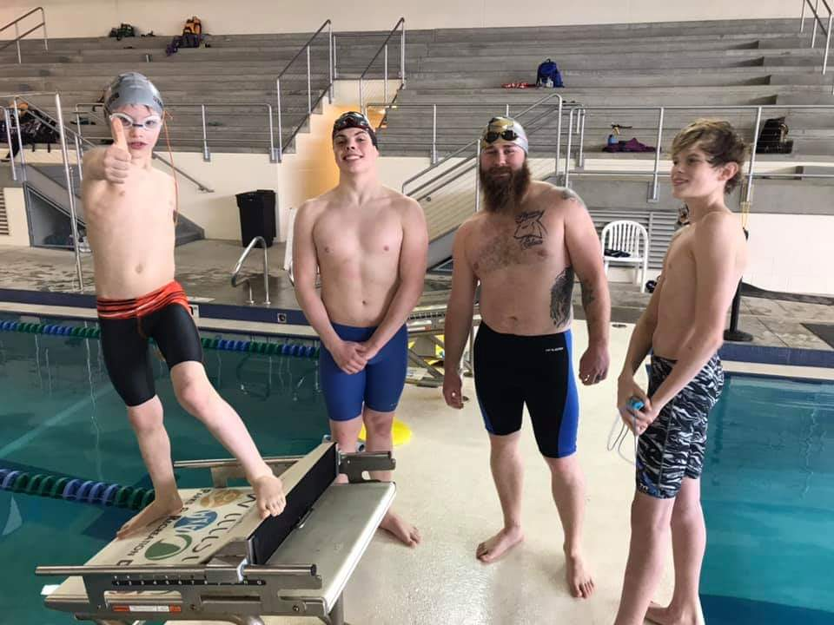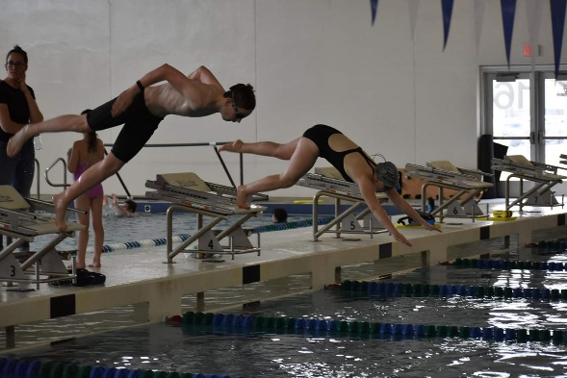

SPONSORSHIP LEVELS
WSL TEAM SPONSOR-$5000 DONATION
- Company Logo on Team Shirt for the Season (approx. 150-200 shirts)
- Joint banner with company logo and WSL logo printed and displayed at WSL Hosted swim meets at the ARC. (approx. 4 meets a year)
- Company logo on WSL homepage for short course or long course season (approx. 6months) as well as posted onto the Sea Lions facebook page
- Full page ad in the printed heat sheets at each WSL hosted swim meet
- Verbal sponsorship announcement at WSL hosted swim meets
WSL SWIM MEET SPONSOR-$2500 DONATION
- Joint banner with company logo and WSL logo printed and displayed at WSL hosted swim meets at the ARC.(approx. 4 meets a year)
- Company logo on WSL homepage for short course or long course season as well as posted on Sea lions facebook page
- Verbal sponsorship announcement at WSL hosted swim meets
- ½ page ad in the printed heat sheets at each WSL hosted swim meet
State Championship T-Shirt Sole Sponsor-$1800 Donation
- Only your company logo on short course or long course State Championship shirt for the season(approx. 150 shirts)
- Company name listed as the sponsor on the WSL website
State Championship T-Shirt Dual Sponsor-$900 Donation
- Your logo and a fellow sponsors on short course or long course State Championship shirt for the season(approx. 150 shirts)
- Shared sponsorship posted on the WSL website
State Championship T-Shirt Tri sponsor-$600 Donation
- Your logo and 2 other sponsors on short course or long course State Championship shirt for the season(approx. 150 shirts)
- Shared sponsorship posted on the WSL website
Lane Sponsorship-$500 Donation
- Company Logo hung on a starting block at a single WSL hosted swim meet of your choice. Can choose your lane # if it is available. There will be approx. 4 meets a year.
- Sponsorship announcement at WSL hosted swim meet
- Online posting for the meet event

Sponsorship Agreement
The following document is considered a contract arrangement between the Williston Sea Lions Swim Club and the Advertising/Business Client for sponsorship services.
Advertising Client(business name):________________________________________________________________
Contact Name:___________________________________________________________________________________
Business Mailing Address:________________________________________________________________________
City:_________________________________ State:___________________________ Zip:______________________
Contact Phone#:________________________________Email:____________________________________________
Check Sponsorship Opportunities
- _______WSL Team Sponsor-$5000
- _______WSL Meet Sponsor- $2500
- _______State Shirt Sole Sponsor- $1800
- _______State Shirt Dual Sponsor-$900
- _______State Shirt Tri Sponsor- $600
- _______Lane Sponsorship- $500

Copy Requirements- Return contract with check for appropriate amount(payable to WSL Swim Club).
- Email finished artwork, word file or pdf to willistonsealions@gmail.com
- High res black and white originals are preferred.
- WSL Swim Club will not accept offensive material nor promote alcoholic beverages or tobacco products
- Your company website to post link on ours

The IRS recognizes the Williston Sea Lions Swim Club as a 501(c)(3) tax-exempt non-profit organization. Williston Sea Lions Swim Club Tax ID #45-0432456. Your contribution is tax deductible. We gratefully acknowledge your charitable contribution.
Advertiser Signature:______________________________________________ Date:________________________
Print:____________________________________________________________________
WSL Club Chair Signature:__________________________________________Date:________________________
Print:________________________________________________________________
Please send all ad agreements with Payment to:
Williston Sea Lions Swim Club
PO Box 122 Williston, ND 58801

