Oklahoma Swimming Junior Athlete Representative Application

OKS Athlete Representative is a position on the Board of Directors for Oklahoma Swimming that requires you to be a representative and a leader for all registered athlete members of OKS and USA-Swimming. The position is a two year commitment where you will become the Senior Athlete Representative.

To apply for this position, you need to be a Junior in the Fall of 2018. Please submit applications to oksathleterep@gmail.com. The deadline is April 27.

After the application period closes, each club will get two votes.

Incomplete applications will not be considered.

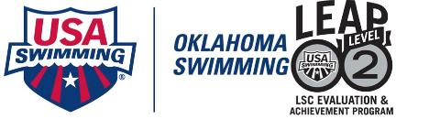
Requirements as an Oklahoma Swimming Athlete Representative:
- Attendance and participation at the USAS convention in mid-September (travel, registration, lodging, and a per diem are provided by OKS)
- Attendance and participation at the HOD and BOD meetings and workshops
- Participation in BOD conference calls
- Attendance at any LSC practice day or LSC-wide function
- Prompt responses to all emails sent out by the BOD
- Completion of the USA-S On Line LSC Leadership Class
- Completion of an annual Conflict of Interest Statement
- Attendance at Central Zone business, leadership, and training workshops
- Participation and planning for OKS Athlete Committee meetings

Name:___________________________________ Team:___________________________________
Age:______ Gender: F M
Email:___________________________________
Phone #:_________________________________
Years Swimming:__________________________
Reference #1:
Name:__________________________________
Email:__________________________________
Phone:__________________________________
Reference #2:
Name:__________________________________
Email:__________________________________
Phone:_________________________________
Experience on OKS athlete committee and/or other LSC committees:

Previous leadership experience and other qualifications:

Community involvement and extracurriculars:

Why do you want to be an Oklahoma Athlete Representative?

What are some ideas you will contribute to Oklahoma Swimming?

