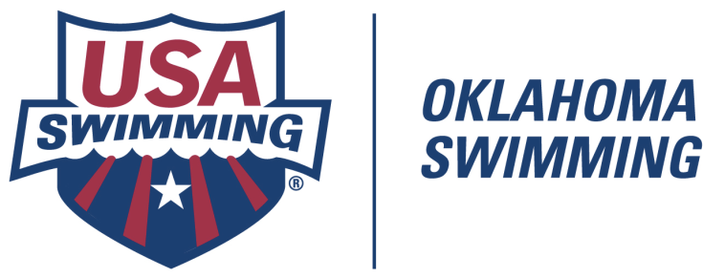

SCHOLAR-ATHLETE PROGRAM

1. Applicant must have completed 10th, 11th, or 12th grade.

2. Applicant must be 2016 OKS member of USA Swimming.

3. Applicant must have participated in an individual event in the summer 2015 Long Course OKS Age Group Championships and the 2016 OKS Short Course Age Group Championships or Region VIII Sectionals. Applicants also may qualify if they participated in two (2) regularly scheduled OKS sanctioned meets during the 2015 long course season and three (3) regularly scheduled CSI sanctioned meets during the 2015-2016 short course season.

4. For the entire 2015-2016 academic year, applicant must have achieved a minimum GPA of 3.5 on a 4.0 scale [A (90-100%) = 4.0; B (80-89%) = 3.0; C (70-79%) = 2.0; D (65-69%) = 1.0].

5. Only solid academic subjects (i.e., English, math, science, foreign language, social studies, performing and visual arts, home economics, industrial arts, etc.) shall be used to calculate the GPA. Subjects which would not normally be considered solid academic will not be considered in computing the GPA (including, but not limited to, physical education, religion, health, etc.).

6. Letter grades will be truncated to exclude “plus” and “minus” marks.

7. Courses clearly designated as “honors” or “AP” will receive additional weighting of 0.5 point in the GPA computation. If your school uses non-standard designations for these types of courses, please provide a copy of the School Profile. All schools maintain such a profile for submission with college applications.

8. Applicant must submit a transcript or report card for the entire 2015-2016 academic year.

9. The completed Oklahoma Swimming Scholar-Athlete Application must be received no later than Wednesday, August 10, 2016.

1. Certificate of recognition will be awarded to each individual achieving OKS Scholar-Athlete status.

2. A special award of recognition will be conferred on all swimmers who achieve OKS Scholar-Athlete status in all three (3) years.

Application
3. Interested athletes must submit an application, together with a transcript or report card, by August 10, 2016. The OKS Scholar-Athlete Committee will reject all applications not meeting the deadline. Applications may be submitted electronically (preferred) or by mail.

