Instructions for Creating a Login for Your Account in SWIMS 3.0
(These instructions are just for creating a login to your current account with USA Swimming. This process will not renew your registration for 2023. You will use a link sent from your club to renew your registration.)
Click https://hub.usaswimming.org/landing to create a new login for your USA Swimming account. This will provide access to information available in your current Deck Pass account.
- On the page that opens you’ll need to select Create a Login.
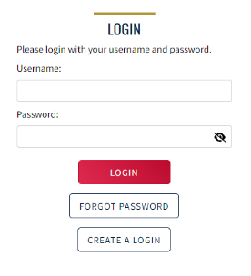
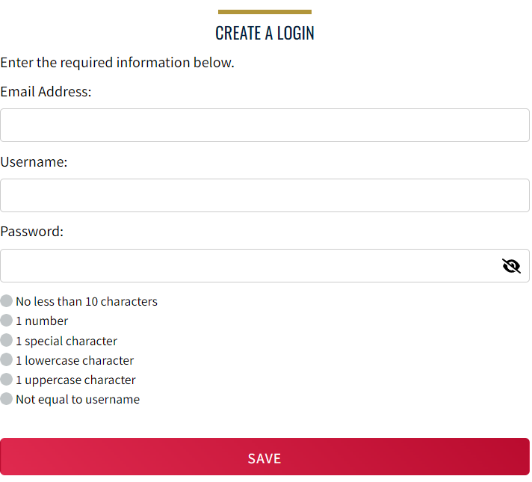
Please make sure to use a personal email address instead of a shared account since this will be linked to your individual membership or account. Shared or group email addresses such as office@abcde.com should not be used.

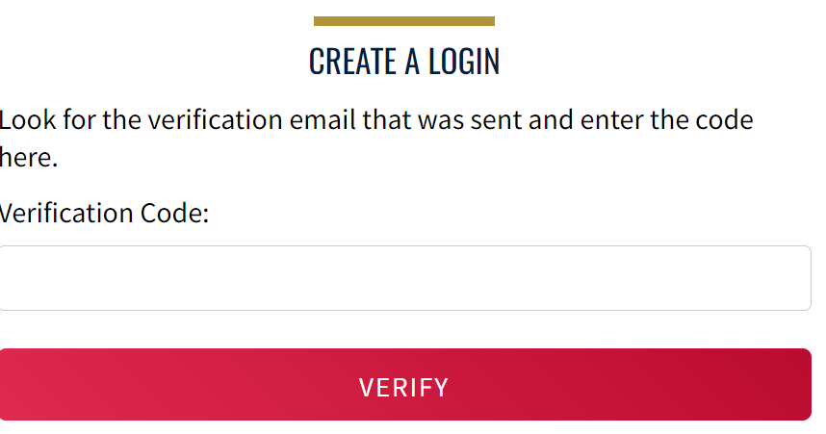
- You’ll receive an email with a verification code. Once the verification code is entered you’ll be you’ll be asked to log in using the username and password you just created. If you do not receive the email with the code, please check your spam. It should come from PingOne (noreply@pingidentity.com)

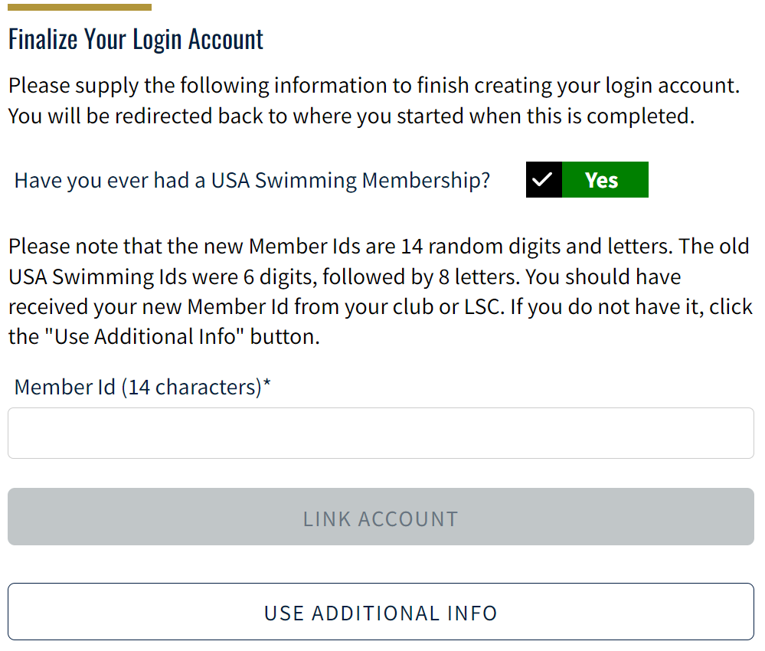
- Then you’ll be asked if you’ve ever been a member of USA Swimming in the past. If the answer is Yes (you’ll need to click on the icon for it to indicate Yes or No), select Use Additional Information unless you already have your new ID number. Be certain to enter your name as it is listed on your most recent membership card. If you’re unsure how you were registered in the past or your account is not found, STOP and contact registrar@ozarkswimming.com for help.
After you complete the requested information your new ID will be emailed to address shown in the form. Once received, copy and paste the Member ID in the appropriate field and click Link Account.
If you have never been a member of USA Swimming, click the icon to show No and complete the steps shown on the screen. You will automatically be logged into SWIMS 3.0.
That’s all there is to it! The username and password you entered in step 1 is the login for your new account.
Instructions for 2023 Registering with USA Swimming
(These instructions are for registering for 2023 with USA Swimming if you have already followed the previous instructions for creating a login for your account!
- Click on your club’s registration link. You need to get this link directly from your club. If you are registering as unattached, you need to email registrar@ozarkswimming.com to obtain the link.
You’ll see the following:
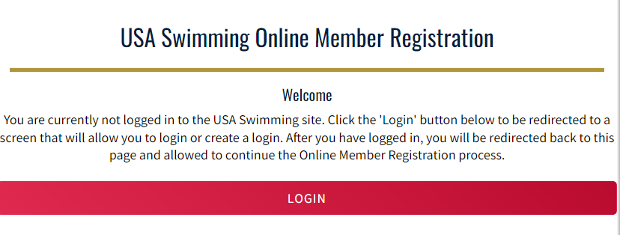

- Click on LOGIN, and log in to the account you previously created. You should see the following with your club listed.

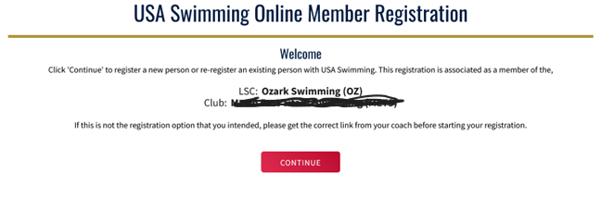

- Click Continue. At the end of the first registration that you create, you’ll see the option to Add Another Member before you check out. You will receive an email confirmation of the registrations that you have submitted.

- You will next be asked to select if the membership is for you or someone else. If you are registering for yourself, click yourself and complete all the steps. If you are registering for your child, click “The membership is for someone other than the logged-in user.”

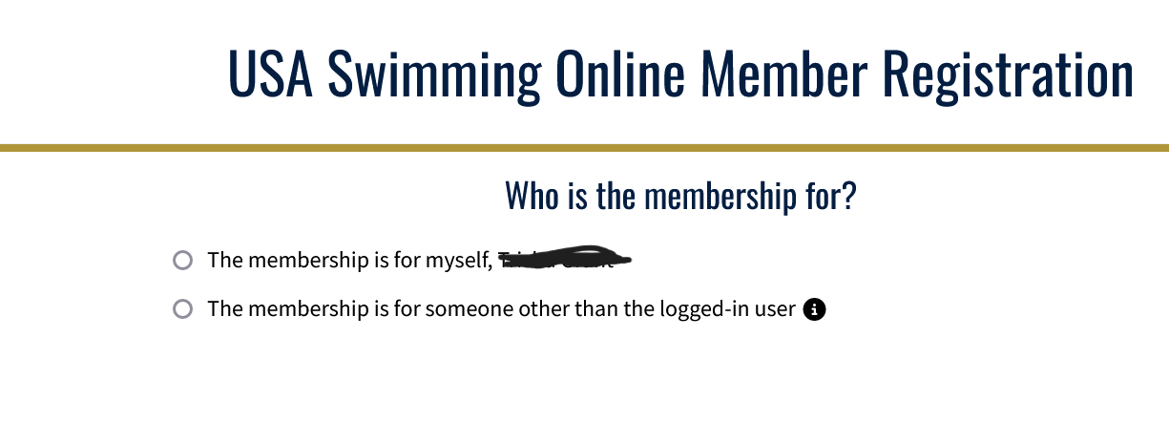

- If you are registering for someone else, you will be asked if the person has ever had a USA Swimming membership. If you are registering for a child that has never had a USA Membership, you would click the box to show “No” and then click “New Member” and follow the steps to completion.

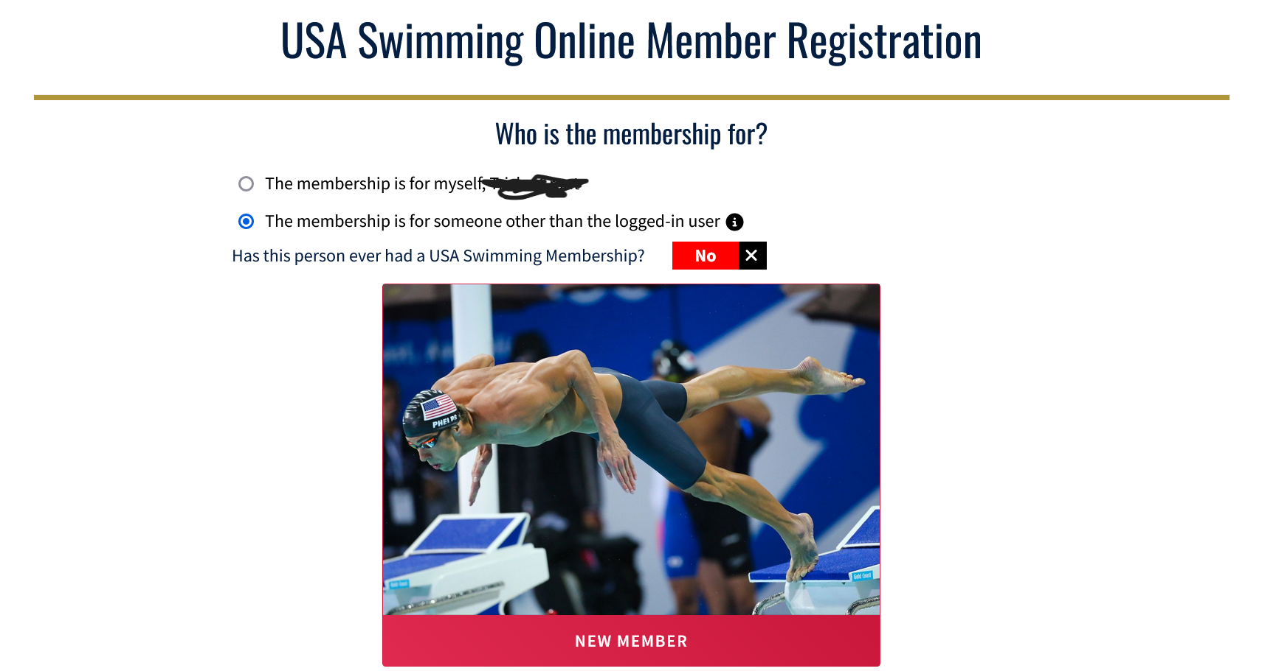

- If you are registering for yourself or for a child that has every been previously registered with USA Swimming, click the box to show “Yes” and then click “ Renew Member.”

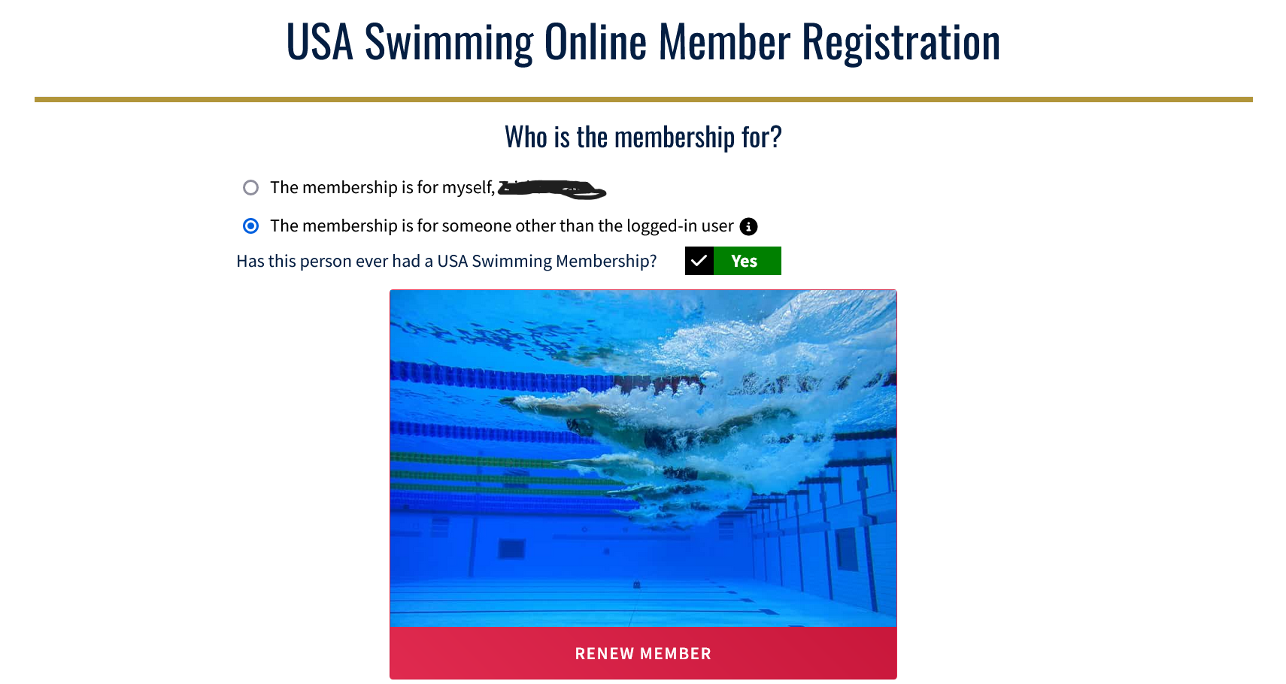

- Fill in the name and birth date of your child and click “Search for Member.”
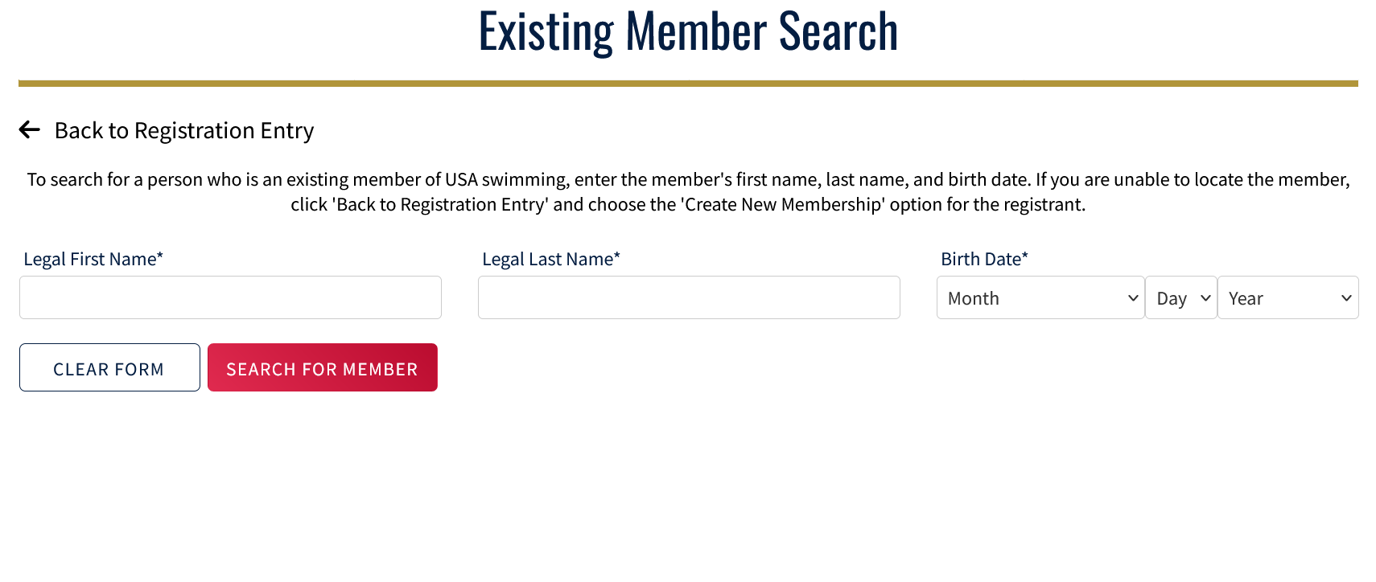
- When you see the result showing your child’s information, click on their name. It will be in blue. If no results were returned for your child’s name and birth date, STOP and please email registrar@ozarkswimming.com to verify your child’s info.
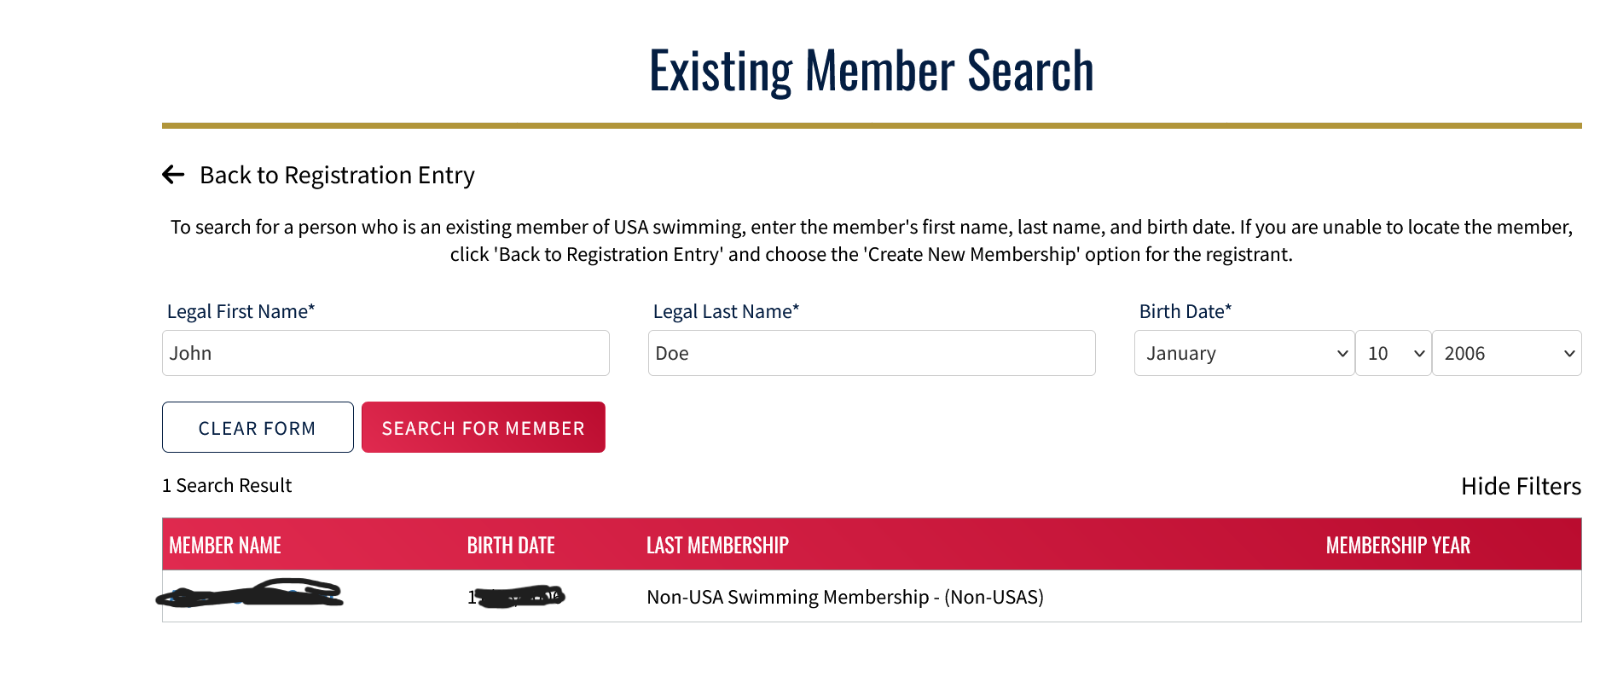

- Complete the steps to complete registration and payment or at the end of the first registration, click “Add a New Member” to complete registration for another member. 