Instructions for 2023 Registering with USA Swimming
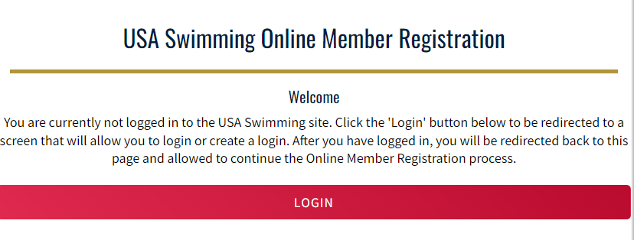
Click on the link provided by your club for registering with USA Swimming. You’ll see the following:

Click on LOGIN.
If you already have created an account with USA Swimming, log in to that account and proceed through the process to register yourself or your children or both! At the end of the first registration that you create, you’ll see the option to Add Another Member before you check out. You will receive an email confirmation of the registrations that you have submitted
If you have not created an account with USA Swimming you can do so from the login screen.
- Select Create a Login.
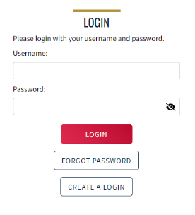
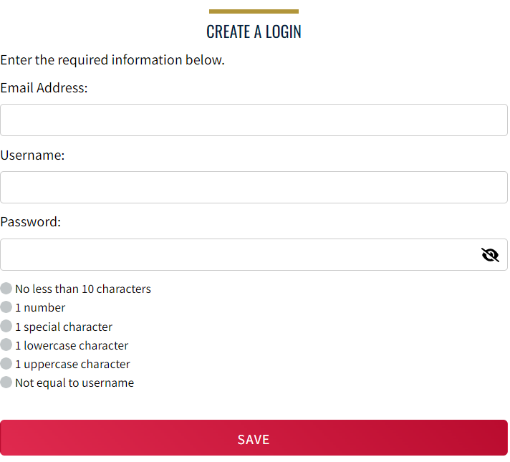
Please make sure to use a personal email address instead of a shared account since this will be linked to your individual membership or account. Shared or group email addresses such as office@abcde.com should not be used.

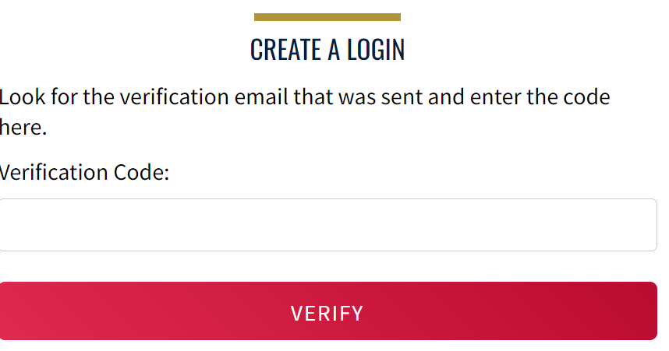
- You’ll receive an email with a verification code. Once the verification code is entered you’ll be you’ll be asked to log in using the username and password you just created.

- Then you’ll be asked to select if the membership is for you or someone else. Select the appropriate answer and complete the remaining steps to register yourself and/or other family members. At the end of the first registration that you create, you’ll see the option to Add Another Member before you check out. You will receive an email confirmation of the registrations that you have submitted.
That’s all there is to it! The username and password you entered in step 1 is the login for your new account.

