Instructions for 2023 Registering with USA Swimming for Non-USA Swimming Parents Registering for their Child(ren)
Please Note: These instructions are for those parents who have never been USA Swimming members themselves and are registering their child(ren)!
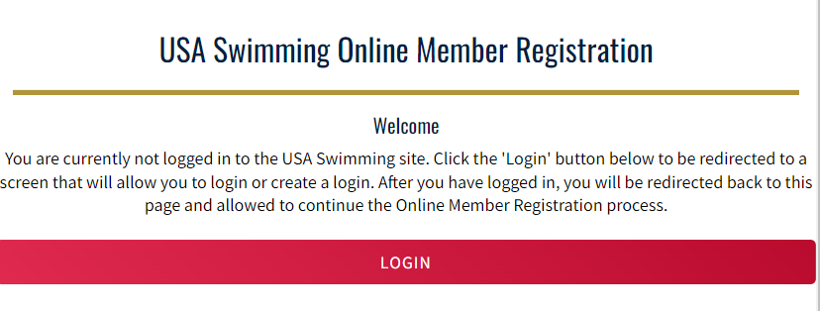
Click on the link provided by your club for registering with USA Swimming. You’ll see the following:

Click on LOGIN.
If you already have created an account with USA Swimming, log in to that account and proceed through the process to register yourself or your children or both! At the end of the first registration that you create, you’ll see the option to Add Another Member before you check out. You will receive an email confirmation of the registrations that you have submitted
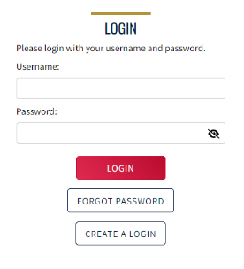
If you have not created an account with USA Swimming you can do so from the login screen.
- Select Create a Login.
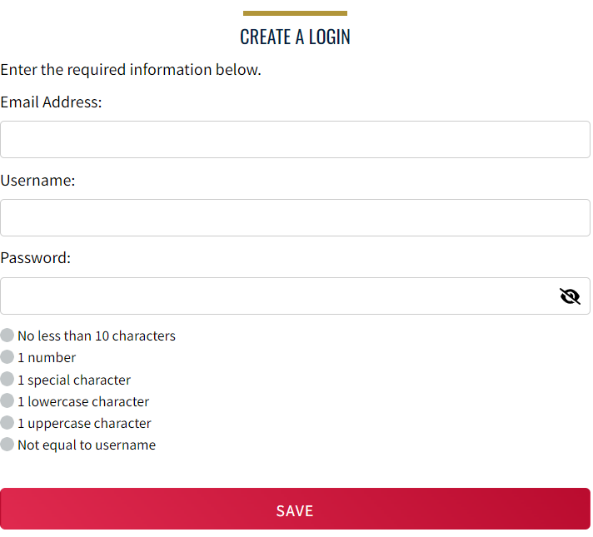
Please make sure to use a personal email address instead of a shared account since this will be linked to your individual membership or account. Shared or group email addresses such as office@abcde.com should not be used.

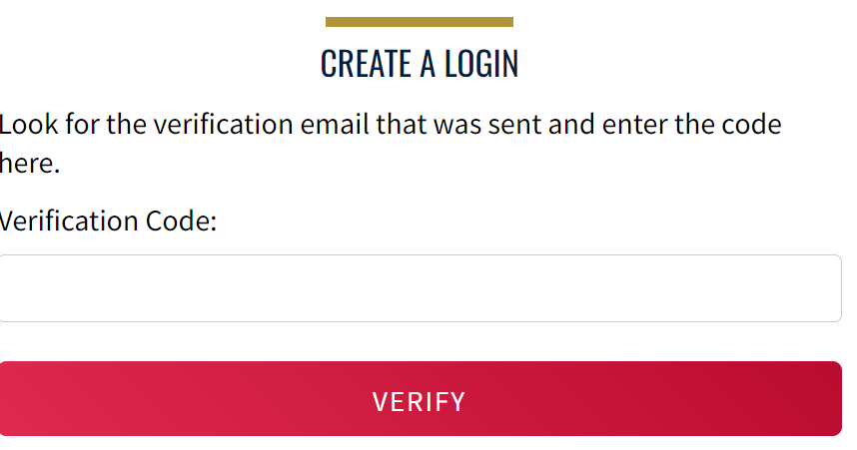
- You’ll receive an email with a verification code. Once the verification code is entered you’ll be you’ll be asked to log in using the username and password you just created. If you do not receive the verification code, please check your spam folder. The email should come from PingOne (noreplay@pingidentity.com)

- Then you’ll be asked to select if the membership is for you or someone else. Select “The membership is for someone other than the logged-in user.”
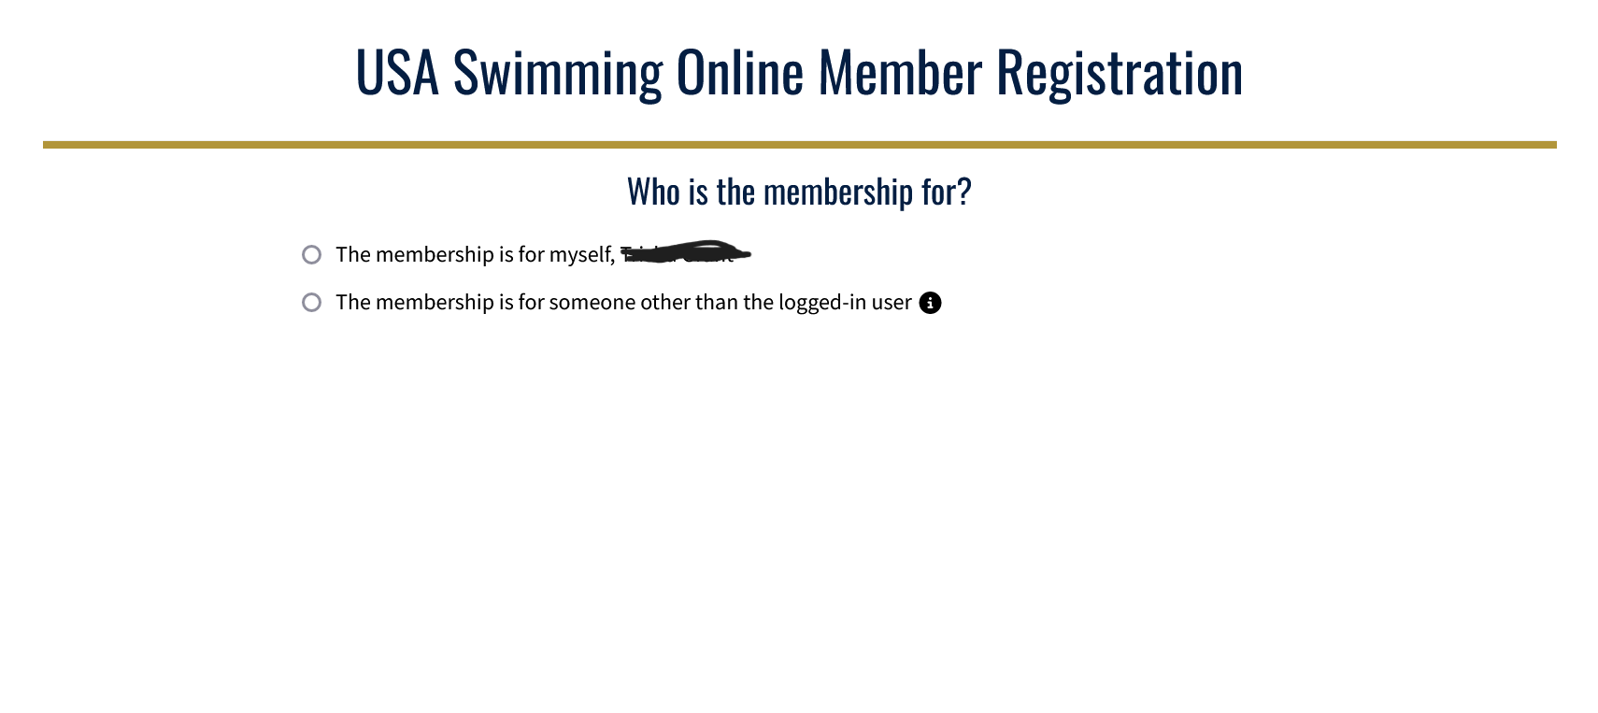
- You will be asked if the person has ever had a USA Swimming membership. Answer this question for your child you are registering for. If they have not, continue through the following steps, without clicking yes on this box.

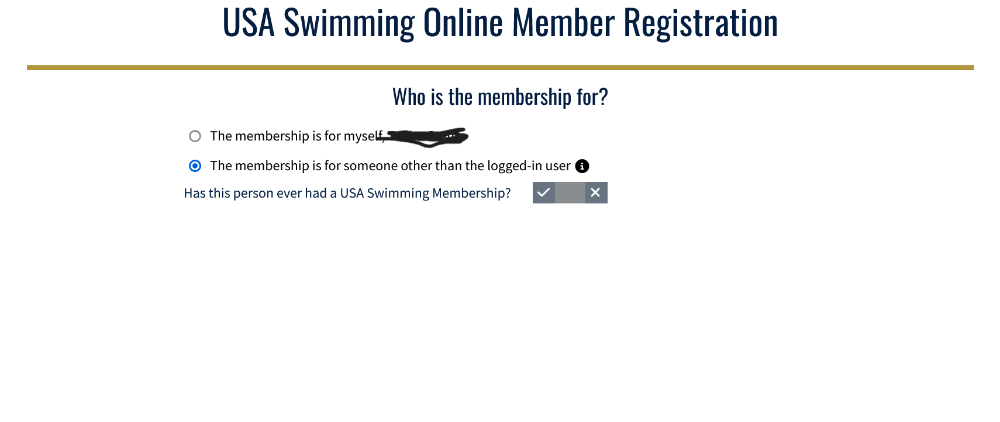5. If your child who you are registering has had a USA Swimming membership previously, click the box to show yes. Then click on Renew Member
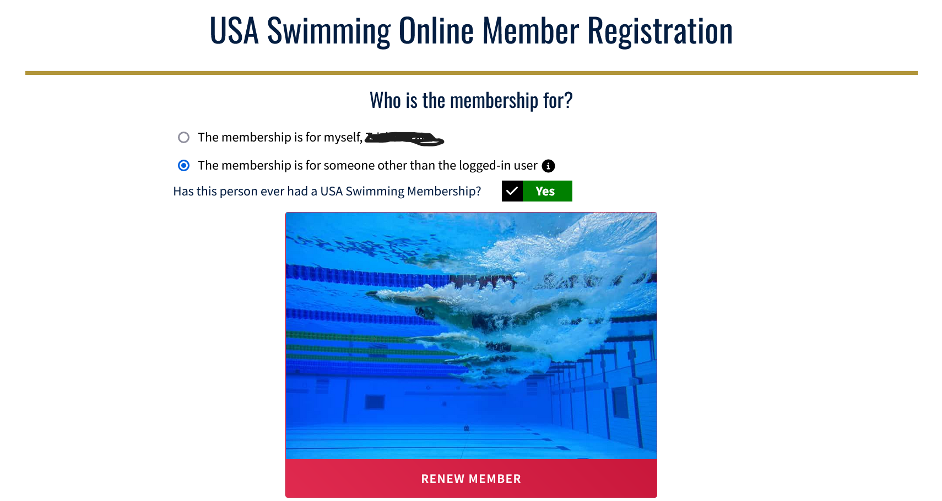
- Fill in the name and birth date of your child and click “Search for Member.”
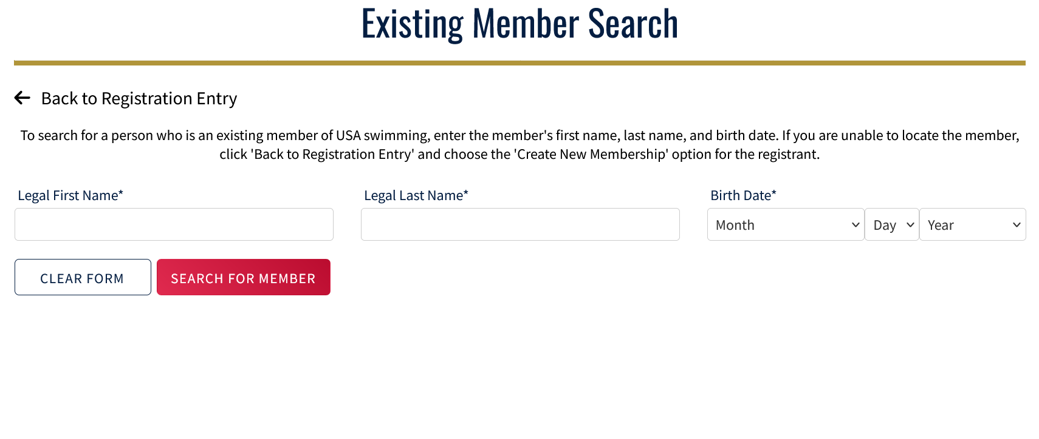
- When you see the result showing your child’s information, click on their name. It will be in blue. If no results were returned for your child’s name and birth date, STOP and please email registrar@ozarkswimming.com to verify your child’s info.
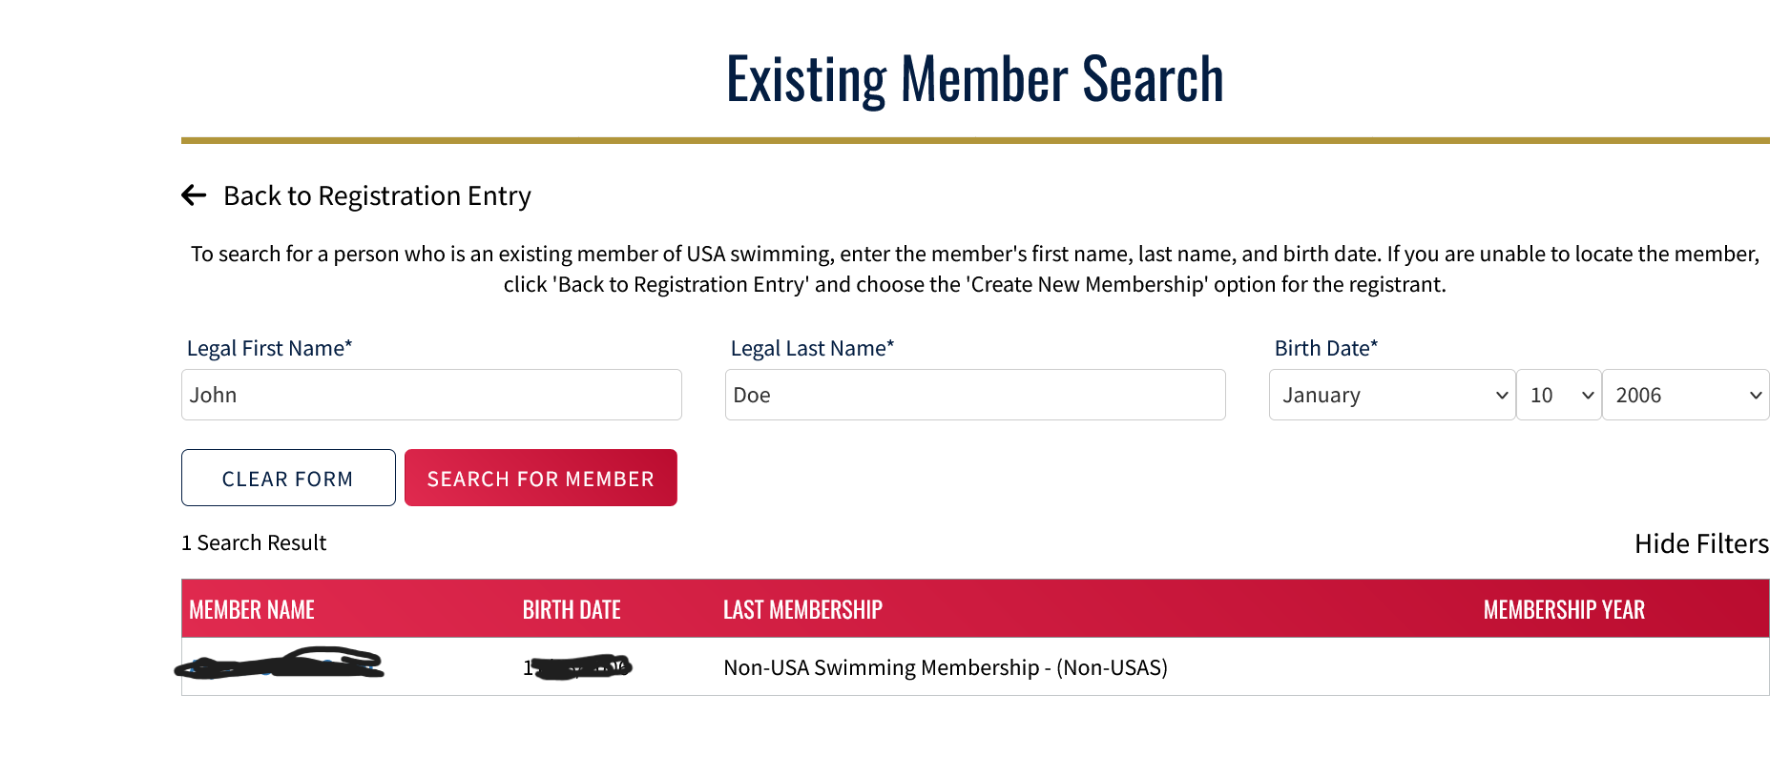

- Complete the steps to complete registration and payment for your child.
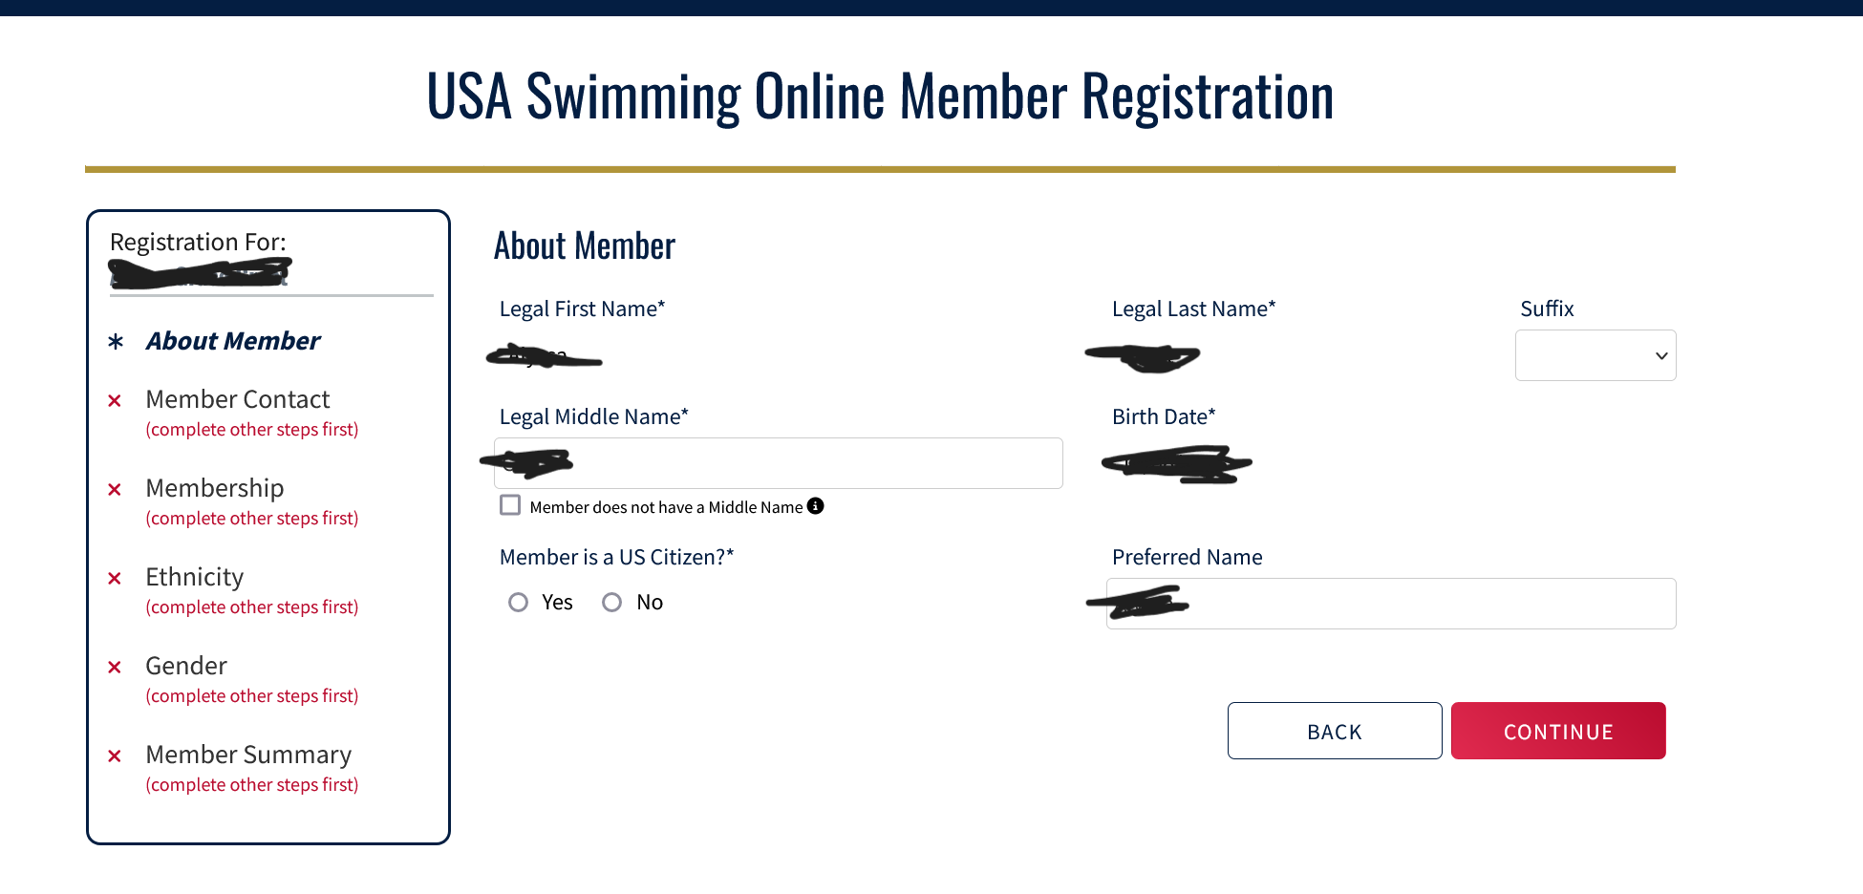

- At the end of the first registration that you create, you’ll see the option to Add Another Member before you check out. You will receive an email confirmation of the registrations that you have submitted.
That’s all there is to it! The username and password you entered in step 1 is the login for your new account.

