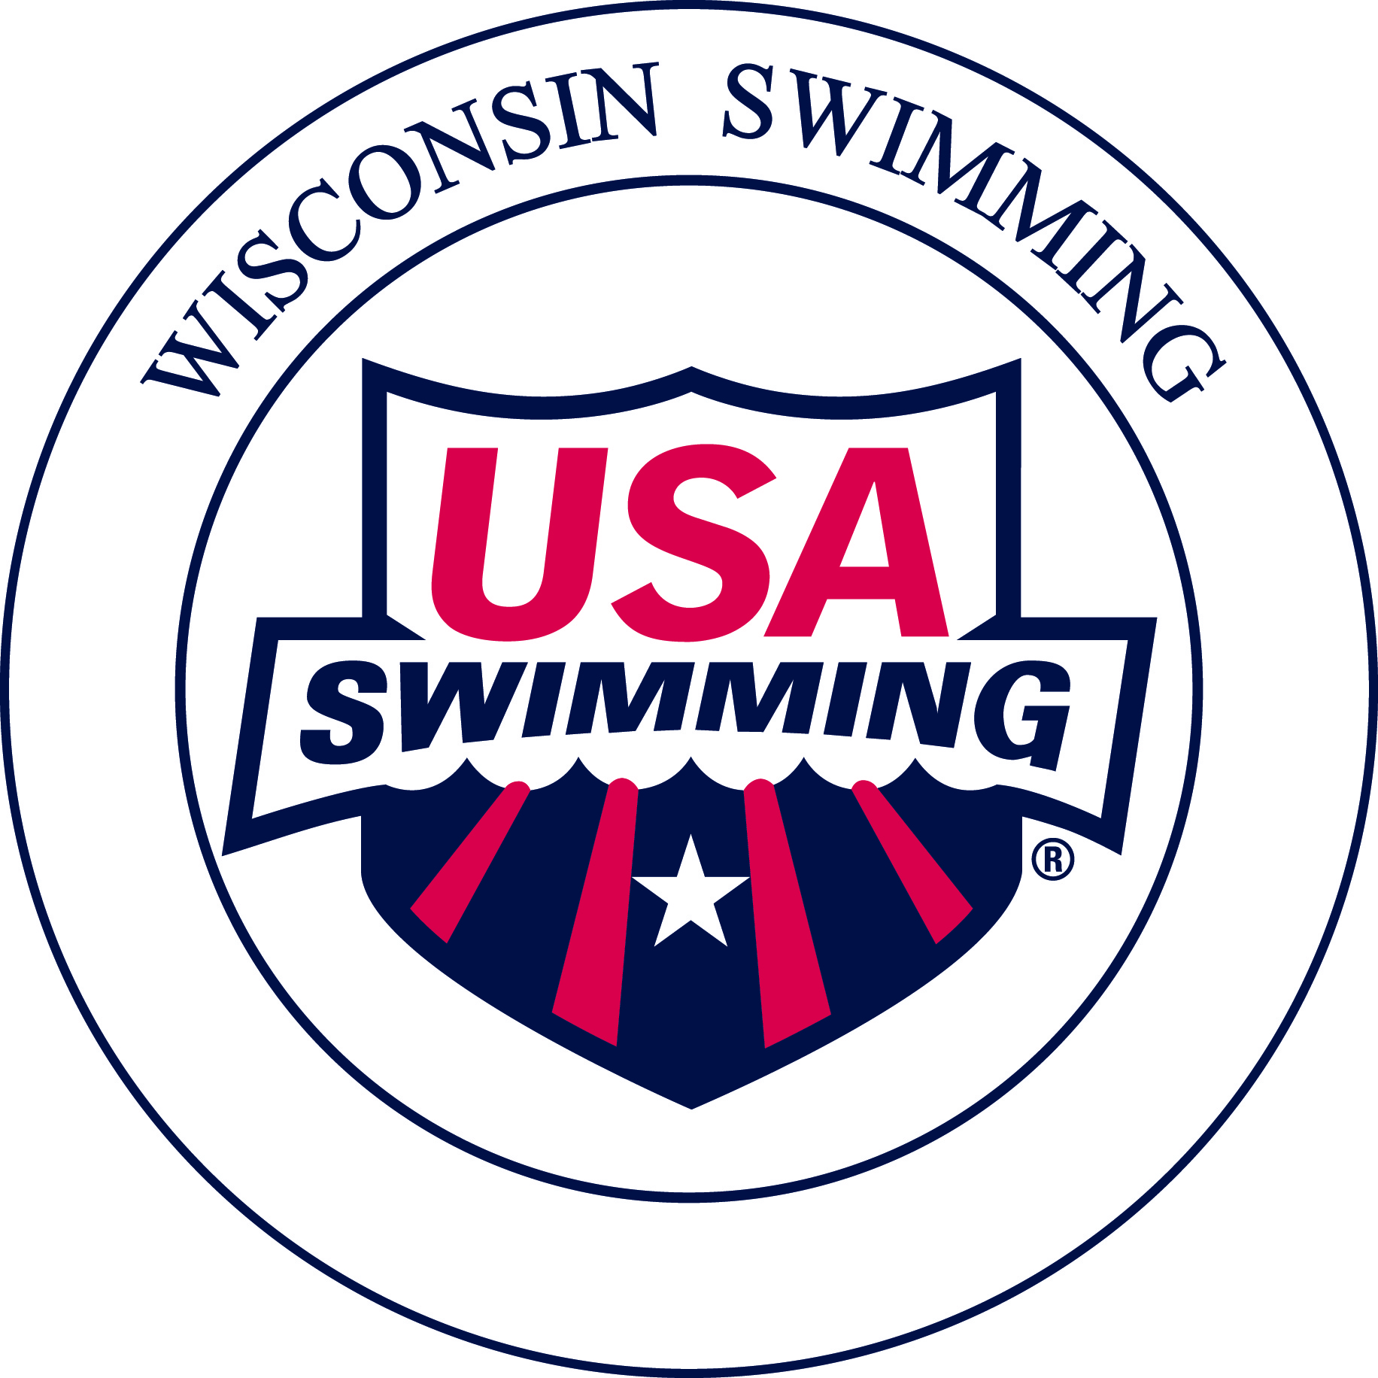
Becoming a USA Swimming Certified
Stroke & Turn Judge Official

Benefits of Becoming an Official
- Support an excellent sport for children and promote a healthy lifestyle for children.
- Gain a more thorough understanding of competitive swimming.
- Fulfill volunteer obligations at Club meets.
- Get closer to the action; know what’s happening on deck with the “best seat” at the pool.
- Get mentally and physically engaged during the meet rather than merely “spectating.”
- Be cooler on deck than in the stands.
- Receive free admission and great hospitality during sessions officiated.

Requirements for Stroke and Turn Judge Certification
1. Take a Training Clinic
- Attend a “New Officials Training Clinic - Stroke and Turn Judge.” The Wisconsin Swimming Officials Committee conducts Clinics periodically in various locations
- Clinic announcements are located on the Wisconsin Swimming website.
- The Clinic consists of:
- 3-4 hour education session
- Discussions of rules, strokes, turns and relay exchanges.
- Review of the USA Swimming-produced Officials Training videos.
- Club sponsored Clinic: If a Club has volunteers interested in becoming Officials, a clinic can be arranged at the Club’s preferred location.
- To request an Officials Clinic, please use the online request form found on the Officials Page of the Wisconsin Swimming Website: HERE
NOTE: The Wisconsin Swimming Officials’ Committee provides a trainer and training materials.

- Complete the USA Swimming Registration
Apprentice officials have 60 days from the start of their training before they are required to join as non-athlete members of USA Swimming and complete all membership requirements in order to continue being on deck.
- Non-current Non-Athlete Members of USA Swimming who are apprenticing to become certified Stroke and Turn Judges or Administrative Officials prior to bringing all required membership requirements current or re-joining as Non Athlete (Official) Members, must submit a USA Swimming Apprentice Official Application. There is no cost for this.
Prior to certification, complete the current year USA Swimming Non-Athlete Registration (form provided at the clinic or located on the Wisconsin Swimming website) and submit it along with the fee to the Registration Chair, Angela Monty (1907 Cedarhurst Dr. New London, WI 54961-2297)
- Some clubs will reimburse this fee for their officials, typically upon certification.
- Complete the online Officials Release of Information found: HERE

- USA Swimming Athlete Protection Policy
- Legislation passed at the September, 2010, Aquatic Sports Convention
- All Non-Athlete USA Swimming members, including Officials, must complete the following:
- USA Swimming Level 2 Criminal Background Check (regardless of any previous criminal background check you may have completed). There is a $39 fee, which can be reimbursed at the completion of all training requirements by Wisconsin Swimming.
- USA Swimming online Athlete Protection Training module.
- The Level 2 Criminal Background Check must be passed prior to becoming a Non-Athlete USA Swimming member.

4. Take the USA Swimming Test: Complete USA Swimming’s on-line, open book test, “Stroke and Turn/Timer” certification test. This test must be successfully completed prior to the 2nd on-deck apprentice training session.

5. Fulfill On-Deck Apprentice Session Requirements
- Complete a minimum of four sessions as an apprentice, at two or more meets, under the supervision of USA Swimming Certified Officials.
- Contact the Meet Referee or Meet Director prior to the Meet for permission to attend as an Apprentice and to ensure one-on-one mentoring.
- Attend the Pre-Meet Officials Briefing, 45-60 minutes prior to the start of the meet session (or at the time determined by the Meet Referee).

6. Other Requirements
- Minimum age of 18 years
- Attire: Solid navy blue skirt, shorts or pants, white collared polo shirt and white athletic shoes/socks
- Attitude: Positive attitude, willingness to volunteer, and dedication

7. Certification
- Achieved after becoming a USA Swimming Non-Athlete Member (including completion of Criminal Background Check & USA Swimming online Athlete Protection Training module), Training Clinic, USA Swimming on-line test, and the Apprentice sessions.
- Submit a scanned or photo copy of the completed and signed apprentice card via email to: Michael Harbert, Officials Committee Chair, aquaymca@yahoo.com.
- Wisconsin LSC Certified officials will use their current year USA Swimming Membership Cards as their primary credentials to verify they may be permitted on deck for USA Swimming Sanctioned, Approved, or Observed meets or events.
- Wisconsin LSC officials will use a copy of their OTS generated USA Swimming Official Certification Card as their USA Swimming Membership Card which also includes verification of their LSC and National official certification levels needed for serving in assigned positions. These Official Certification Cards also show the expiration dates of the official’s USA Swimming registration, Criminal Background Check, and Athlete Protection Training.

After Certification as Stroke and Turn Judge
- On Deck
- Attend the Pre-Meet Officials Briefing, usually starting 45-60 minutes prior to the beginning of each meet session or at the discretion of the Meet Referee
- Accept deck assignment from the Meet Referee or his/her designee
- Encouraged to volunteer at any meet attended

- Maintenance of Certification
- Recertification required every even numbered year
- Attend a Wisconsin Swimming Recertification Clinic, take the USA Swimming on-line Recertification Test or participate in other alternatives provided by the Wisconsin Swimming Officials Committee
- Must officiate a minimum of four sessions, at two or more different meets each year
- Must complete the Criminal Background Check and the online Athlete Protection Training module every 2 years.

- Advancement
  - Starter/Referee: After serving 10 months as a certified Stroke and Turn Judge and having completed ten sessions as a Stroke and Turn Judge, officials may begin the process of advancement to USA Swimming certification at the Starter/Referee level. Wisconsin Swimming requires dual certification as a Starter/Referee, and independent certification as a Starter or Referee is not accepted.
  - Please see the document “Becoming a Certified Starter/Referee” located on the Wisconsin Swimming website.

- National Certification
  - N1-LSC Certification: May officiate at any LSC level meet in any USA Swimming LSC
  - N2- National Certification: recognizes that an official is experienced and has been evaluated as capable of working the position at Sectional, Zone, Grand Prix and similar higher profile meets
  - N3- National Championship Certification: recognizes that an official has the experience, skills, and knowledge to be considered for selection to work National Championship level meets in the position certified.
  - For the N2 and N3 Certifications, the positions of Stroke and Turn Judge, Starter, and Deck Referee, as well as Chief Judge, Administrative Referee, and Meet Referee are available

2018 Fees
- New Officials Training Clinic Fee: Usually $25.
- USA Swimming Criminal Background Check Fee: $39.
  - This is reimbursed by Wisconsin Swimming.
  - For reimbursement, print a copy of the second page of the Criminal Background Check and submit to the LSC Treasurer Pat Lewno (5330 Linden, Racine, WI 53406) after completing all the training requirements.
- USA Swimming Annual Non-Athlete Member Registration:
  - 2018: $66
  - Registration after September 1 is valid through December of the following year. Membership includes:
    - USA Swimming insurance
    - USA Swimming Rule Book
- Clubs may reimburse participants for their Training Clinic fee, annual USA Swimming registration fee, and/or Recertification Clinic fee.
- Exception: If a person already is a member of USA Swimming as an athlete, coach, Club Safety Coordinator, Board President, or other Board position, the registration fee paid for any of these positions also applies to becoming an Official.

For More Information:
Please contact:
- Michael Harbert, Chair, Wisconsin Swimming Officials’ Committee (mailto:aquaymca@yahoo.com)

