Checklist of Responsibilities and Information for Stroke & Turn Judges as Observers

Checklist of Responsibilities and Information for Stroke & Turn Judges

Thank you for being a USA Swimming observer. Please note the following:

- Please adhere to all facility or jurisdictional policies related to COVID-19 safety, including wearing of masks, and social distancing as much as possible.
- As an observing official, you should wear your “normal” Wisconsin Swimming official attire of blue pants/shorts/skirt, white polo shirt, white socks, white shoes, and name badge.
- In some cases, you may be asked to bring a USB memory stick with you to get an electronic copy of the HyTek Meet Manager backup file from the host meet manager at the end of the meet. However, we normally can get those from the WIAA directly.
- Two or more certified USA Swimming Stroke & Turn Judges are assigned to your meet. Please work out with the other observer which end of the pool you will observe.
- Position yourself at a stationary location on the opposite side and end of the other observing official, so that both ends and side of the course can be observed.
- Sometimes one or both observers will also be WIAA assigned meet officials. In that case be sure to coordinate with that official on where best to be positioned, based upon their WIAA assignment. Regardless, in no case shall you walk as a stroke official, even if your fellow observing WIAA official is doing so.
- You are only observing where the USA Swimming technical rules differ from the rules of the organization running the meet. All other violations are handled by the organization’s officials. See the attached chart for details.
- Please refer to the “Observed Swim Observation Report” document that the Stroke & Turn Judges observing the meet must complete and submit after the meet. This report must include a list of Association officials that shall consist at a minimum of a referee, starter, and two stroke & turn officials (4 officials).
- Immediately after the meet please complete and send this report, and a copy of the Hytek Meet Manager backup file to Jeanne Drzewiecki (sanctioncoordinator@wisconsinswimming.org). The two observers may share a single report.

Observed Swim Certification Report

Date of Event:
Event Name:
Location:
Course (Circle Two) Short Long Yards Meters

Officials Info USA-Swimming Officials

Referee
Starter(s)
Stroke & Turn Judges (2 minimum)

(Print) Yes No

(Print) Yes No

(Print) Yes No

(Print) Yes No

(Print) Yes No

(Print) Yes No

(Print) Yes No

Officials Assigned to
Observe
(Please Print)

(Please Print)

Timing System Requirements:
Electronic Timing must be used in accordance with conditions outlined in 102.24, USA Swimming
Rules & Regulations. (Describe both Primary(P) and Backup(B) system )
Pads: | Yes | No
Buttons: | (P) (B) | (1) (2) (3)
Watches: | (P) (B) | (1) (2) (3)

Recommendation of Observers:

Did the conduct of the observations conform to all conditions
outlined in USA-S rule 103.14.1 & .2. and 102.24
Yes No

The above competition and all swims, unless otherwise noted on the attached sheets, have met all the conditions outlined in Article 202.8 Requirements for Observed Swims and Article 101
Individual Strokes & Relays, USA Swimming Rules & Regulations and approval is recommended.

Observer Signature:

Observer Signature:

The above competition and swims did not meet all the conditions outlined in Article 202.7
Requirements for Observed Swims and Article 101 Individual Strokes & Relays, USA Swimming Rules & Regulations and approval is not recommended. (Please list on back of this form specific reason for not recommending for approval)

Observer Signature:

Observer Signature:
Please email completed form to: LSC NTV Official, Jeanne Drzewiecki: sanctioncoordinator@wisconsinswimming.org

Observed Infractions of Rules
Unique to USA Swimming

Meet:
Location:
Date:
Official Name:
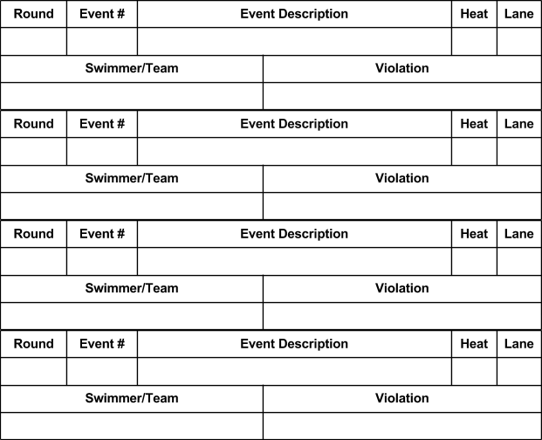

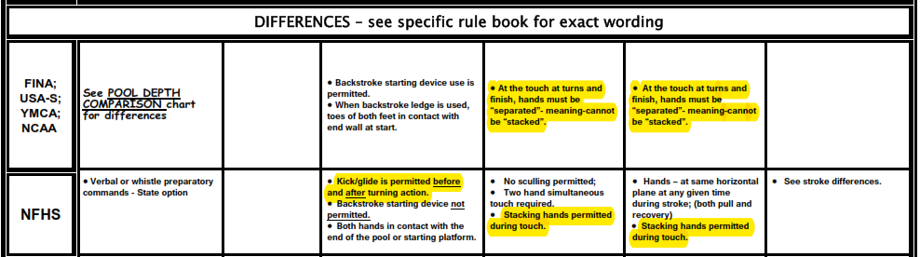

Other rule differences: NFHS rules permit taping to treat a documented medical condition, provided signed documentation from an appropriate health-care professional has been produced. Taping is generally not allowed under USA Swimming rules regardless of medical need, and use of Kiniseo tape is never permitted.

