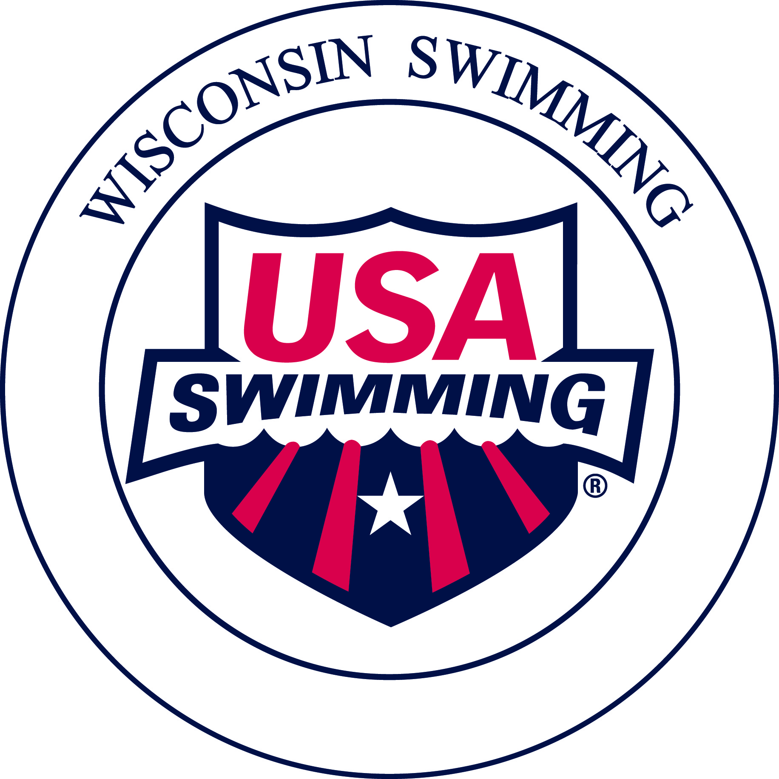

Protocols for USA Swimming Observers

As we are invited by the WIAA and/or NCAA to be on deck as observers for USA Swimming we must maintain our professionalism on deck.

The following points are intended as guidelines for observing swims at WIAA and NCAA season ending meets for our Wisconsin, USA Swimming registered athletes:

- Uniform is white officials shirt, blue pants/shorts/skirt, white socks and white shoes. Please wear your name badge and have your credentials (card) visible.
- Have a clipboard available with the Observed Swim Certification Report (OSCR) form/instruction sheets.
- Have some current USA Swimming Disqualification (DQ) report forms.
- The WIAA and/or NCAA Meet Referee and Meet Management will already know who will be representing Wisconsin Swimming, Inc. on deck as an observer. Please report to the Meet Referee, introduce yourself and show your credentials.
- Leave recording devices, cameras, pagers and cell phones with your personal belongings. If you have need of a pager or cell phone due to a professional requirement of being “on-call” please set on vibrate.
- A room for storage of coats and valuables, as well as breaks, will be provided by the host institution.
- WIAA and/or NCAA officials will be the assigned administrators of these championship competitions and the Meet Referee will meet with you so please follow the verbal instructions.
- You will be given a heat/psych sheet, if not, ask for one.
- Bring a USB memory stick with you to use in getting a complete final result package from the administrative table at the conclusion of the meet.
- At the end of the meet please thank the WIAA and/or NCAA staff for allowing your presence on deck.
- Sign the OSCR form.
- Send the OSCR form, final results and any DQ report form to Sara Landolt, LSC Records Coordinator,
  - Scan and email: sklandolt@yahoo.com
  - Please make certain scanned documents have sufficient resolution to be legible.
- Email a final unlocked Meet Manager backup file to: sklandolt@yahoo.com

Thank you for volunteering to do this important role for our athletes.

