GENERAL SYNOPSIS (The Big Picture in 3-4 sentences):
Teams are working to be more creative to keep swimmers active, invested, and improving in swimming for the long-term. Dynamo in ATL uses a massive pre-team system to feed into the competitive team while the Northern KY Clippers revamped their program to address dwindling numbers and low retention rates.
POSSIBLE MAIN POINTS OR TAKEAWAYS FOR…
LSC Board/Committee Members  Suggestions by Dynamo of “pre-team” swimmers could have negative impact to registration numbers/income. The Flex Membership model is attempting to address that, but that’s much less beneficial for clubs. | Teams in Wisconsin  Teams struggling with kids falling out of their program should look at 1) other options with less commitment early on 2) maintaining honest expectations with swimmers and parents at a young age and 3) adapting to changes in values among families
Coaches  In many cases, coaching a booming age group program can lead to having a burnt out senior program. Coaching with patience and a goal of long-term growth will go a long way in keeping kids invested in the sport & improving as senior swimmers. | Officials  None
Athletes  None | LSC Others

Additional Notes:

Atlanta has a massive summer league of almost 20K swimmers. Because of that, there’s an abundance of swimmers coming from the not-so-serious into the very focused Dynamo program. To bridge the gap, the Dynamo Junior program was put in place. Approximately 300 swimmers have two days of practice a week and zero competition. They’re not USA registered (separate insurance) and must commit to the age group program before going to competition (think of it as a try-before-you-buy situation). The arrangement requires enough pool space to keep them separate from the competitive team for insurance reasons.

After initial success, the Northern KY Clippers faced dropping numbers and bad retention rates a few years ago. Big red flags came from numbers that indicated 13-over athlete numbers surpassed 12-under numbers in 2014.

Groups
Groups were re-structured, to give clear expectations to swimmers & parents.
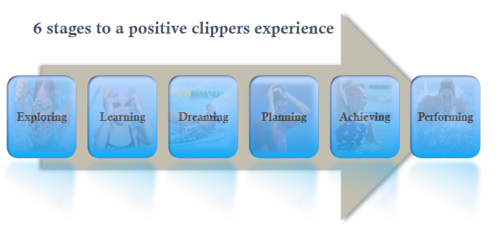
(More details about each are in the posted PDF)

Practice Group Assignments
In addition to “short course” and “long course” registration, there are smaller registrations for Winter, Spring, and Summer (much like the Wisconsin model) to make trying out the team more financial feasible. In addition, there are combo registrations (Session 1 & 2), (Session 2 & 3). The performing group requires year-long registration.

