Observed Swims at High School Meets

Overview
USA Swimming rules provide a means for results at swimming competitions not sanctioned by USA Swimming (i.e. high school, college) to be submitted for entry into the SWIMS database. These are termed “observed swims” because the rules specify that certified USA Swimming officials must be in attendance to verify compliance of the swims with that part of the USA Swimming rule that differs from the organization’s rule. While other swimming organizations such as high school and college have very similar rules there are a few differences. Observers ensure that where there are differences, a swim confirms to USA Swimming rules. If it does, then it is eligible for submission into SWIM.

The following conditions must be met for a meet to be observed.
- The meet must be a season-culminating Championship ( e.g., Conference, Sectional, State) or be specifically approved by the USA Swimming Program Operations Vice President or designee.
- An application for observation must be received at least 10 days before the meet.
- At least two USA Swimming observers, who shall be certified Stroke & Turn Judges assigned or approved by the LSC, must be present, one at each end of the course, to verify compliance of the swim or swims with that part of the USA Swimming rule that differs from the organization’s rule.

How does this affect members of Wisconsin Swimming?

Observed Championships
Having "observed" high school championship results in the USA Swimming SWIMS database simplifies the entry process for your club coach. Thus, the club coach should initiate any request for observation of a season-ending championship by submitting Form B (LSC Request for Observation) to the WI Swimming Times Coordinator, Julia Krueger. If a parent wishes to have their child’s meet to be observer they should work through their club coach.

Ideally, the club coach should collaborate with the high school coaches to have the USA Swimming member ID’s set-up in the high school team’s database. When the import of high school times occurs the swims will automatically tag to the member in the USA Swimming SWIMS database.

It is also recommended that the club coach complete Form C-2 (Request to Load Times) to organize their athlete ID information for email communication to the high school coach and to the WI Swimming Times Coordinator. The WI Swimming Times Coordinator will also see that Form C-2 is used for the high school state championship meet.

Non-Observed Season-Ending Meets

Currently, printable or viewable results from a season-ending high school swim meet are accepted as proof of entry time for Wisconsin Swimming state championships. However, they are not accepted for advanced level USA Swimming meets such as Zones, Sectionals, Grand Prix, Junior Nationals, and Nationals unless the meet was observed and the times were accepted into the USA Swimming SWIMS database.

Checklist of Responsibilities and Information for "Observed" High School Season-Ending Meets

The following information is applicable to the "observation" of season-ending high school championships held within the territory for Wisconsin Swimming, as identified by USA Swimming. Please note that some of the western counties of Wisconsin are in the Minnesota Swimming LSC, and WIAA sectional championship meets held there are observed by the MN LSC. (NOTE: Observation of the WIAA State H.S. Swimming & Diving Championship is handled by WI Swimming.)

WI Swimming Club/Team Coaches
- Initiate the process to have a high school season-ending meet observed.
- Complete the Form B - “LSC Request for Observation” without the names of the observing officials. Form B is available for download from the WI Swimming website under "Forms." Note: The Wisconsin Swimming Officials Committee designated Observed Swims Coordinator will complete & submit “Form B” requests for all H.S. Sectionals and D1/D2 State Championships, and will assign the officials to observe those meets.
- Complete Form C, “High School Request for Electronic Loading”, for the high school coach and WI Swimming Times Coordinator. Form C-2 is also available for download from the WI Swimming website under "Forms."
- If possible, contact the high school coach(es) to have them set-up the USA Swimming member ID’s in the high school team’s database. Thus, the ID’s will embed in the entry file the high school coach sends to a section championship host. Otherwise, only times requested to be loaded using Form C-2 will be entered into the USA Swimming SWIMS.
- No later than 10 days prior to the first day of the meet -- Submit Form B to the WI Swimming Times Coordinator. NOTE: It is possible and acceptable that more than one Form B will get submitted to the WI Swimming Times Coordinator for the same championship meet.
- Coordinate with the Wisconsin Swimming Officials Committee Observed Swims Coordinator to ensure that at least two USA Certified Stroke & Turn Judges are in attendance to observe.
- Within two weeks after an observed meet has concluded, check to see if the times appear in the USA Swimming SWIMS database. If they do not, one possibility is the ID’s were not accurately entered for the athlete. At that point it is the WI Swimming coach’s responsibility (not the parent/guardian) to contact the WI Swimming Times Coordinator with the applicable name(s), ID information, and the championship meet observed. The other possibility is the swim was disqualified by the observer for violating the USA Swimming technical rules that differ from NFHS rules. The WI Swimming Times Coordinator would be aware of those disqualifications reported by the observers.
- WI Swimming coaches may submit inquiries to the LSC Swimming Times Coordinator via email.

Parents/Guardians
- Know that requests for observed status may only be submitted through the athlete’s WI Swimming coach.
- Be aware that times from unobserved season-ending high school meets can be used for entry into WI Swimming Championships, however, that is not the case for Zones, Grand Prix, Speedo Sectionals, Junior Nationals, and National meets.
- You may request collaboration between the WI Swimming coach and their high school coach to have the ID’s set-up in the high school team's database. But step aside when/if the conversation with the WI Swimming coach has occurred.
- Understand every effort will be made to observe a meet if a Form B is submitted by the WI Swimming coach. However, the process still requires two WI Swimming certified officials to volunteer and be present at both prelims and finals.
- If you are a certified USA Swimming Stroke and Turn Judge and are willing to be an observer let your WI Swimming coach or Officials Committee Observed Times Coordinator know you are available.
- Be aware the USA Swimming and NFHS stroke rules are almost the same. So if a violation is called by the high school officials it will stand as a disqualified swim and will not go into the SWIMS database.
- The observers will submit a report to WI Swimming after the meet. For any swims where the observers report a violation where USA Swimming’s stroke rules differ from the NHFS rules, the times are not loaded into SWIMS either. You may view this document to note the difference between USA Swimming and NFHS stroke rules.
- For times from an Observed Meet to be loaded into the USA Swimming SWIMS database, a Form C High School Request for Electronic Loading must be submitted. This is usually done by the club/team coach, but it may be done by a parent/swimmer.
- If you have any questions please contact your swimmer's WI Swimming coach.

Checklist of Responsibilities and Information for Stroke & Turn Judges
Thank you for being a USA Swimming observer. Please note the following:
- Please bring a USB memory stick with you to get an electronic copy of the HyTek Meet Manager backup file from the host meet manager at the end of the meet.
- Two or more certified USA Swimming Stroke & Turn Judges are assigned to your meet. Please work out with the other observer which end of the pool you will observe.
- Position yourselves in a location(s) where one of you can observe each end of the course. This can be done from the spectator area if that location gives you a good observation position.
- You are only observing where the USA Swimming technical rules differ from the rules of the organization running the meet. All other violations are handled by the organization’s officials. See the attached chart for details.
- Attached to this document is an Observed Swim Observation Report that the Stroke & Turn Judges observing the meet must complete and submit after the meet. This report must include a list of Association officials that shall consist at a minimum of a referee, starter, and two stroke & turn officials (4 officials).
- Immediately after the meet please complete and send this report, and a copy of the Hytek Meet Manager backup file to Julia Krueger (juliak3@me.com). The two observers may share a single report. Please make certain scanned documents have sufficient resolution to be legible.

Observed Swim Certification Report

Date of Event:
Event Name:
Location:
Course (Circle Two) Short Long Yards Meters

Officials Info USA-Swimming Officials

Referee
Starter(s)
Stroke & Turn Judges (2 minimum)

(Print) Yes No

(Print) Yes No

(Print) Yes No

(Print) Yes No

(Print) Yes No

(Print) Yes No

(Print) Yes No

Officials Assigned to
Observe
(Please Print)

(Please Print)

Timing System Requirements:
Electronic Timing must be used in accordance with conditions outlined in 102.24, USA Swimming
Rules & Regulations. (Describe both Primary(P) and Backup(B) system )
Pads: | Yes | No
Buttons: | (P) (B) | (1) (2) (3)
Watches: | (P) (B) | (1) (2) (3)

Recommendation of Observers:

Did the conduct of the observations conform to all conditions
outlined in USA-S rule 103.14.1 & .2. and 102.24
Yes No

The above competition and all swims, unless otherwise noted on the attached sheets, have met all the conditions outlined in Article 202.7 Requirements for Observed Swims and Article 101
Individual Strokes & Relays, USA Swimming Rules & Regulations and approval is recommended.

Observer Signature:

Observer Signature:

The above competition and swims did not meet all the conditions outlined in Article 202.7
Requirements for Observed Swims and Article 101 Individual Strokes & Relays, USA Swimming Rules & Regulations and approval is not recommended. (Please list on back of this form specific reason for not recommending for approval)

Observer Signature:

Observer Signature:
Please email completed form to: Julia Krueger (juliak3@me.com)

Observed Infractions of Rules
Unique to USA Swimming

Meet:
Location:
Date:
Official Name:
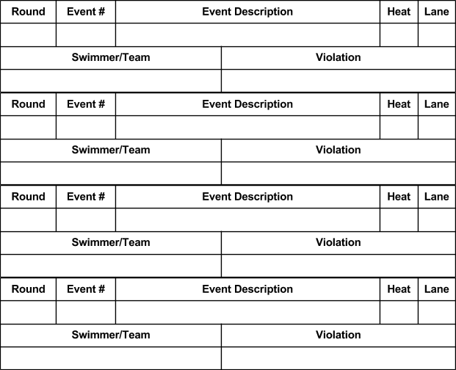

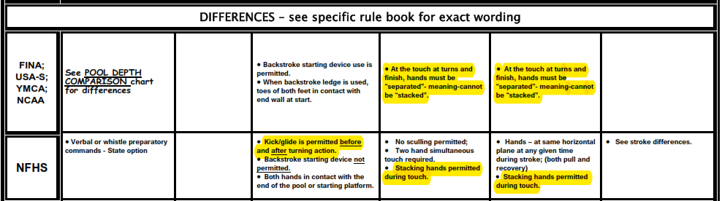

Other rule differences: NFHS rules permit taping to treat a documented medical condition, provided signed documentation from an appropriate health-care professional has been produced. Taping is generally not allowed under USA Swimming rules regardless of medical need, and use of Kiniseo tape is never permitted.

