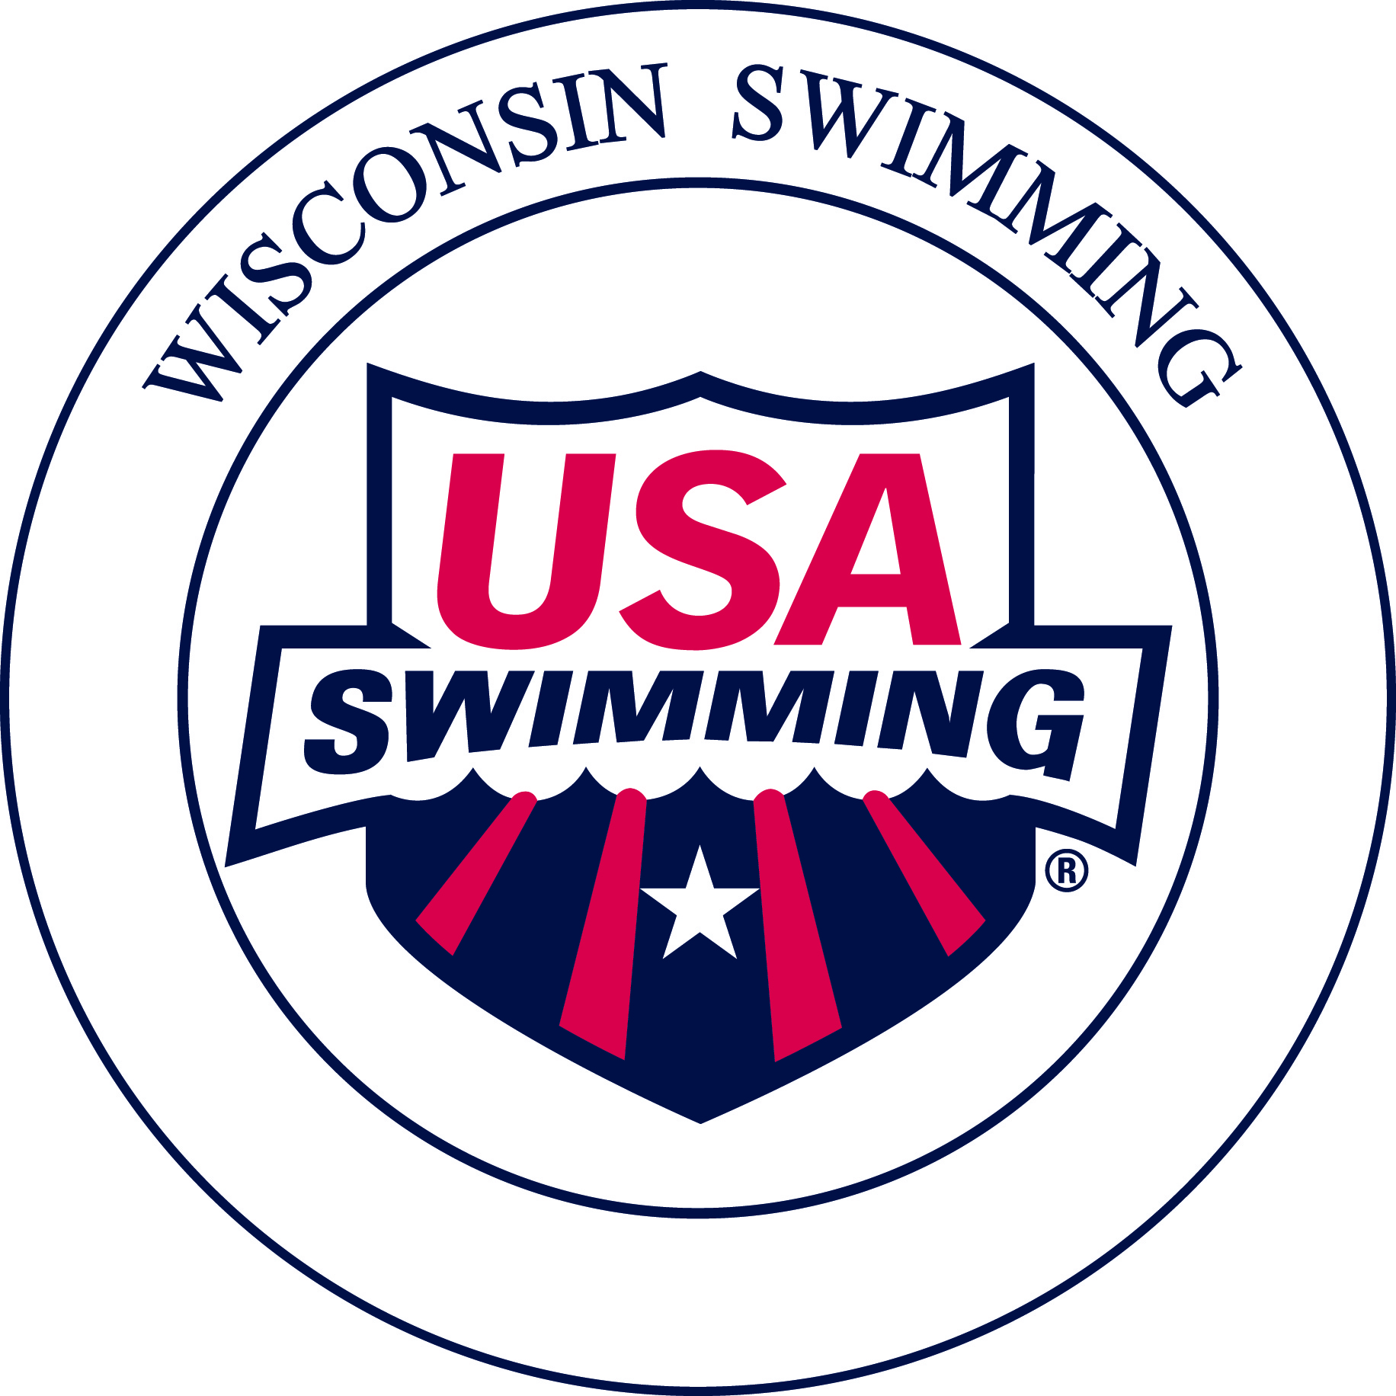
Becoming a USA Swimming
Certified Administrative Official

Requirements for Administrative Official Certification
1. Participate in a Training Clinic
- Attend a “New Officials Training Clinic – Administrative Official.” The Wisconsin Swimming Officials Committee conducts Clinics periodically in various locations
- Clinic announcements are located on the Wisconsin Swimming website.
- The Clinic consists of a 3-4 hour education session covering the following:
- Determining official time
- Timing Resolutions
- Entry Process
- Seeding
- Relays
- National Scratch Rule
- Common Admin Scratch process work-flow
- Common Admin Forms and their use
- Club sponsored Clinic: If a Club has volunteers interested in becoming Officials, a clinic can be arranged at the Club’s preferred location. To request a Clinic, please contact one of these Wisconsin Swimming Officials’ Committee members:
Michael Patton (mcseclp@yahoo.com), Training Coordinator, or
Paul Roehr (pdroehr53527@yahoo.com), Training Coordinator
NOTE: The Wisconsin Swimming Officials’ Committee provides a trainer and training materials.
- Complete the USA Swimming Registration
Apprentice officials have 60 days from the start of their training before they are required to join as non-athlete members of USA Swimming and complete all membership requirements in order to continue being on deck.
- Non-current Non-Athlete Members of USA Swimming who are apprenticing to become certified Stroke and Turn Judges or Administrative Officials prior to bringing all required membership requirements current or re-joining as Non Athlete (Official) Members, must submit a USA Swimming Apprentice Official Application. There is no cost for this.
- Prior to certification, complete the current year USA Swimming Non-Athlete Registration (form provided at the clinic or located on the Wisconsin Swimming website) and submit it along with the fee to the Registration Chair, Carol Graham (1716 W. Thrush Lane, Mequon, WI 53092).
- Some clubs will reimburse this fee for their officials, typically upon certification.
- USA Swimming Athlete Protection Policy
- Legislation passed at the September, 2010, Aquatic Sports Convention
- All Non-Athlete USA Swimming members, including Officials, must complete the following:
- USA Swimming Level 2 Criminal Background Check (regardless of any previous criminal background check you may have completed). There is a $39 fee, which can be reimbursed at the completion of all training requirements by Wisconsin Swimming
- USA Swimming online Athlete Protection Training module.
- The Level 2 Criminal Background Check must be passed prior to becoming a Non-Athlete USA Swimming member.

4. Take the USA Swimming Test: Complete USA Swimming’s on-line, open book test, “Administrative Official” certification test. This test must be successfully completed prior to the on-deck apprentice session.
5. Fulfill On-Deck Apprentice Session Requirements
- For Administrative Official – Level 1 (AO-L1) Certification - Complete a minimum of two sessions as an apprentice under the supervision of USA Swimming Certified Administrative Official (L1 or L2) or Administrative Referee.:
- For Administrative Official – Level 2 (AO-L2) Certification - Complete a minimum of two sessions as an apprentice under the supervision of USA Swimming Certified Administrative Official – Level 2 or Administrative Referee. At least one apprentice session must be at a preliminaries session of a preliminaries/finals type meet.
- Contact the Meet Referee or Meet Director prior to the Meet for permission to attend as an Apprentice and to ensure one-on-one mentoring.
6. Other Requirements
- Minimum age of 18 years
- Recommended Attire: Solid navy blue skirt, shorts or pants, white collared polo shirt and white athletic shoes
- Attitude: Positive attitude, willingness to volunteer, and dedication
7. Certification
- Achieved after becoming a USA Swimming Non-Athlete Member (including completion of Criminal Background Check & USA Swimming online Athlete Protection Training module), Training Clinic, USA Swimming on-line test, and the Apprentice sessions.
- Submit the completed and signed apprentice card to: Rick Potter, Officials’ Committee Chair, 6549 Winding Way, DeForest, WI 53532.
- Wisconsin LSC Certified officials will use their current year USA Swimming Membership Cards as their primary credentials to verify they may be permitted on deck for USA Swimming Sanctioned, Approved, or Observed meets or events.
- Wisconsin LSC officials will use a copy of their OTS generated USA Swimming Official Certification Card as a supplement to their USA Swimming Membership Card as a means of verification of their LSC and National official certification levels needed for serving in assigned positions. These Official Certification Cards also show the expiration dates of the official’s USA Swimming registration, Criminal Background Check, and Athlete Protection Training.

After Certification as an Administrative Official
- On Deck
- Encouraged to volunteer at any meet attended
- Maintenance of Certification
- Recertification required every odd numbered year
- Attend a Wisconsin Swimming Recertification Clinic, take the USA Swimming on-line Recertification Test or participate in other alternatives provided by the Wisconsin Swimming Officials Committee
- Must officiate a minimum of four sessions, at two or more different meets each year
- Must complete the Criminal Background Check and the online Athlete Protection Training module every 2 years.

- Advancement - From Administrative Official – Level I to Administrative Official Level II
- Complete a minimum of two sessions as an apprentice under the supervision of USA Swimming Certified Administrative Official – Level 2 or Administrative Referee.
- At least one apprentice session must be at a preliminaries session of a preliminaries/finals type meet.

2015 Fees
- New Officials Training Clinic Fee: Usually $15.
- USA Swimming Criminal Background Check Fee: $39.
  - This is reimbursed by Wisconsin Swimming.
  - For reimbursement, print a copy of the second page of the Criminal Background Check and submit to the LSC Treasurer Pat Lewno (5330 Linden, Racine, WI 53406) after completing all the training requirements.
- USA Swimming Annual Non-Athlete Member Registration:
  - 2015: $60
  - Registration after September 1 is valid through December of the following year. Membership includes:
    - USA Swimming insurance
    - USA Swimming Rule Book
- Clubs may reimburse participants for their Training Clinic fee, annual USA Swimming registration fee, and/or Recertification Clinic fee.
- Exception: If a person already is a member of USA Swimming as an athlete, coach, Club Safety Coordinator, Board President, or other Board position, the registration fee paid for any of these positions also applies to becoming an Official.
For More Information:
Please contact one of the following:
- Rick Potter, Chair, Wisconsin Swimming Officials’ Committee (RickPotter@charter.net)
- Michael Patton, Member and Training Coordinator, Wisconsin Swimming Officials’ Committee (mcseclp@yahoo.com)
- Paul Roehr, Member and Training Coordinator, Wisconsin Swimming Officials’ Committee (pdroehr53527@yahoo.com).

