How to Print Your Certification Card from OTS
This document is a quick guide on how to print your Certification Card from the Officials Tracking System.

Step 1: Go to USA Swimming Web Site
http://www.usaswimming.org/DesktopDefault.aspx

Step 2: Member Resources, Official Tracking System
From the main menu, select Member Resources, Official Tracking System. You will be presented with the Officials page.

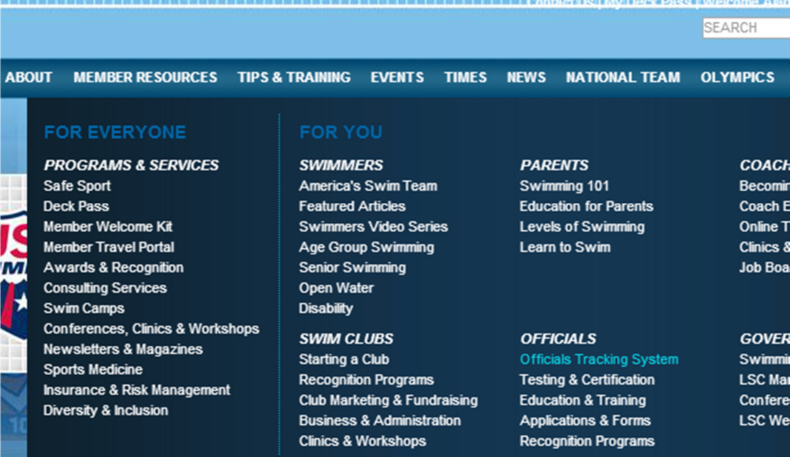

Step 3: My Certification Card
From the left navigation menu on the Officials page, select My Certification Card.

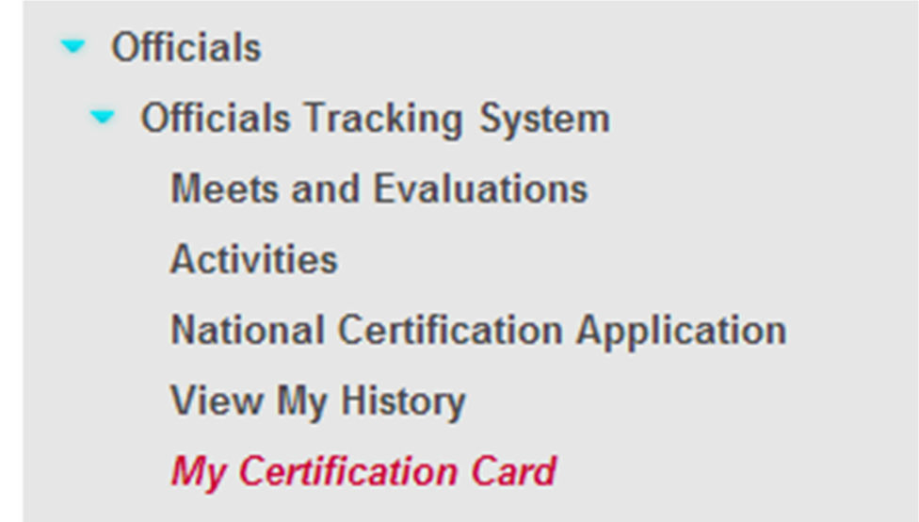

If you have not logged in prior to doing this, you will be prompted to input your account information before accessing your card.

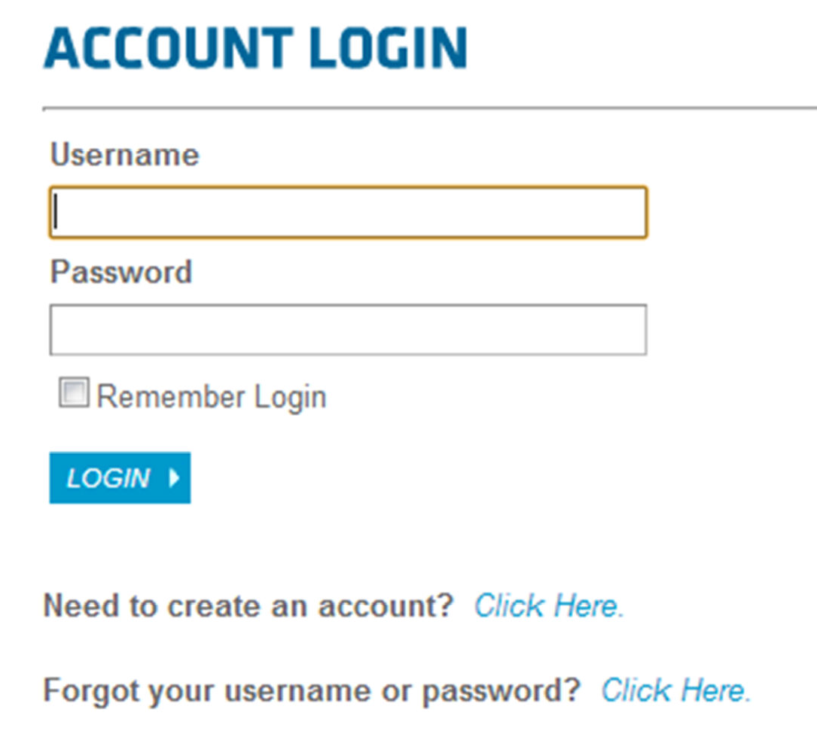
If you do not currently have a USA Swimming account, please refer to page 2 of the document below for instruction on how to create an account.
http://www.usaswimming.org/_Rainbow/Documents/9c117993-a2d0-445a-9686- 7965a551d170/Instructions%20for%20using%20OTS.pdf

Step 4: Print Your Card
On the bottom right of the page will be an image of your certification card. You can either:

- click on the link to have a copy of the card e-mailed to yourself (good for MAC users and to save a .pdf version on your smartphone).
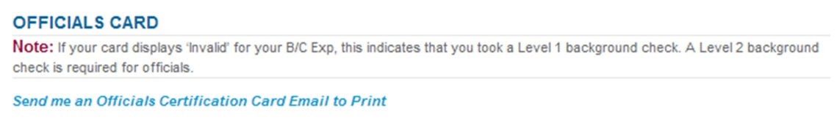

- Or, right click on the card image and select print.
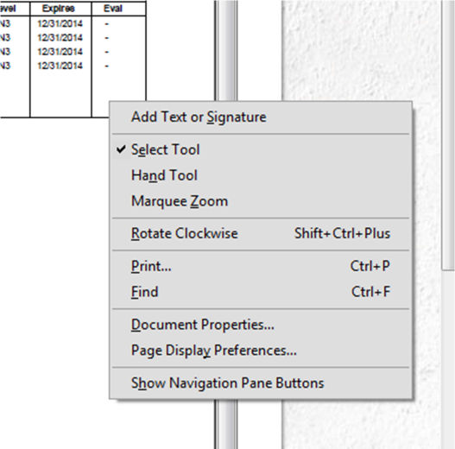
- NOTE: Depending on how you have set up your browser, you may get a notice at the bottom of the page to open a .pdf file in Adobe Reader, or a new Adobe Reader will appear with your card in it.

