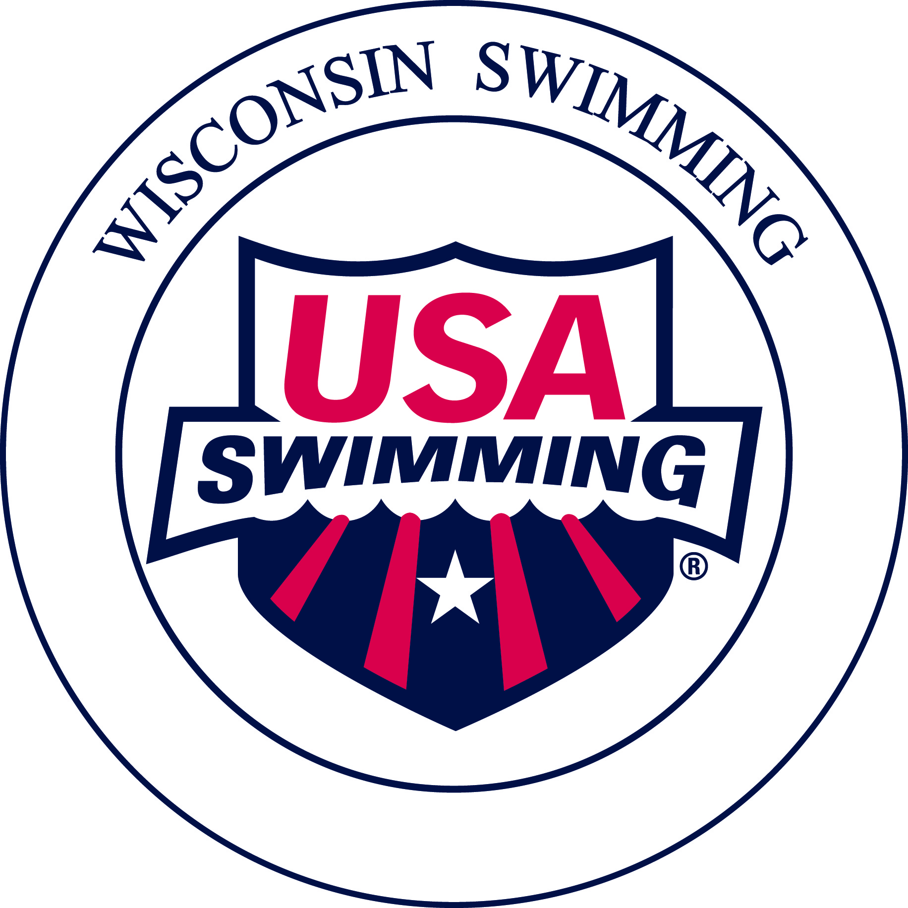
Wisconsin Swimming
Official of the Year Award

Purpose: Wisconsin Swimming, Inc. and the Officials Committee wish to recognize a Stroke/Turn Official and a Starter/Referee for their outstanding contributions to Wisconsin Swimming. Each year, one Stroke/Turn Official and one Starter/Referee may be selected from those nominated by their peers.
In lieu of an “Official of the Year” award, the Officials Committee may instead choose to honor an LSC official with a “Lifetime Achievement” award. For either award, the selected officials will receive a plaque from Wisconsin Swimming, Inc.

Procedure:
- One USA Swimming certified Stroke/Turn Official and one Starter/Referee may be recognized annually.
- The Officials Committee Chair will post an application for “Officials of the Year Award” on the Wisconsin Swimming, Officials web site.
- Wisconsin Swimming Officials will solicit nominations from among all USA Swimming/Wisconsin Swimming certified Officials, coaches and those involved in Wisconsin Swimming.
- The Officials Committee will appoint an Officials of the Year Awards Coordinator to solicit and collect nominations.
- The Officials Committee will receive the nominations at its May meeting. Any members of the Officials Committee being considered for the award shall recuse themselves from the selection process.
- The Officials of the Year Awards Coordinator is not eligible for the award.
- The Officials Committee will meet in May to review nominations and to select recipients.
- The Officials Committee Chair will announce the “Officials of the Year” prior to the Wisconsin Swimming 13 & Over Long Course Championship Meet.
- The “awards,” not to exceed $100 each, will be presented during the LSC 13 & Over Long Course Championship Meet.

Selection Criteria for Consideration:
  - Except for posthumous awards, the nominee is a current member of USA Swimming and currently is a certified Wisconsin Swimming Official in good standing as a Starter/Referee, or as a Stroke and Turn Official.
  - The nominee has made significant contributions to Wisconsin Swimming through outstanding performance or experience in the capacity as an Official.

