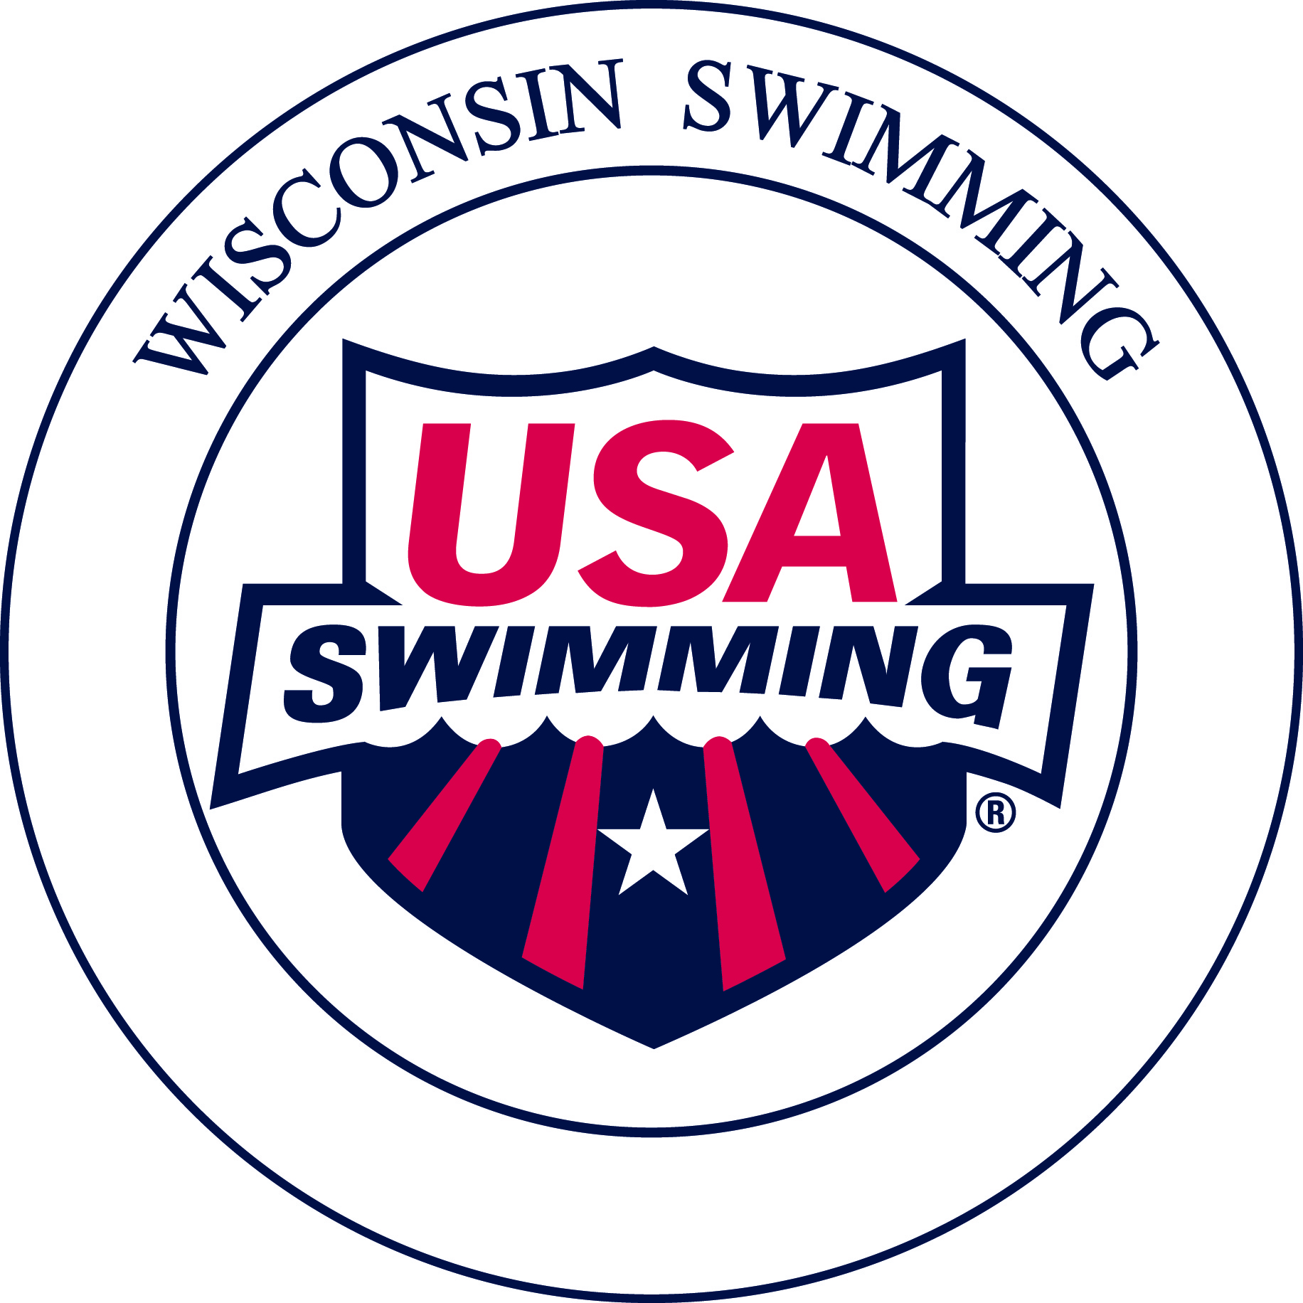
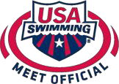Wisconsin Swimming, Inc.

Polo Shirts for Officials

USA Swimming officials may now purchase white polo and light blue oxford shirts directly from the USA Swimming Meet Official Shirt Store. These shirts are available for all officials. However, only newly certified Stroke and Turn Judge or Administrative Officials are eligible for reimbursement for their first white polo shirt. No reimbursement is available for additional or replacement shirts.

Ordering and Reimbursement Process:

Please order shirts at least 2 weeks in advance of when needed to allow for processing and shipping. For order information and pricing please go to www.usaswimofficials.com.

- Official completes order by going to www.usaswimofficials.com
- USA Swimming Meet Official Shirt Store sends shirt to the Official with a paid invoice showing name, address, and total purchase cost.
- Official sends a copy of the paid invoice to Pat Lewno
Wisconsin Swimming Treasurer 5330 Linden D,
Racine, WI 53406
- Pat Lewno sends reimbursement check to official.

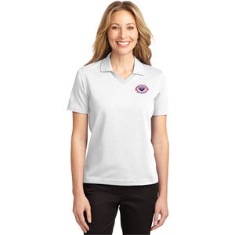
Shirt Information:

Three styles are available for your selection as follows (pricing as of 10/2015):

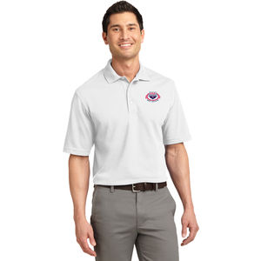
The Rapid Dry Polo Shirts, being the most popular, are usually in inventory so if you need quick delivery, consider these. 5.6 ounce baby pique knit fabric that wicks moisture away from your body. - $26.00

The Pique Knit Polo Shirts are a slightly heavier pique knit material, 7 ounce. - $27.50 ($28.00 for Tall version)

The Silk Touch Polo shirts are a smooth lighter weight pique knit material, 5 ounce. - $27.50

