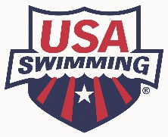
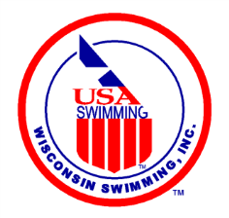
Final Steps:
Becoming a Stroke/Turn Official
December 16, 2019
Congratulations! You have completed the Stroke/Turn Clinic. While your enthusiasm is high, please complete the few short remaining steps on your road to the world of Swim Officiating.

- Become an apprentice member of USA Swimming, which gives you 60 days to complete the requirements of becoming a certified USA Swimming Official, without paying a fee. https://www.teamunify.com/czwilsc/UserFiles/Image/QuickUpload/202-apprentice-official-application-fillable_056337.pdf
- Complete the LSC official registration on the Wisconsin Swimming website. https://www.teamunify.com/MemRegStart.jsp?team=czwilsc&event_id=1078615
- Pass the open book USA Swimming Stroke and Turn/Timer online test (may complete one apprentice session prior to completing the test).
- Finish all 4 required apprentice sessions, having your mentor sign your apprentice card at the completion of each session.
The following four steps need to be completed prior to working as a certified official. They may be done in any order.
- Complete the Level 2 Criminal Background Check (not Level 1). Submit screenshot of the payment page for reimbursement to plewno@gmail.com.
- Take the USA Swimming online Athlete Protection Training.
- Take the concussion training either at CDC- https://headsup.cdc.gov/ or NHFS- https://nfhslearn.com/courses/61151/concussion-in-sports
- Become a Non-Athlete member of USA Swimming by completing the appropriate form and send it together with a check to Angela Monty, 1907 Cedarhurst Dr. New London, WI 54961-2297. https://www.teamunify.com/SubTabGeneric.jsp?team=czwilsc&_stabid_=187120
Now send your completed apprentice card to the Wisconsin Swimming Officials Committee Chair, Jacqueline Jugenheimer at officialschair@wisconsinswimming.org to receive a confirmation that you are now officially a certified USA Swimming Stroke/Turn Official!
Purchase a Wisconsin Swimming Polo shirt and Name tag (order forms located here: https://www.teamunify.com/SubTabGeneric.jsp?team=czwilsc&_stabid_=187123 “Officials Polo Shirt Ordering” and ”Officials Name Badge Order Form”). Submit for re-imbursement to Wisconsin Swimming Treasurer Pat Lewno (5330 Linden Drive, Racine, WI 53406) (or plewno@gmail.com). If you already purchased these items prior to becoming certified, please submit for re-imbursement.
Enjoy your volunteer commitment to your athlete(s) and the sport of swimming!

