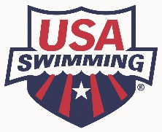
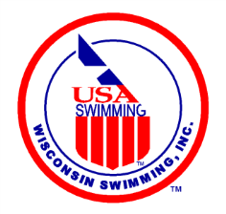
Final Steps:
Becoming an Administrative Official
December 16, 2019
Congratulations! You have completed the Administrative Official Clinic. While your enthusiasm is high, please complete the few short remaining steps on your road to the world of Swim Officiating.

- Become an apprentice member of USA Swimming, which gives you 60 days to complete the requirements of becoming a certified USA Swimming Official, without paying a fee. https://www.teamunify.com/czwilsc/UserFiles/Image/QuickUpload/202-apprentice-official-application-fillable_056337.pdf
- Complete the LSC official registration on the Wisconsin Swimming website. https://www.teamunify.com/MemRegStart.jsp?team=czwilsc&event_id=1078615
- Pass the open book USA Swimming Administrative Official online test (may complete one apprentice session prior to completing the test).
- Finish all 2 required apprentice sessions, having your mentor sign your apprentice card at the completion of each session.
The following four steps need to be completed prior to working as a certified official. They may be done in any order.
- Complete the Level 2 Criminal Background Check (not Level 1). Submit screenshot of the payment page for reimbursement to plewno@gmail.com.
- Take the USA Swimming online Athlete Protection Training.
- Take the concussion training either at CDC- https://headsup.cdc.gov/ or NHFS- https://nfhslearn.com/courses/61151/concussion-in-sports
- Become a Non-Athlete member of USA Swimming by completing the appropriate form and send it together with a check to Angela Monty, 1907 Cedarhurst Dr. New London, WI 54961-2297. https://www.teamunify.com/SubTabGeneric.jsp?team=czwilsc&_stabid_=187120
Now send your completed apprentice card to the Wisconsin Swimming Officials Committee Chair, Jacqueline Jugenheimer at officialschair@wisconsinswimming.org to receive a confirmation that you are now officially a certified USA Swimming Stroke/Turn Official!
Purchase a Wisconsin Swimming Polo shirt and Name tag (order forms located here: https://www.teamunify.com/SubTabGeneric.jsp?team=czwilsc&_stabid_=187123 “Officials Polo Shirt Ordering” and ”Officials Name Badge Order Form”). Submit for re-imbursement to Wisconsin Swimming Treasurer Pat Lewno (5330 Linden Drive, Racine, WI 53406) (or plewno@gmail.com). If you already purchased these items prior to becoming certified, please submit for re-imbursement.
If you are interested in progressing to AO-L2, work 3 preliminary sessions at at least 2 different preliminary finals meets.
Enjoy your volunteer commitment to your athlete(s) and the sport of swimming!

