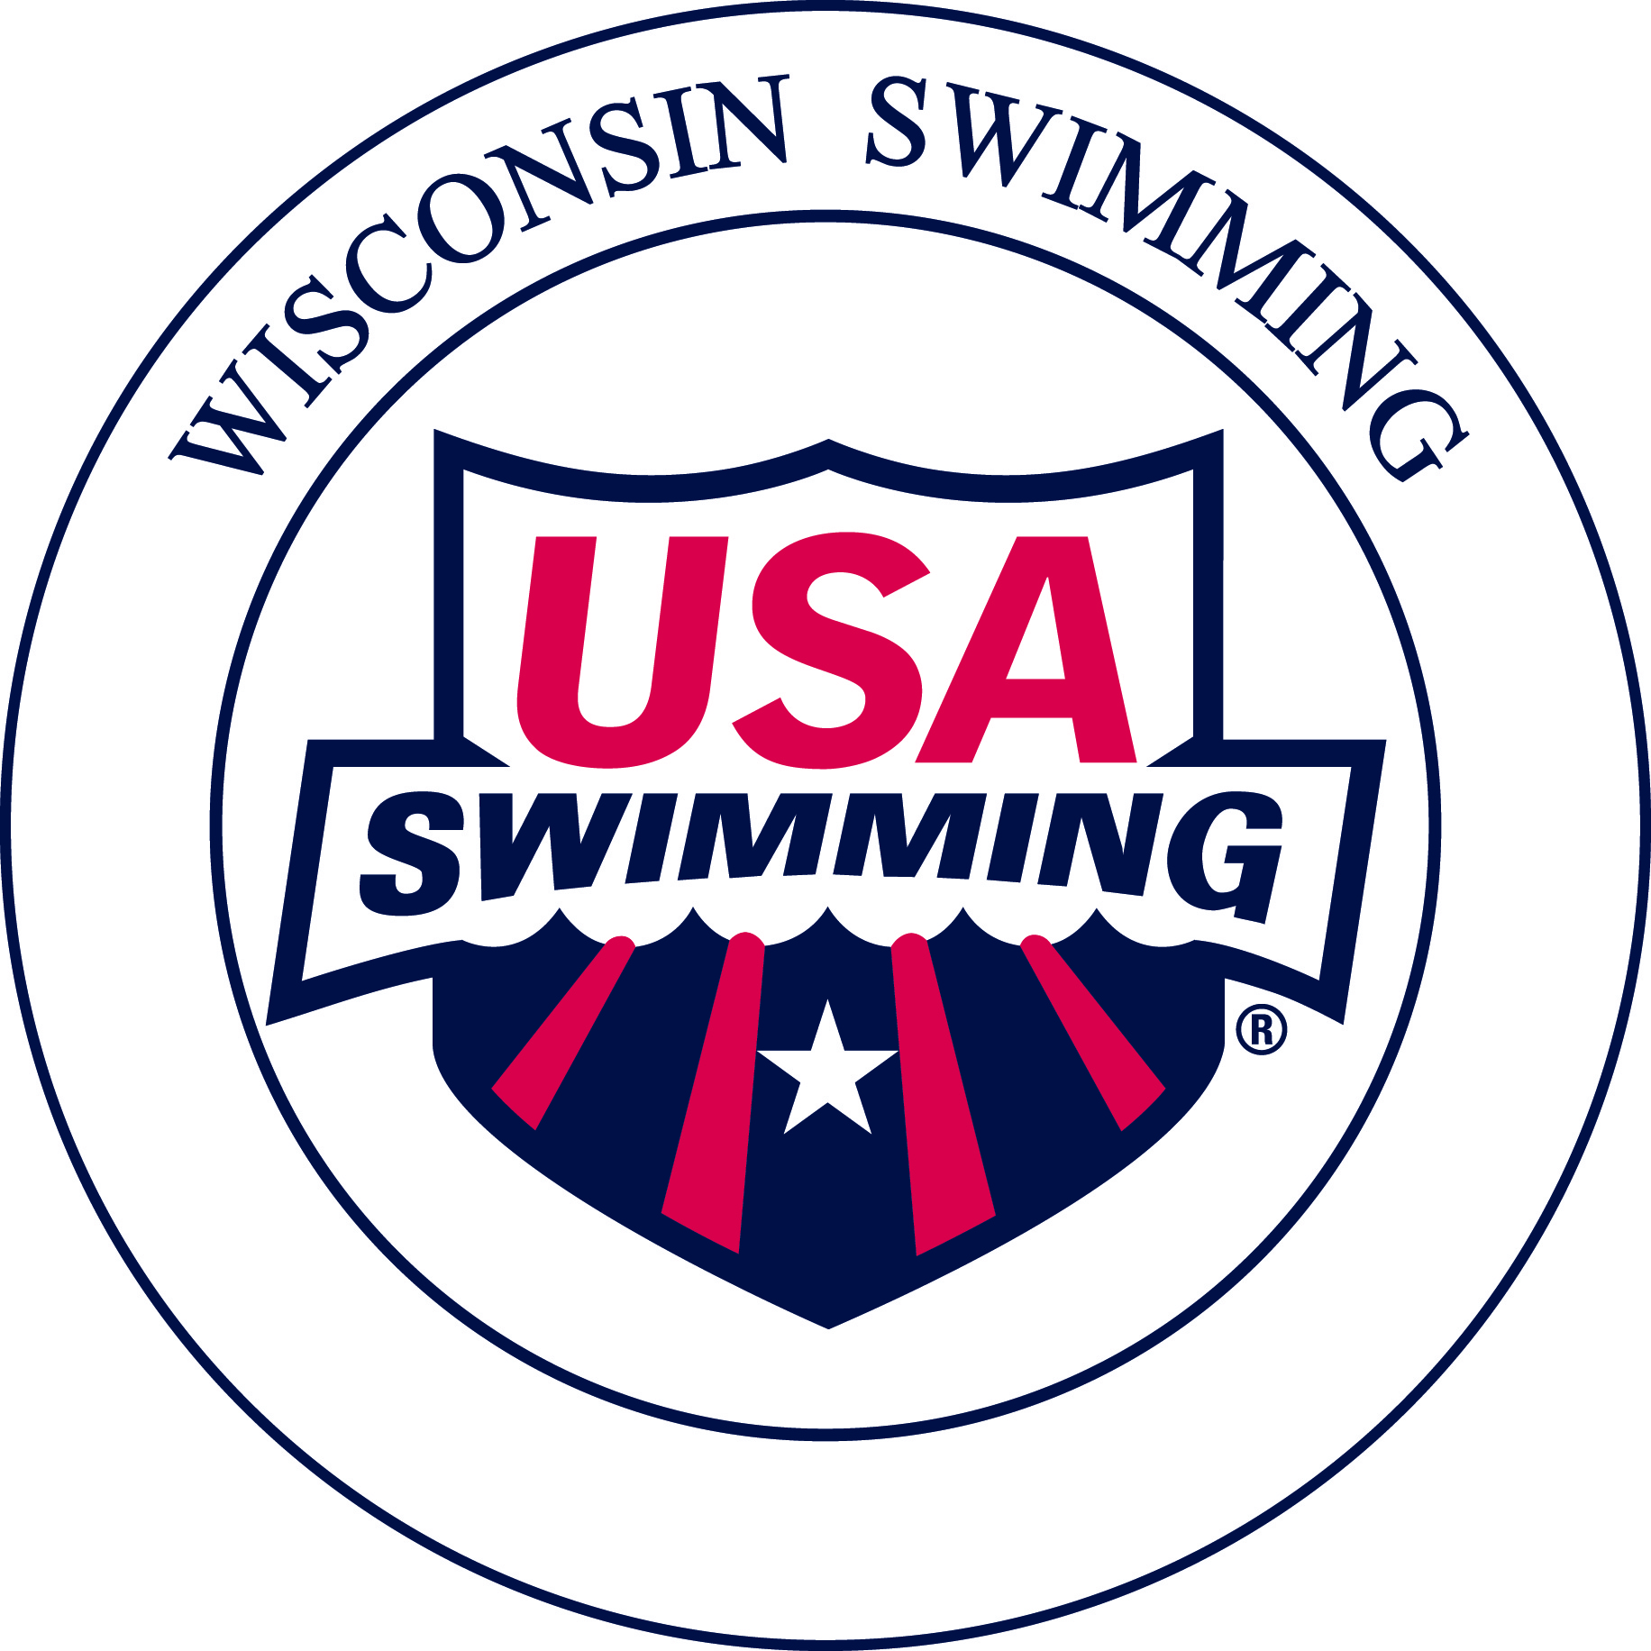
Obtaining and Maintaining Certification as
USA Swimming Certified Administrative Official

Requirements for Administrative Official Certification
1. Participate in a Training Clinic
- Attend a “New Officials Training Clinic – Administrative Official.” The Wisconsin Swimming Officials’ Committee conducts Clinics online based on demand
- Clinic announcements are located on the Wisconsin Swimming website.
- The Clinic consists of a 2 hour education session covering the following:
- Determining official time
- Timing resolutions
- Entry process
- Seeding
- Relays
- National Scratch Rule
- Common admin scratch process work-flow
- Common admin forms and their use

To request an Officials Clinic, please use the online request form found on the Officials Page of the Wisconsin Swimming Website.
NOTE: The Wisconsin Swimming Officials’ Committee provides a trainer and training materials.

- Complete the USA Swimming Apprentice Registration
If you are not currently a Non-Athlete Member of USA Swimming (e.g. because you are not already an official or coach), Apprentice officials have 60 days from the start of their training BEFORE they are required to join as non-athlete members of USA Swimming and complete all membership requirements in order to continue being on deck. There is no cost associated with the USA Swimming Apprentice Official Application. Send the competed application to: Angela Monty, 1907 Cedarhurst Dr. New London, WI 54961-2297 (admin@wisconsinswimming.org).
3. Take the USA Swimming Test: Complete USA Swimming’s on-line, open book test, “Administrative Official” certification test. You can complete a maximum of one (1) apprentice session before passing the online test.
4. Fulfill On-Deck Apprentice Session Requirements
- For Administrative Official – Level 1 (AO-L1) Certification - Complete a minimum of two sessions as an apprentice under the supervision of USA Swimming Certified Administrative Official (L1 or L2) or Administrative Referee. Both sessions may be completed at one meet.
- Contact the Meet Referee or Meet Director prior to the meet for permission to attend as an Apprentice and to ensure one-on-one mentoring.

- USA Swimming Athlete Protection Policy
- Legislation passed at the September, 2010, Aquatic Sports Convention.
- All Non-Athlete USA Swimming members, including Officials, must complete the following:
- USA Swimming Level 2 Criminal Background Check (regardless of any previous criminal background check you may have completed). There is a $39 fee for the initial background check, which can be reimbursed at the completion of all training requirements by Wisconsin Swimming. Send requests to the LSC Treasurer Pat Lewno (5330 Linden, Racine, WI 53406, treasurer@wisconsinswimming.org). The Level 2 Criminal Background Check must be passed prior to becoming a Non-Athlete USA Swimming member.
- USA Swimming online Athlete Protection Training module.
- Complete a one-time online concussion training module.

6. Other Requirements
- Minimum age of 18 years
- Recommended Attire: Solid navy blue skirt, shorts or pants, white collared polo shirt and white athletic shoes
- Attitude: Positive attitude, willingness to volunteer, and dedication

7. Certification
- Prior to certification, complete the current year USA Swimming Non-Athlete Registration (form provided at the clinic or located on the Wisconsin Swimming website) and submit it along with the fee to the Registration Chair, Angela Monty (1907 Cedarhurst Dr. New London, WI 54961-2297). Some clubs will reimburse this fee for their officials, typically upon certification, i.e. completion of all the certification requirements.
- Complete the online Officials Release of Information found on the Officials Page of the Wisconsin Swimming Website.
- Submit a scanned or photo copy of the completed and signed apprentice card via email to: Jacqueline Jugenheimer, Officials’ Committee Chair, officialschair@wisconsinswimming.org
- Wisconsin LSC officials will use a copy of their OTS generated USA Swimming Official Certification Card as their USA Swimming Membership Card which also includes verification of their LSC and National official certification levels needed for serving in assigned positions. These Official Certification Cards also show the expiration dates of the official’s USA Swimming registration, Criminal Background Check, and Athlete Protection Training.

After Certification as an Administrative Official Level 1
- On Deck
- Encouraged to volunteer at any meet attended
- Maintenance of Certification
- Recertification required every odd-numbered year, therefore the Officials’ Committee offers recertification activities every even-numbered year.
- Activities qualifying as recertification activity: Attend a Wisconsin Swimming Recertification Clinic, take the USA Swimming on-line Recertification Tests, successful evaluation at the N2 level, or completion of 75% of the sessions of a National Qualifying Meet without evaluation in that calendar year, such as the Wisconsin 13 and up State Meet, Zone, Speedo or above.
- AO-only certified officials must officiate a minimum of four sessions, at two or more different meets each year
- AO/Stroke & Turn certified officials – 4 sessions as stroke and turn official and 1 session as AO each year
- AO/Starter and Referee certified officials – 6 sessions as starter/referee (with at least 1 session as starter and at least 1 session as referee) and 1 session as AO, Administrative Referee or Meet Referee each year
- Must complete the Criminal Background Check every 2 years
- Must complete the online Safe Sport training module (also called Athlete Protection Training module) every year.
- Advancement - From Administrative Official – Level I to Administrative Official Level II
- For Administrative Official – Level 2 (AO-L2) Complete at least three additional sessions as an apprentice under the supervision of USA Swimming Certified Administrative Official – Level 2 or Administrative Referee. These additional apprentice session must be at preliminaries sessions of a preliminaries/finals type meet and must be completed at at least 2 different meets under and the supervision of at least two different officials, who are certified as AO-Level 2 or Administrative Referee.
- Grandfathering in of officials.
  - Starting December 1, 2019, no more applications for grandfathering in of officials as Administrative Officials will be accepted. Officials wishing to obtain the certification of Administrative Officials L1 or L2 need to meet all the certification requirements listed above.

2020 Fees.
- USA Swimming Criminal Background Check Fee: $39 for the initial background check, renewals are $19.
  - The initial background check is reimbursed by Wisconsin Swimming, subsequent background checks are often reimbursed by clubs.
  - For reimbursement: After completing all the training requirements, print or scan a copy of the second page of the Criminal Background Check and submit to the LSC Treasurer Pat Lewno (5330 Linden, Racine, WI 53406, treasurer@wisconsinswimming.org).
- USA Swimming Annual Non-Athlete Member Registration:
  - 2020: $72
  - Registration after September 1 is valid through December of the following year. Membership includes:
    - USA Swimming insurance
    - USA Swimming Rule Book
- Clubs may reimburse participants for their Training Clinic fee, annual USA Swimming registration fee, and/or Recertification Clinic fee.
- Exception: If a person already is a member of USA Swimming as an athlete, coach, Club Safety Coordinator, Board President, or other Board position, the registration fee paid for any of these positions also applies to becoming an Official.

For More Information:
Please contact: Jacqueline Jugenheimer, Chair, Wisconsin Swimming Officials’ Committee (officialschair@wisconsinswimming.org)

