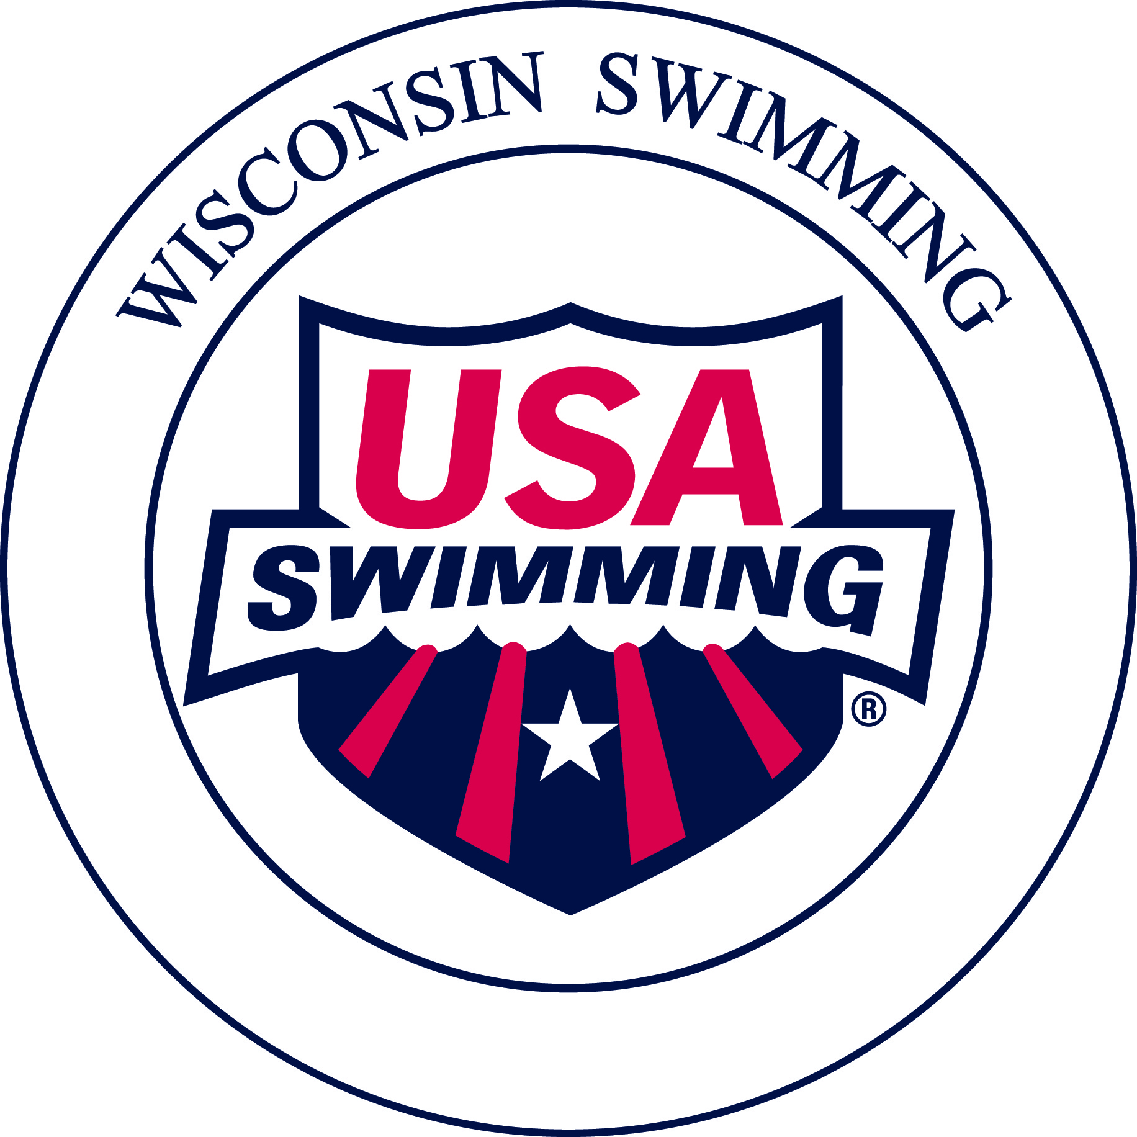
Wisconsin Swimming Officials
Name Badge Ordering Form

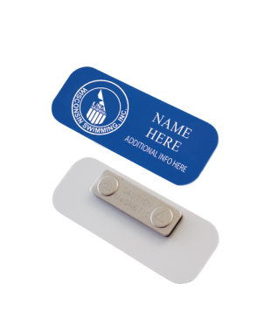
Name Badge with Wisconsin Swimming “Official” Logo: Royal blue, 1 ¼” x 3 ¼” plastic badge with rounded corners; magnet closure; LSC logo and Official’s name, and the word “Official” imprinted by recessed white engraving on badge
Supplier: Hasty Awards
Cost: $5.95 per badge, including shipping
Delivery: Allow up to fifteen (15) days for delivery directly from Hasty Awards
Questions: Jacqueline Jugenheimer, WI Swimming Officials Chair, 608-695-2894, aquaymca@yahoo.com
Official completes order:
  - Using form below, writes check payable to Hasty Awards, or provides credit card requested and mails to
Hasty Awards, 1015 Enterprise Street Ottawa, Kansas 66067
or
  - Online by going to: https://www.hastyawards.com/catalog/Nametags/136/product/Wisconsin%20Swimming%20Nametag/437/
    - For Engraving Choice, select “Yes – Each award has SAME engraving as specified below”
    - Then in the “Engraving Text” box, type in your first and last name for line 1, hit enter twice to create a blank line 2, and then type “Official” for line 3.
PLEASE NOTE: Submit your request for refund to: Wisconsin Swimming Treasurer Angela Monty (1907 Cedarhurst Dr. New London, WI 54961-2297) (or admin@wisconsinswimming.org).

---------------------------- Clip here to retain upper portion for your Records-------------------------------

Wisconsin Swimming, Inc.
OFFICIAL’S NAME BADGE ORDER FORM
Please print clearly all information.

Payment: Make check payable to Hasty Awards or complete credit card information.

Circle one: MasterCard Visa

Card Number ________________________________ Expiration Date ____________ Security Code _________

Name as it Appears on Card _________________________________________________________________________
Please Print Clearly

Signature ________________________________________________________ Date ___________________________

Ship To:
Name _____________________________________________________ Telephone (______) ___________________
Name As It Should Appear On Name Badge

Address ________________________________________________________________________________________
Street City ZIP

Send Order To: Shay Shotton, Hasty Awards, 1015 Enterprise Street, Ottawa, Kansas 66067
Phone: 800-448-7714 x 115 Email: hasty@hastyawards.com or ShayShotton@hastyawards.com

