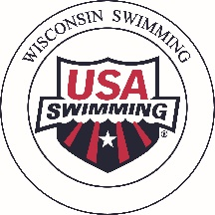
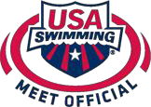
Wisconsin Swimming, Inc.

Polo Shirts for Officials

USA Swimming officials may now purchase white polo shirts directly from the USA Swimming Meet Official Shirt Store. These shirts are available for all officials. Regular white polo shirts can be worn (it can, but does not have to have a USA Swimming, WI Swimming, meet or manufacturer logo).
PLEASE NOTE: Currently, no reimbursement is available for polo shirts.

Ordering Process:

Please order shirts at least 2 weeks in advance of when needed to allow for processing and shipping. For order information and pricing please go https://www.usaswimmingbrandstore.com/products?s%5Bf%5D%5Bc%5D%5B%5D=%2FMeet+Officials.

- Official completes order by going to https://www.usaswimmingbrandstore.com/products?s%5Bf%5D%5Bc%5D%5B%5D=%2FMeet+Officials
- USA Swimming Meet Official Shirt Store sends shirt to the Official with a paid invoice showing name, address, and total purchase cost.

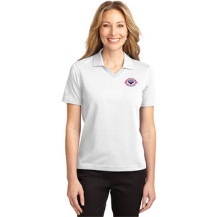
Shirt Information:

Several shirt styles are available:

