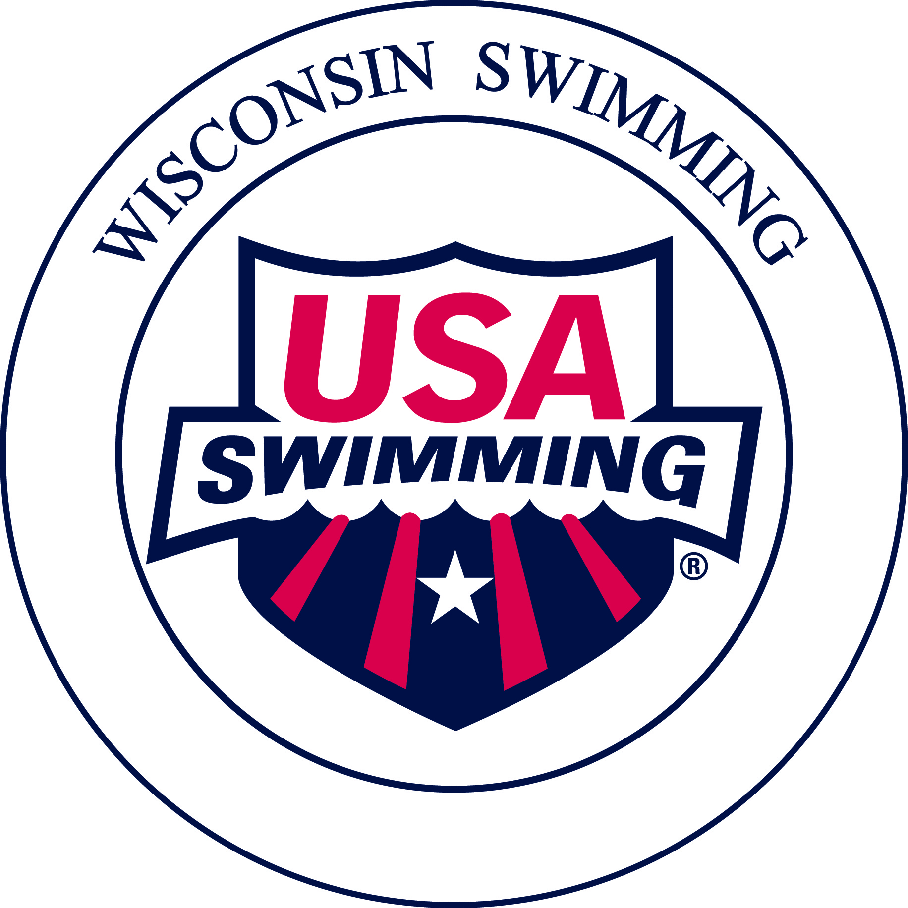
Wisconsin Swimming
Officials Registration and
Recertification procedure - 2017

◆ | Complete the enclosed USA Swimming 2017 Non-Athlete Registration Application. All officials must be non-athlete members of USA Swimming. This registration is done on a calendar year basis.
❖ | Pay the USA Swimming registration fee of $64.00. (Make check payable to Wisconsin Swimming).  NOTE: The registration process is quicker and simpler if you send an individual check. If your club pays this fee for you, please seek reimbursement after you have registered.
⬥ | Please review the contact information contained in the Officials Roster and make any changes/corrections to the information listed on the Wisconsin Swimming Officials’ Annual Release of Information form. Be sure to include your current e-mail address (please print legibly). Communications from the Officials Committee will be sent via e-mail Therefore, it is important that we have a current e-mail address.
 | Certifications for Wisconsin Swimming are done on a two-year (bi-annual) schedule. The current certification period is 1/1/2016 through 12/31/2017. Bi-annual re-certification clinics are held every other even year, this fall for the 2017-2018 certification period.
    
  To maintain certification on an annual basis, as for 2017, a Stroke/Turn Judge must complete 4 sessions per year, and a Starter/Referee must complete 6 sessions per year. Administrative Officials must complete 4 sessions per year, with at least one session as an Administrative Official. The remaining may be in any of the 6 positions for which the Administrative Official supervises/directs: Entry/Registration Personnel, Clerk of Course, Timing System Operator, Scoring Personnel, Timing Judge, or Meet Management Software Operator. May also work in a higher capacity as Administrative Referee, or Meet Referee.
  Officials not meeting the annual minimum session requirements must instead complete one of the following to maintain their certification for 2017:
    - Online: Complete and pass with a score of 80% or above the required Re-Certification test(s) for your level. Go directly to http://www.usaswimming.org/Online Testing. Once logged into the USA Swimming website, please be certain to select the “Re-Certification” test from the “Start Test” pull down. Results are sent directly to the Wisconsin Officials Committee Chair and recorded for your recertification.
  RECERTIFICATION TESTS REQUIRED:
  Certification Level | Tests
  Stroke & Turn Judge | Stroke & Turn Recertification
  Starter/Referee | Starter Recertification & Referee Recertification
  Administrative Official | Administrative Official Recertification
  - Attend an officials certification training clinic. This includes participation in a Starter/Referee training clinic as a Stroke and Turn Judge.
  - Successful evaluation at the N2 or N3 level
  - Completion of 75% of the sessions of a National Officials Qualifying Meet (OQM) with or without evaluation in that calendar year such as at Zone Championship, Speedo Sectionals or above.
  As of 9/2013, you must complete the online Athlete Protection Training (APT) every two years, coinciding with renewal of your USA Swimming Official Certification. Officials must also renew their USA Swimming Level 2 Back Ground Check (CBC) every 24 months. Please note the BGC expiration date is not the end of a calendar year, and it will reflect 24 months from when last completed.
NOTE: |  | For 2016 and forward, USA Swimming non-athlete membership cards will no longer be issued to Wisconsin officials. Instead, officials will use a copy of their OTS generated USA Swimming Official Certification Card as their primary means of verification of their LSC and National official certification levels needed for serving in assigned positions. These Official Certification Cards also show the expiration dates of the official’s USA Swimming registration, Criminal Background Check, and Athlete Protection Training. However, officials may view or print their USA Swimming Registration card by signing into their USA Swimming account and going to Deck Pass. Please allow three weeks for processing.
? |  | For any questions, contact Michael Harbert, WI Swimming Officials Chair, at mharbert@woodsonymca.com

Registration Year: 2017


Officials Annual Release of Information

Name: |  |  |  | Date:
 | Last | First | M.I.

Please review the contact information contained in the Officials Roster and make any changes/corrections to the following information:

Mailing Address:
 | Street | City | State | Zip Code

E-Mail Address: (PRINT CLEARLY)

(Please provide an e-mail address, as this is our primary form of communication with officials).

Preferred Telephone: | ( )

Club Affiliation: |  | Club Code:

Current Certification Level: Stroke & Turn Judge Starter/Referee Administrative
(Check all that apply) Stroke/Turn Apprentice Starter/Referee Apprentice Administrative Apprentice

Initial year of Certification:
There are NO CHANGES to my contact information.
I consent to publication of my mailing address and phone number on the website
Please DO NOT publish my mailing address and phone number on the website
Certified YMCA Official: Stroke/Turn Starter/Referee Administrative
I am interested in serving in an assigned position at the following LSC Championship Meet(s):

12 and Under SC 12 and Under LC 13 and Over SC 13 and Over LC
UW-Madison (BAC) WSAC (SWAT) WSAC (LAKE) WSAC (WEST)
Feb. 24-26, 2017 July 27-30, 2017 March 2-5, 2017 August 3-6, 2017
Meet Referee Meet Referee Meet Referee Meet Referee
Head Chief Judge Head Chief Judge Admin Referee Admin Referee
Head Chief Judge Asst. Admin Referee
Head Chief Judge

USA Swimming Membership fees to Submit with Registration Form

2016 USA Swimming Non-Athlete Membership Individual (Includes one *USA-S rule book) $64.00

*Refers to USA Swimming Rule Books which are shipped by USA Swimming in Colorado Springs, CO after January 1st.

All Wisconsin Officials must be current Non-Athlete Members of USA Swimming.
PLEASE include your completed USA Swimming Non-Athlete Registration Application with this form. Please make your check payable to WISCONSIN SWIMMING, INC. (If your club pays this fee, please submit your individual check and seek reimbursement. Group registrations can slow down the recertification process.)

Please mail 1 - this release form, 2 - the USA Swimming Non-Athlete Registration form and
3 – the USA registration fee to:
Wisconsin Swimming
Carol Graham Thanksgiving-mid May use
1716 Thrush Lane PO Box 27
Mequon, WI 53092 Goodland, FL 34140

