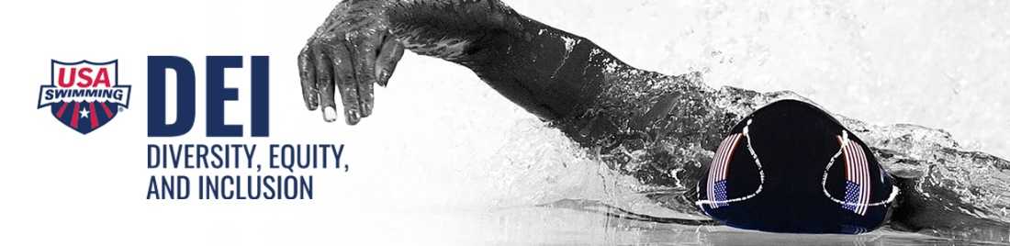

USA Swimming is committed to a culture of inclusion and opportunity. We strive to create equity by providing resources specific to the needs of our members.
This is consistent with USA Swimming’s Code of Conduct Article 304.3.2 that states discrimination against any member or participant on the basis of age, gender, race, ethnicity, culture, religion, sexual orientation, gender expression, gender identity, genetics, mental or physical disability, or any status protected by federal, state, or local law, where applicable is prohibited.

