CSS (Critical Swim Speed)

If you don't know already, your CSS (Critical Swim Speed) is your threshold pace when swimming. It's roughly the pace you can swim a flat-out 1500m and is a single number which you can base all your training intensities from.

CSS = 'Critical Swim Speed' - a close approximation to your lactate threshold swimming speed.

If you have trained with a power meter on the bike you probably know your FTP (Functional Threshold Power) and running you might be aware of your threshold pace (the pace you can sustain for a race around 10km to 10 miles in length). CSS, FTP, and threshold running pace are the equivalent thing in all three sports. Know them and you can train different energy systems accurately and track your progress over time.

So how do you find your CSS pace? Swim a 1500m time trial? Well you could... but it would be mentally challenging to do and actually there's another way of doing it that gives more insight into your fitness:

The Standard CSS Test

After a thorough warmup and after a few key drills, swim a 400m time-trial. Pace it well and remember this is a flat out effort, you shouldn't finish and think "maybe I could have gone harder!”

Time the first 100m split of the 400m to get a better insight into your pacing abilities. Record your overall time and also your 100m split.

Allow a few minutes recovery with some easy laps of freestyle until the swimmer is ready for part 2 - a 200m time-trial. Again, well paced and a good hard effort. Record their time.

Swim an easy cool down to recover from your efforts.

Calculating Your CSS Pace

Enter your numbers into the basic CSS calculator here:

http://swimsmooth.com/improve/intermediate/css-training

Using Your CSS Pace & Finis Tempo Trainer

So how do you control your pace to swim at CSS?

Use a Finis Tempo Trainer.
- Set it to beep at regular intervals such that you pace things out to be passing every 25m when it beeps.
  - For instance, if your CSS pace is 2:00 /100m then set your beeper to 30 seconds. Get ahead of the beep every 25m and you are going too fast, behind the beep and you're travelling too slowly.

The key to CSS training is sustained speed with short recoveries.

An example CSS set is:

3x (100m + 200m + 300m) - all swum at CSS pace with 10 seconds rest between ea

That's 1800m in total, suitable for swimmers with a CSS pace around 1:30 /100m.

If your CSS pace is around 1:20 /100m, design sets around 2000m in length.
If your CSS pace is around 1:45 /100m we suggest a set around 1600m
If your CSS pace is around 2:00 /100m try 1400m in total

The key to these sets is sustained speed with short recoveries between swims. This will effectively develop your "diesel engine".

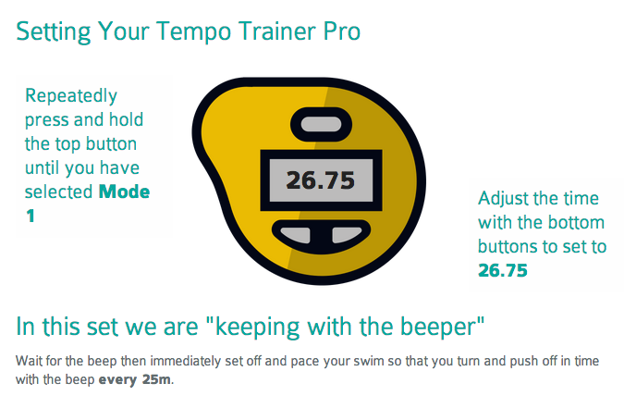

In Summary

In essence, CSS testing helps the swimmer by:

- Providing focused training to improve their distance swimming.

- Is quicker to recover from than many other training sets.

- Allows you train scientifically using a Tempo Trainer Pro.

- Inherently develops good pacing skills.

Ramp Test

The Stroke Rate Ramp Test is a series of 50m swims with a short break in between. The stroke rate during each 50 is controlled by the Tempo Trainer Pro and gradually increases. Take a short rest between the 50s to change the stroke rate on the Tempo Trainer Pro.

Performing a Stroke Rate Ramp Test
- Measure the swimmers stroke rate using your stopwatch.
  - Measure each arm since we are measuring symmetry. 0-1-2-STOP.
  - This is different than the documented method of measuring stroke rate.
- Start the Ramp Test about 10-strokes per minute below their initial rate and increase it by three strokes per minute for each 50m swim.
- Test until they are about 15-25 beats above their natural rate in order to experience their full stroke spectrum.
- Time each 50m with a stopwatch, count the strokes taken (counting both arms) and record how that stroke rate felt, in terms of effort.
- Use a scale of 1 to 10 to record their effort level where 1 is no effort at all and 10 is eyeballs out!
Evaluate the data to determine the swimmers most efficient stroke rate based upon their time, effort, and DPS.

Resources:
- Swim Smooth. http://previous.swimsmooth.com/ramptest.html

