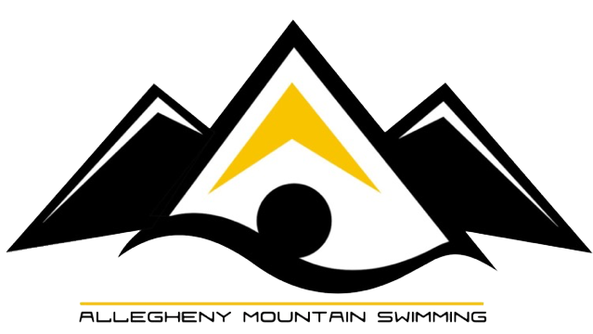
MLAC Senior Champs, sponsored by
March 3rd-4th

Senior Champs
Girls | Session 1  Saturday Morning | Boys
1 | 200 Freestyle Relay  **SWUM IN PRELIMS ONLY | 2
3 | 200 Butterfly | 4
5 | 100 Backstroke | 6
 | 10 Minute break
7 | 100 Breaststroke | 8
9 | 50 Butterfly | 10
 | 10 Minute break
11 | 100 Freestyle | 12
13 | 200 Individual Medley | 14
 | 10 Minute break
15 | 400 Medley Relay  **SWUM IN PRELIMS ONLY | 16
17 | 500 Freestyle  **SWUM IN PRELIMS ONLY | 18
19 | 1650 Freestyle  **SWUM IN PRELIMS ONLY | 20
 | Finals will be swum in the same order with breaks
Girls | Session 3  Sunday Afternoon | Boys
21 | 200 Medley Relay  **SWUM IN PRELIMS ONLY | 22
23 | 200 Breaststroke | 24
25 | 50 Backstroke | 26
 | 10 minute break
27 | 100 Butterfly | 28
29 | 200 Freestyle | 30
 | 10 minute break
31 | 50 Breaststroke | 32
33 | 200 Backstroke | 34
 | 10 minute break
35 | 400 Freestyle Relay  **SWUM IN PRELIMS ONLY | 36
37 | 400 Individual Medley  **SWUM IN PRELIMS ONLY | 38
39 | 1000 Freestyle  **SWUM IN PRELIMS ONLY | 40

